**Attended Robot concept:**

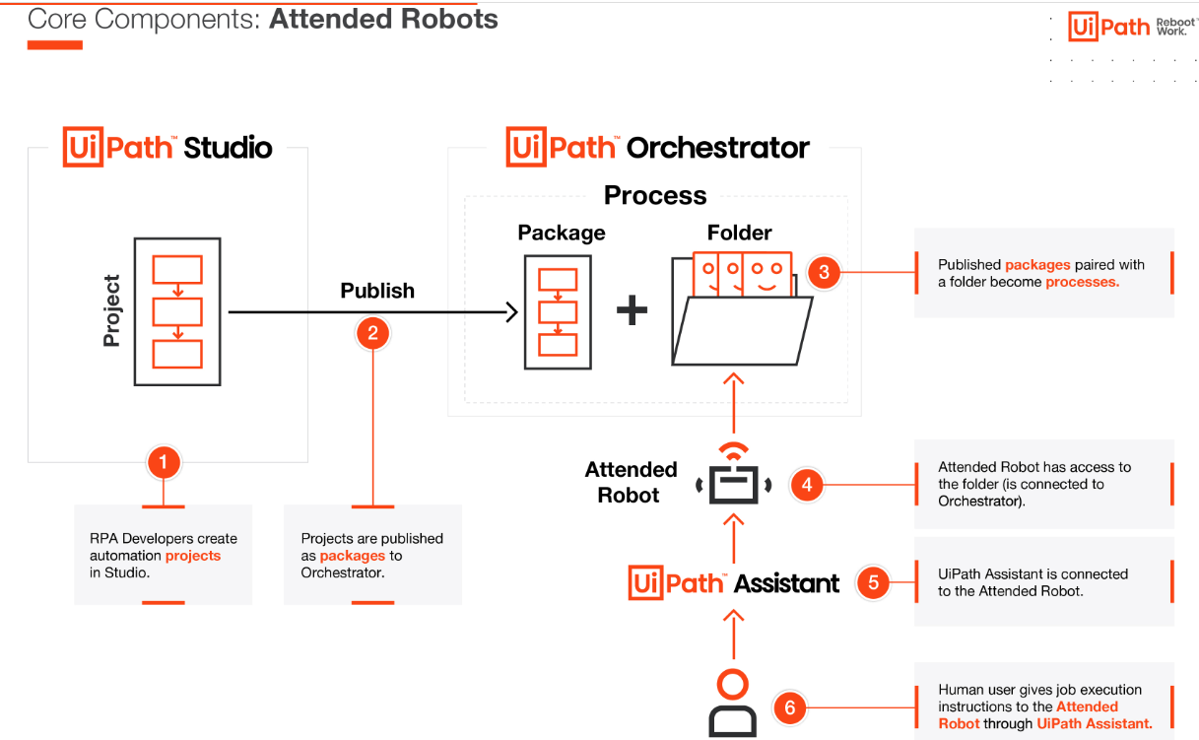

**Unattended Robot Concept:**

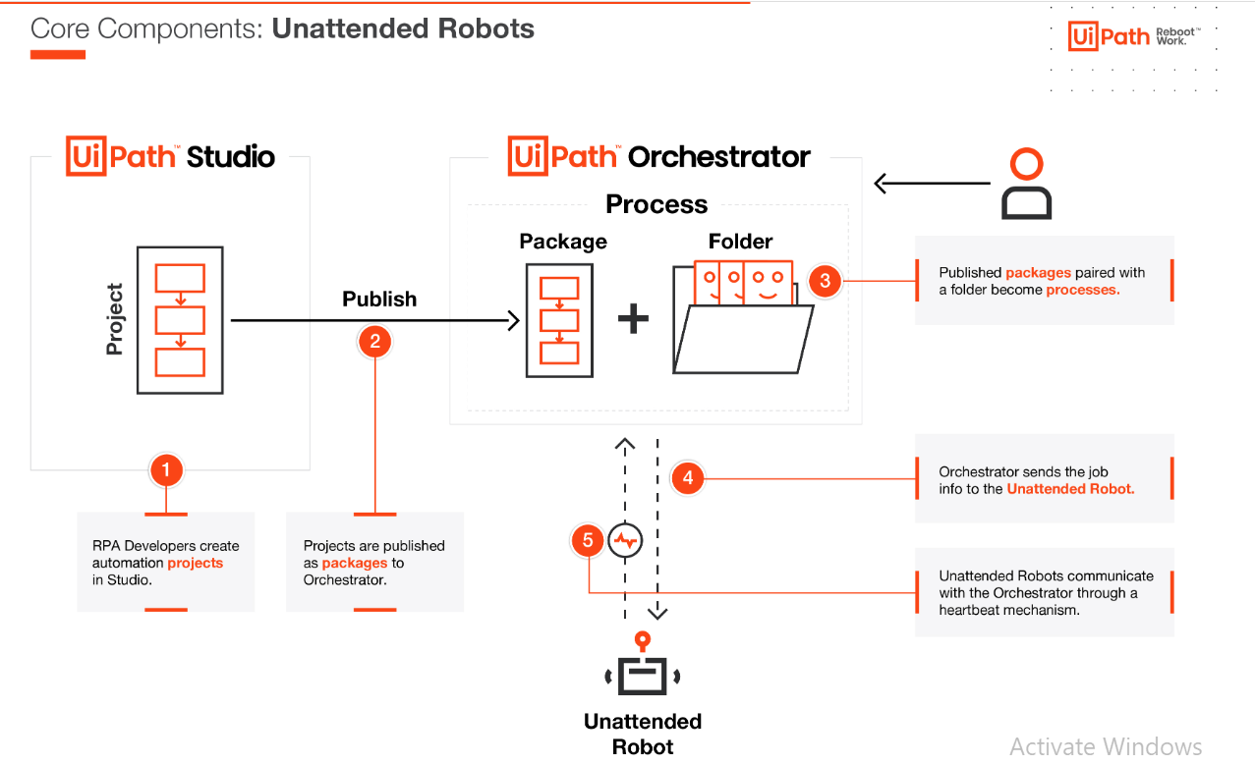

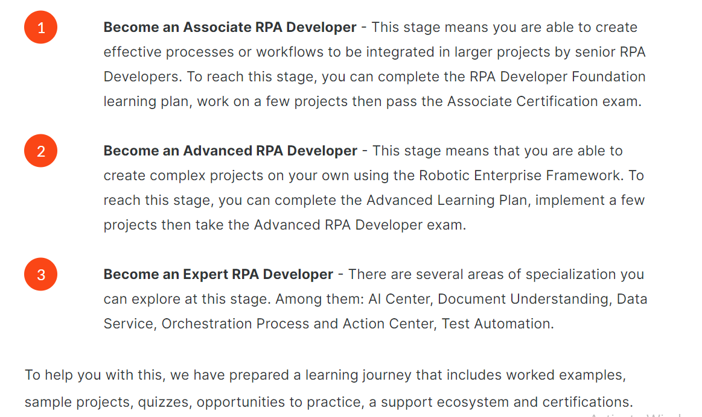

**Important Concepts in UiPath:**

**Studio**

The component of the UiPath RPA Platform for developing Robotic Process Automation projects.

**Studio Family**

The Studio family consists of three profiles available in the same application. While no additional installation is needed, accessing the profiles depends on the license:

* StudioX - the Citizen Developer profile
* Studio - the RPA Developer profile

The licenses are incremental, meaning that a Studio license will offer access to StudioX. All these licenses typically include an attended robot and UiPath Assistant.

**Robot**

The Robot is UiPath’s execution agent installed on a machine and enabling you to run automation jobs based on processes developed in Studio.

**Attended robot**

A type of robot working on the same machines as the humans, during the same hours. They are triggered directly by humans (usually through UiPath Assistant) or by an event related to what the human user does.

**Unattended robot**

A robot typically deployed on a separate machine than any human user. Their jobs are triggered exclusively from Orchestrator.

Since robots do not exist as separate entities in Orchestrator, a more technical definition would position unattended robots as execution slots - a user logged in on a machine, executing an automation job, as instructed by Orchestrator.

**Assistant**

The interface between the human user and the attended robot. It allows the human to trigger jobs, but also to organize processes, add reminders and so on.

**Orchestrator**

The component of the UiPath RPA Platform in charge of the management of automations, users and robots, as well as the management of the assets used in development or in running automations.

**Automation Cloud**

The cloud platform of UiPath, the single place for managing users and services, such as cloud Orchestrator, cloud AI Fabric, cloud Data Service, and so on.

**Automation project**

A business process or task automated with Studio family. Depending on the complexity and development approach, an automation project may consist of one or several workflows.

A workflow is a set of actions following a given logic set by the developer, having an input and an output. Workflows are typically linked in the same automation project through input and output arguments.

**Package**

An automation project published as a NuGet package from the Studio family to Orchestrator or locally.

**Process**

A package in Orchestrator linked to an Orchestrator folder where human users or robots have access. If stored locally, packages can be used as processes when they are run by attended robots.

**Job**

A single execution of an automation process by an attended or unattended robot. If the robots are connected to Orchestrator, both attended and unattended jobs appear there.

**UiPath Overview:**

UiPath Studio is a powerful tool that encompasses many features and capabilities that enable you to build the best automation solutions. To use Studio at its full potential, you must be well acquainted with the user interface.

The Studio user interface (UI) consists of:

* The **Backstage View**
* The **Ribbon**
* The **Command Palette**
* The **Panels**
* The **Status bar**

**What is a business process?**

**Definition:** A process is a set of interrelated or interacting activities that transforms inputs into outputs.

* **Components of a process:**
  + **Inputs** - the data that goes in the process.
  + **Process Flows** - the sequences of sub-processes or activities undertaken in the process.
  + **Source Applications** - the applications or systems used to perform the sub-processes or activities of the process.
  + **Outputs** - the result generated by the process.
  + **Things to remember:**The outputs of a process can serve as inputs for other processes.

**Process example: Order-to-Cash**

To better understand this, let's take a commonly used automated business process and compare the **manual ("As Is")** flowchart with the **automated ("To Be")** flowchart.

**manual ("As Is")**

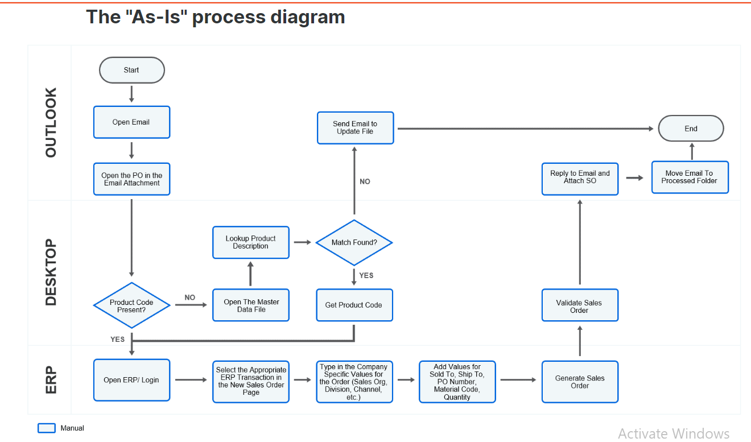

* **Inputs** - The received Email message.

**Process Flows** - the verification of the product code presence, the SAP transaction execution and the SAP fields population.

**Source Applications** - Outlook, Desktop and SAP.

**Outputs** - the result generated by the process.

In the context of an RPA implementation, the process flow we have just described, along with the procedure documenting it, would be considered the “As-Is” process.

**Automated Process(“To-Be”)**

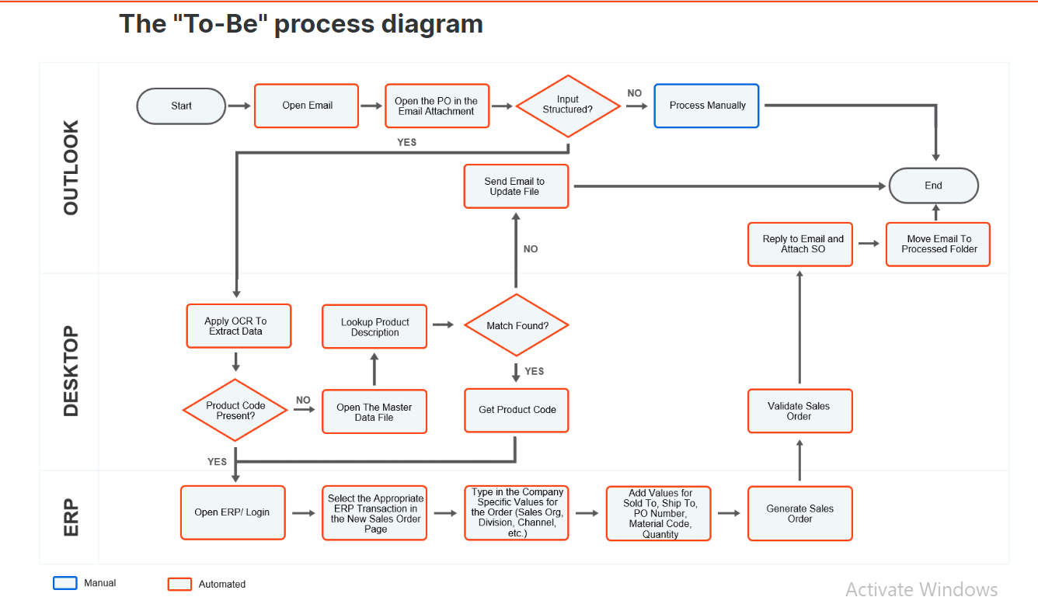

The “To-Be” process for our example factors in the potential of RPA. As we can see, most of the manual steps of the process (previously colored in blue) can be automated through RPA.

**How do RPA project implementations work?**

We often find the implementation process broken down into six stages.

Let's take a moment and explore each stage!

**What is the RPA Developer's responsibility throughout an implementation?**

To have a good understanding of the RPA Developers' responsibility and collaboration with other roles throughout the six stages of implementation, let's explore the diagram.

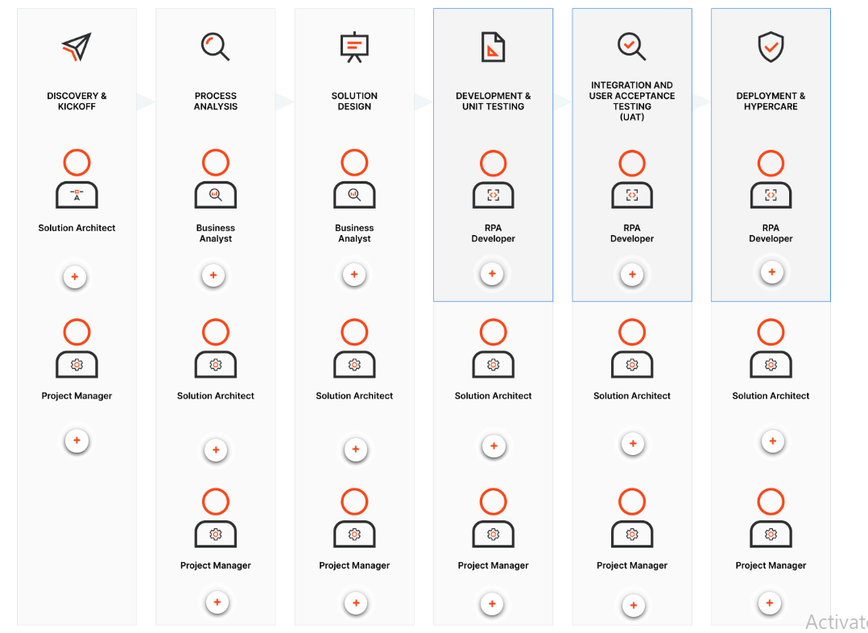

**Process:**  
A process is typically documented via a diagram, be it a flowchart or workflow, which aims to highlight the logical sequence of the process steps.

**Procedure:**

A procedure, on the other hand, is often a complex, written document, focused on providing guidelines

**Variables and Arguments:**

**What are variables?**

Variables are containers that can hold multiple data entries (values) of the same data type.

**EmailAddress** can be a variable that holds the value "rpadeveloper@uipath.com".

Likewise, the speed of a car, the age of a person, bank account balance, and marks obtained in an examination are some examples of variables.

The value of a variable can change through an external input, data manipulation, or passing from one activity to another.

### Why are they important?

Variables help us pass data from one activity to another. Advancing with any automation process would be hardly possible without using variables.

In Studio, variables are used to store multiple types of data. This data can be an integer, a boolean, a string, and many more data types.

**Name**

It should be as descriptive as possible to make your automation easy to read by other developers and to save time.

While not the only option, we recommend:

* using PascalCase for variable names. PascalCase is a naming convention in which the first letter of each word in a variable is capitalized. Eg: ItemValue, LastName.
* assigning meaningful names to the variables to accurately describe the usage of variables throughout the project.

The variable's name is its unique ID and it defines the way it's displayed and used.

This is a **mandatory** field. If you don't add a name to a variable, then, one is automatically generated.

**Variable type**

It defines what kind of data is stored in the variable. In UiPath, the data type is declared when the variable is created.  The dropdown field provides quick access to the most used data types (seen below), but there are many more options available to you, if you select "Browse for Types".

1. Boolean
2. Int32
3. String
4. Object
5. System.Data.DataTable
6. Array of [T]
7. Browse for Types

**Note**:

* Other types can be included in this list if previously used in Studio.
* Browse for Types is an option that'll open a dialog to select any supported type from the imported dependencies.

This is a **mandatory** field.

**Scope**

The part of the workflow in which the variable is called by name. A typical automation project consists of different workflows, nested, or connected in different ways.

The scope of a variable is defined by the name of the workflow in the automation project. Once the scope is defined, the variable can be used in that workflow and in all its children's workflows.

In real-life automation scenarios, there are many variables in use. Making all of them unnecessarily global can cause efficiency issues as well as create the conditions for confusion.

In UiPath, the scope of a variable cannot exceed the workflow in which it was defined. Since business automation projects rarely consist of single workflows, we need a different kind of vehicle to pass data between workflows, and this is called an argument.

You'll learn more about arguments shortly in the course.

The scope is a **mandatory** field.

**Default**

In general, variables have initial values that change throughout the process. For most variables, if no initial value is assigned when the variable is declared, then, there's a default rule that assigns a value.

This is an **optional** field.

**Creating Variables**

There are **four** main ways to create variables in UiPath:

**From the Variables panel**

–

* Navigate to the Variables panel.
* Select the ‘Create Variable’ line and type in the name.
* Whenever needed, provide its name in the Designer panel or in the desired Properties field.

**From the body of an Activity**

–

Variables can be created from the body of an Activity by pressing **Ctrl + K** in an input field that can accept a variable name. Alternatively, variables can be created from expressions directly in an activity input field or the Expression Editor.

* Select a part of the expression and press**Ctrl+K.**
* The **Set Var** field is displayed.
* Fill in the name and press Enter.
* Check its type and scope in the Variables panel.

**From the Properties panel**

–

In the Properties panel of any activity:

* Select a field that can be edited and press Ctrl+K.
* The Set Var field is displayed.
* Fill in the name and press Enter.
* Check its type and scope in the Variables panel.

**By performing right click in the input field of an activity**

–

* Right-click on any activity used in the sequence.
* Select Create Variable option from the list of options.
* This creates a new variable in the variable panel.
* Fill in the name, type, and scope in the Variables panel.

### What are data types?

Data Types describe what type of data a variable can hold.

For example, if the data type is Int32, then the variable must hold an integer number.

Likewise, if the data type is a String, then the variable must hold a text.

**Why are they important?**

Variables and arguments in Studio need to have a specific data type defined. This makes sure that the right data format is applied at each stage of an automated process.

The base data types are basic data types such as integers, strings, dates, and so on.

They include all the types that are part of any .NET programming language.

1. They're used as variable values.
2. They're used as constant values.
3. The processors can easily recognize them.

**String**

–

System.String: used to store text. This type of data comes with many specific methods of processing, and will be addressed in depth in another lesson, namely **Data Manipulation with Strings in Studio.**

**Numeric (category)**

–

Used to store numbers. There are different sub-types of numerical variables. For a few examples:

* **Int32** - System.Int32 (signed integers): 10, 299, -100
* **Long** - System.Int64 (long integers): 54354353430, -11332424D
* **Double** - System.Double (allows decimals, 15-16 digits precision): 19.1234567891011

**Boolean**

–

System.Boolean: Used to store one of two values – True or False.

**GenericValue**

–

This is a UiPath proprietary variable type that can store any kind of data, including text, numbers, dates, and arrays. This type is mainly used in activities in which we aren't sure what type of data we'll receive, yet in general, using this is temporary.

**Collection (category)**

–

This category reunites all collections of objects. Collections are largely used for handling and processing complex data. Some of the most encountered collections are:

* **Array**- ArrayOf<T> or System.*DataType*[]: used to store multiple values of the same data type. The size (number of objects) is defined at creation.
* **List**- System.Collections.Generic.List<T>: used to store multiple values of the same data type, just like Arrays. Unlike Arrays, their size is dynamic.
* **Dictionary**- System.Collections.Generic.Dictionary<TKey, TValue>: used to store objects in the form of (key, value) pairs, where each of the two can be of a separate data type.

You'll learn Arrays in the next lesson after arguments, and Lists and Dictionaries in more detail in the **Data Manipulation with Lists and Dictionaries in Studio**lesson.

**DataTable**

–

DataTable variables represent a type of variable that can store big pieces of information, and act as a database or a simple spreadsheet with rows and columns.

You'll find out more about DataTables in the **DataTables** **and Excel Automation in Studio** lesson.

**Date and Time (category)**

–

* **DateTime**- System.DateTime: Used to store specific time coordinates (mm/dd/yyyy hh:mm:ss).  
  This kind of variable provides a series of specific processing methods (subtracting days, calculating time remaining vs. today, and so on).  
    
  For example, to get the current time, assign the expression DateTime.Now to a variable of type DateTime.
* **TimeSpan** - System.TimeSpan: Used to store information about a duration (dd:hh:mm:ss). You can use it to measure the duration between two variables of the type DateTime.  
    
  For example, you can save the time at the start of the process in one variable (of type DateTime), the time at the end in another (of type DateTime) and store the difference in a variable of type TimeSpan.

**How to convert variable one data type to another:**

**Convert.ToString Method**

–

This method converts the specified value to its equivalent string representation.

It can be Int32 to String.

**ToString(Int32, Int32) -**Converts the value of a 32-bit signed integer to its equivalent string representation in a specified base.

Eg: **StrVar = Convert.Tostring(IntVar)**

**Convert.ToInt32**

–

This method converts a specified value to a 32-bit signed integer.

**ToInt32(String) -**Converts the specified string representation of a number to an equivalent 32-bit signed integer.

There's another method to convert a string to an integer - **CInt(String)**

**ToInt32(Double) -**Converts the value of the specified double-precision floating-point number to an equivalent 32-bit signed integer.

Eg:

**IntVar = ToInt32(StrVar)**

**IntVar = CInt(StrVar)**

**IntVar = ToInt32(DblVar)**

**Double.ToString Method**

–

This method converts the numeric value of this instance to its equivalent string representation.

Eg: **StrVar = DblVar.ToString**- This method displays the string representations of a number of Double values.

**Double.Parse Method**

–

This method converts the string representation of a number to its double-precision floating-point number equivalent.

Eg: **DblVar = Parse(StrVar)**

**Boolean.ToString Method**

–

This method converts the value of this instance to its equivalent string representation (either "True" or "False").

Eg: **ToString()**

**Convert.ToBoolean Method**

–

This method converts a specified value to an equivalent Boolean value.

Eg:**ToBoolean(Int32)** - Converts the value of the specified 32-bit signed integer to an equivalent Boolean value.

**Convert DateTime to String**

–

**DateTime.Now** Property - Gets a DateTime object that's set to the current date, and time on this computer, expressed as the local time.

**ToString(DateTime) -**Converts the value of the specified DateTime to its equivalent string representation.

Eg: **Now.ToString(“dd-MM-yyyy”) or DateTimeVar.ToString("dd-MM-yyyy")**- Provides the date format: 01-06-2022.

**What is a workflow?**

A workflow represents a relatively small piece of an automation project, typically executing a specific part of the process. Once built, it can be reused across different projects.

A workflow is made of Studio activities, interconnected through variables to form a routine. The routine typically has an input and an output. Basically, it defines the flow of automation. Hence the name, workflow.

UiPath Studio provides you with predefined workflow layouts to suit all the needs of a fast and reliable automation process.

**The workflow layouts are:**

* [**Sequences**](https://docs.uipath.com/studio/v2021.10/docs/sequences)
* [**Flowcharts**](https://docs.uipath.com/studio/v2021.10/docs/flowcharts)
* [**State Machines**](https://docs.uipath.com/studio/v2021.10/docs/state-machines)
* [**Global Exception Handler**](https://docs.uipath.com/studio/v2021.10/docs/global-exception-handler)

### Why is it important?

The fastest, most reliable, and useful way of automating a process is to break it down into smaller bits.

This allows for independent testing of components, enables team collaboration, and component reuse.

Hence, most of the automation projects require the use of multiple workflows that come together to provide a solid business automation solution.

**What are arguments?**

Arguments are very similar to variables:

* They store data dynamically.
* They have the same data types.
* They support the same methods and properties.

The difference is that they pass data between workflows, and they have an additional property for this – the direction. Arguments have specific directions: In, Out, and In/Out. These tell the Robot where the information stored in them is supposed to go.

### Why are they important?

Arguments are a key component when it comes to building more complex automation, where you need to store and use data between multiple workflows.

**Creating arguments**

Argument names should be in PascalCase with a prefix stating the argument direction, such as in_DefaultTimeout, in_FileName, out_TextResult, io_RetryNumber.

Let's check out the ways of creating arguments.

**From the body of an Activity**

–

Directly from the activity panel in an activity input field:

* Right-click a field and select Create In Argument or Create Out Argument from the context menu. Alternatively, **press Ctrl+M or Ctrl+Shift+M.**
* The **Set Arg** field is displayed.
* Fill in the name and press Enter. An argument is created.
* Check its direction and type in the Arguments panel.

Alternatively, from the Expression Editor:

* Select a part of the expression and**press Ctrl+M (for In arguments) or Ctrl+Shift+M (for Out arguments)**.
* Then **Set Arg** field is displayed.
* Fill in the name and press Enter. The argument is created.
* Check its direction and type in the Arguments panel.
* Arguments created in these ways automatically receive the type according to the activity.

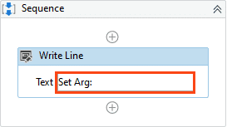

**From the Properties panel**

–

In the Properties panel of any activity:

* Right-click a field that can be edited.
* Select Create In Argument or Create Out Argument from the context menu. Alternatively,**press Ctrl+M (In) or Ctrl+Shift+M (Out)**.
* The **Set Arg** field is displayed.
* Fill in the name and press Enter. The argument is created and visible in the field. Check its direction and type in the Arguments panel.

The argument type is automatically generated depending on the selected property.

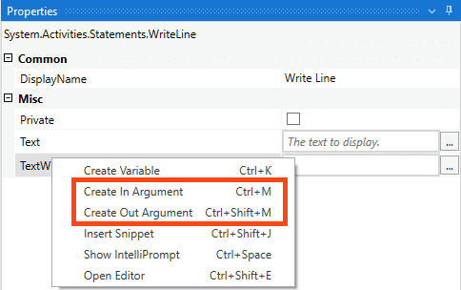

**From the Arguments panel**

–

* Navigate to the Arguments panel.
* Select the Create Argument line.
* Fill in the name, direction, and type. A new argument is created.

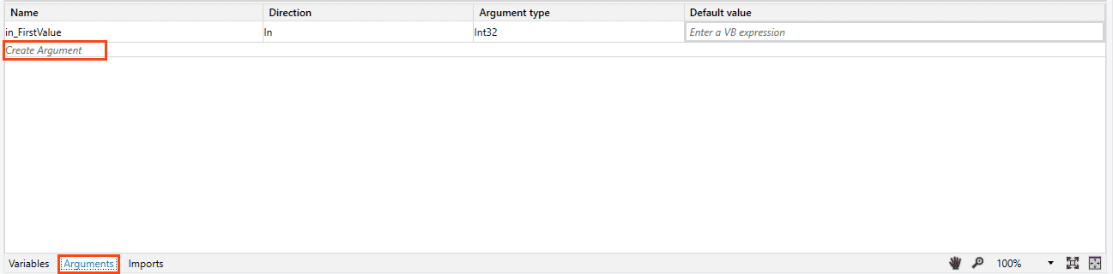

**Difference between Variables and Arguments:**

| **Variables** | **Arguments** |
| --- | --- |
| Used to pass data from one activity to another within a workflow. | Used to pass data dynamically between automation. |
| Don't have directions like In, Out, or In/Out. | Do have directions like In, Out, In/Out. |
| To create a variable press: Ctrl + K. | To create an In Argument press: Ctrl +M. To create an Out Argument press: Ctrl+Shift+M. |
| To create variables, there must be at least one activity in the Designer Panel. | Arguments can be created if the Designer panel doesn't contain any activity. |
| Variables aren't used with the Invoke workflow file and Launch workflow Interactive activities. | Due to their nature, arguments are used a lot in relation with the Invoke workflow file and Launch workflow Interactive activities. |
| Require a defined scope. | Do not require a scope. |

**Array:**

**What are Collections?**

If you have data entries that are similar, like invoice numbers, book names, and account numbers, and you want to group them together, then collections come in handy. They're data types that allow the storage of entries of the same base data type as elements of one variable. This way, you can work both with all the objects in the collection variable and with each object. To make this work, the name of the collection variable and its position in the collection can identify the objects of a collection.Let's take the example of an Array of Strings:

**StrArray = {"John", "Paul", "George", "Ringo"}**

**StrArray(0) = "John"**

**Note:**

* **vbLf** = visual basic line feed: This will add a new line in the text. Similar methods: Environment.NewLine, "\n", "\r\n".
* **Math.Round** = rounds the floating number to a given precision.

Eg: Math.Round(2.34123, 2) = 2.34; Math.Round(2.34678, 2) = 2.35.

**Control Flow In Studio:**

### The workflow layouts

There are four predefined workflow layouts – Sequence, Flowchart, State Machine, and Global Exception Handler.

State Machine is a type of automation that uses a finite number of states in its execution. It can go into a state when it's triggered by an activity, and when another activity is triggered, it exits that state.

The Global Exception Handler is a type of workflow designed to determine the project’s behavior when encountering an execution error.

1. In **Sequences**, the process steps flow in a clear succession. Decision trees are rarely used.  
     
   Activities in sequences are easier to read and maintain, and thus they're highly recommended for simple, linear workflows.
2. In **Flowcharts**, the individual activities are a bit more difficult to read and edit, but the flows between them are much clearer.  
     
   Use flowcharts when decision points and branching are needed to accommodate complex scenarios and decision mechanisms.

**The control flow statements**

These are activities and methods that define the decisions to be made during the execution of a workflow.  
  
The most common control flow statements are **If**, **While**, **Do While**, **For Each**, **Switch**, and**Parallel**.

The graphic below highlights the most important control flow statements available in UiPath Studio. They are of 3 types:

* The conditional, also known as decision-making activities such as If, Else If, and Switch.
* Loops such as While, Do While, and For Each.
* Parallel Activity that executes child activities asynchronously, in parallel.

**What is the importance of control flow?**

Control flow takes care of the order in which the actions are performed in automation.

Activities like If/Else If, For Each, enable us to define rules and automate conditional statements within the project.

* 3

Loops enable us to run a part of the automation a specific number of times until a condition is met, or indefinitely.

**\*) Flow Decision activity is same as if else in flowchart.**

**Loops:**

**Do While**

It executes a specific sequence while a condition is met. The condition is evaluated **after** each execution of the statements.

For example, a robot could perform a refresh command on a website and then check if a relevant element was loaded. It will continue the refresh - check cycle until the element is loaded.

The key difference between Do While and While is that for Do While, the activities contained within it are executed at least once.

The graphic depicts how a Do While loop appears in a simple workflow in UiPath Studio.

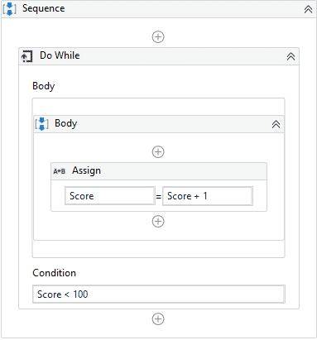

**While**

It executes a specific sequence while a condition is met. The condition is evaluated **before** each execution of the statements.

For example, if a Robot would play Blackjack, it should calculate the hand before deciding whether to draw another card.

The graphic depicts how a While loop appears in a simple workflow in UiPath Studio.

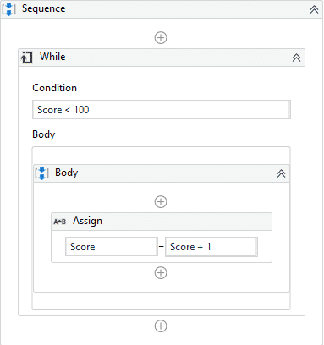

**For Each**

–

It performs an activity or a series of activities on each element of an input collection.

This is very useful in data processing. Consider an Array of integers. For Each would enable the robot to check whether each numeric item fulfills a certain condition.

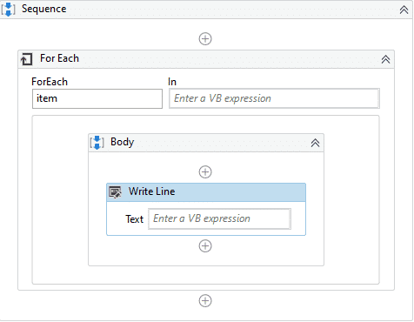

**How do you exit a loop?**

* The **While** and **Do While** loops will exit when upon checking, the condition is no longer true.
* The **For Each** loop will exit when it has finished processing every item in the input collection.
* The **Break**activity enables you to exit the current loop activity (e.g. For Each, While, or Do While) at a chosen point and continues the workflow with the activity that follows it.

**Differences between For Each and While**

| **For Each loop** | **While loop** |
| --- | --- |
| Performs an activity or series of activities on each element of an enumeration. | Executes contained activities while the condition is True. |
| Iterates through each element in the collection. | Iterates as long as the condition is met. |
| Exits upon completion of processing of each item in the collection. | Exits upon checking if the condition is false. |

**Differences between Switch and If**

| **Switch** | **If** |
| --- | --- |
| Useful when we need at least three potential sources of action. | Useful only with two potential courses of action. |
| Uses a condition that is not boolean. But enables the selection of one choice out of multiple, based on the value of a specified expression. | Uses a condition that is boolean in nature. |
| Workflow design with multiple nested If-Else replaced by switch activity is easy to follow. | Workflow design with multiple nested If-Else looks cluttered and difficult to follow. |
| By default, switch activity uses an integer argument in the Case Value section in Studio. | If statement uses an integer or character. |

**Parallel Activity:**

### What is it?

The Parallel activity enables you to execute two or more child activity branches at the same time.

In UiPath Studio, the Parallel activity can be found in the **Activities**panel, under **Workflow**> **Control** > **Parallel.**

The Parallel activity finishes only after all child activities are complete or when its CompletionCondition property evaluates to true.

### Why is it important?

The Parallel activity is very beneficial when there are one or more blocking activities in the branches, because it executes all child activities simultaneously and asynchronously, thus saving time and being very efficient.

*) Asynchronously means totally independent activity.

**Important:**

**Value.Substring(0,2).ToLower** 🡪 Value variable madhlya string cha 0 pasun start karun 2 chya aadhiche character he lower case madhe convert karan.

**AxArray = AxArray.Concat({Value}).ToArray 🡪** AxArray navachya array variable madhe Value madhe store asleli value AxArray madhe store karan as a array.

**string.join(" ",AxArray)** 🡪 AxArray variable madhlya strings join karan separated by space.

# Introduction to User Interface (UI) Automation

**What is it?**

User interface or graphical user interface automation (UI Automation) refers to the process of interacting with graphical elements within applications by simulating mouse and keyboard controls.  
  
Just as human users use applications through activities such as **clicking**, **typing**, or **selecting text,** UiPath Robots can be configured in UiPath Studio by RPA Developers to perform the same tasks faster and error-free.

Through a deep integration between UiPath and all of the major GUI frameworks from Win32 to WPF, HTML, and Java, RPA Developers can easily automate all types of desktop applications.  
UiPath recognizes graphical objects by its own platform-specific attributes and provides a unified GUI automation API that works the same way everywhere.

**UI Automation is built upon seven key concepts. These are:**

* 1. **UI Automation activities**
  2. **Activity properties**
  3. **Targeting methods**
  4. **Input and output methods**
  5. **Recorders** **and Scraping Wizards**
  6. **The object repository**
  7. **AI Computer Vision**

1. **Activities (What to do)**

Activities tell the Robot what to do. You can find them in the Activities panel and they are of four types:

* + **Containers** - Select a specific app or browser
  + **Input** - Send input to an app interface
  + **Output** - Get output from an app interface
  + **Synchronization** - Control your process flow based on the states of UI Elements (e.g. do something when an UI Element appears)

1. **Properties (How to do it)**

Properties control how the Robot executes an activity. Here you can control if you want the Robot to wait before or after executing the activity, what element to execute the activity on, how much to wait if it cannot find the element and so on.

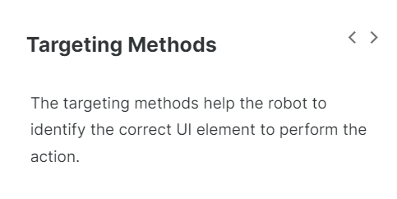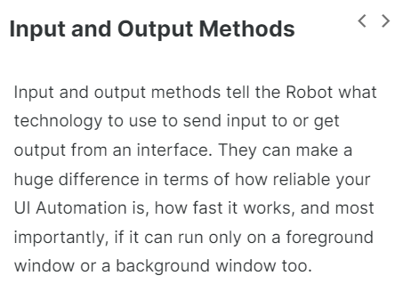

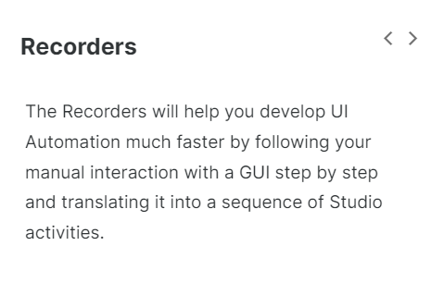

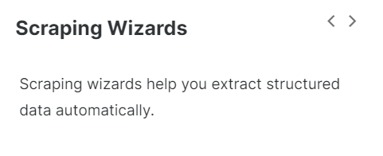

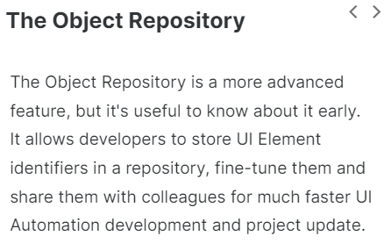

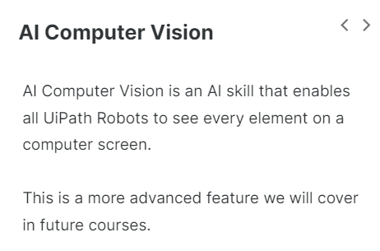

**Now let's look at the below diagram to understand how everything fits together. We will learn more about each as we progress in this course.**

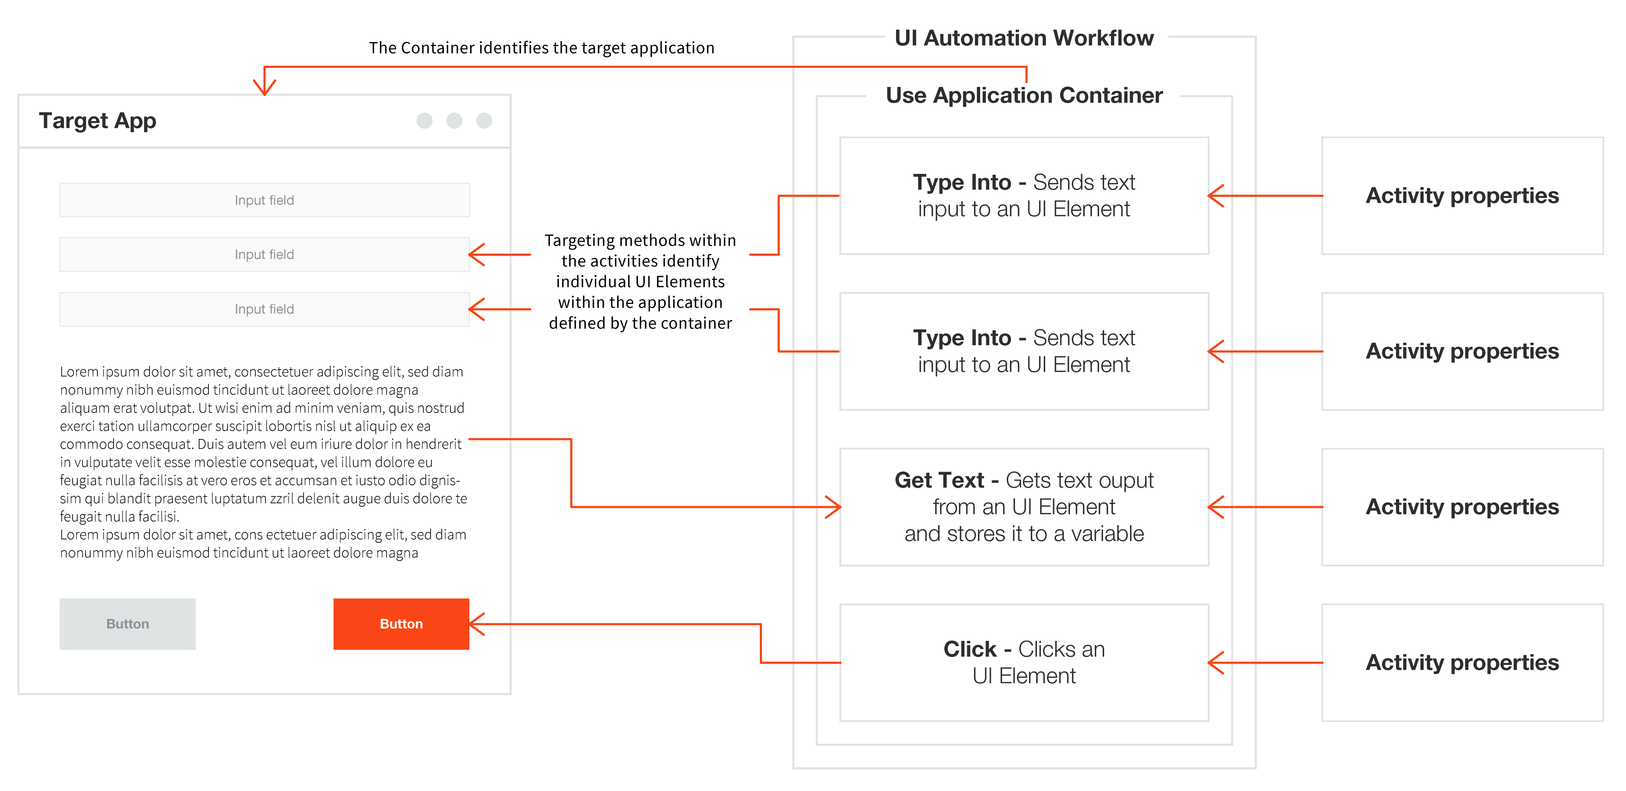

**GUI 🡪 Graphical User Interface**

**1) Activity properties**

Just like for other types of activities, properties determine **how**the robot performs an action. They can be found in the **Properties panel**. UI Automation activities have specific sets of properties depending on the type of activity. Here are a few examples of common properties:

|  |  |
| --- | --- |
| **Property** | **What it does** |
| **DelayAfter**/**DelayBefore** | How many milliseconds the robot waits before or after executing the activity. |
| **ContinueOnError** | Will an exception encountered while executing the activity be thrown or ignored? For example, if the element isn't found, will robot throw an error and stop the execution, or will it ignore it and continue? |
| **Target** | Provides several properties related to identifying the target UI Element. |
| **Timeout (milliseconds)** | How many milliseconds will the Robot try to perform an action on an UI element. |
| **SendWindowsMessages**/**Simulate Type** | What input method do we use for input activities. |
| **Output** | It Stores the output of the activity in the form of variables. |

2) **Targeting methods**

Targeting methods are a subset of Properties. They provide several ways to identify the UI element the Robot will be interacting with.

The key targeting methods are:

* **Selectors**
* **Fuzzy Selectors**
* **Image**
* **Native Text**

You'll learn more about these in the **Selectors in Studio** and **Descriptors in Studio** courses.

3) **Input and output methods**

As we've discussed already, every time we insert data into an application, or we send a command to a system to produce a change (or to continue), we perform an input action. Output actions are used to extract data (in general, as text) from a UI element. Output methods are what enables output actions to extract data from UI elements.

**Input Methods:**

**Hardware Events**

–

* Clicking: the mouse cursor moves across the screen.
* Typing: the keyboard driver is used to type individual characters.
* Compatible with all applications.
* Does not work in the background.
* The attended user cannot touch the mouse or keyboard during the automation.

**SendWindowMessages**

–

* Replays the window messages that the target application receives when the mouse/keyboard is used.
* Works in the background.
* Users can work on other activities during the execution of the automated processes.

**Simulate**

–

* Uses the technology of the target application (the API level) to send instructions.
* It is the fastest targeting method.
* Works in the background.
* Users can work on other activities during the execution of the automated processes.

**ChromiumAPI**

–

* It is a browser automation input method based on the Devtools protocol.
* It allows direct communication with the browser, in turn fewer communication channels, and thus improved automation reliability.
* Works in the background.
* Users can work on other activities during the execution of the automated processes.

**Output methods**

**Full Text**

–

The FullText method is the default method and good enough in most cases. It is the fastest, it can extract hidden text, it has 100% accuracy, and can work in the background.

**Native**

–

The Native method is compatible with applications that use Graphics Design Interface (GDI), the Microsoft API used for representing graphical objects. It doesn’t extract hidden text and it cannot work in the background; and just like FullText, it doesn’t support virtual environments.

**OCR**

–

OCR (or Optical Character Recognition) is the only output method that works with virtual environments and with “reading” text from images. Its technology relies on recognizing each character and its position. On the other hand, it cannot work in the background, it cannot extract hidden text, and its speed is by far the lowest.

4) **Recorders and Scraping Wizards**

Recording is an important part of UiPath Studio, that can help you save a lot of time when automating your business processes. This functionality enables you to easily capture a user’s actions on the screen and translate them into sequences. These projects can be modified and parameterized so that you can easily replay and reuse them in as many other processes as you need.  
  
Scraping Wizards helps to extract structured data from your browser, application or document to a database, .csv file or even Excel spreadsheet.

5) **The object repository**

The object repository ensures the management, reusability, and reliability of UI elements by capturing them as objects in a repository, sharable across projects. It allows for creating and reusing UI taxonomies inside and across automation projects. This is a more advanced feature we will learn more about later.

**6) AI Computer Vision**

The AI Computer Vision activity package contains refactored fundamental UI Automation activities such as Click, Type Into, or Get Text. The main difference between the CV activities and their counterparts is their usage of the Computer Vision neural network developed in-house by our Machine Learning team. The neural network is able to identify UI elements such as buttons, text input fields, or check boxes without the use of selectors. This is an advanced feature we will learn more about later.

**Main takeaways**

–

* The key concepts of UI Automation in UiPath are: UI Automation Activities, Activity Properties, Targeting Methods, Input and Output Methods, Recorders, The Object Repository and Computer vision.
* **UI Automation Activities** - Activities can be containers, input activities, output activities or synchronization activities.
* **Activity Properties** - Properties determine how the Robot performs an action. They can be found in the Properties panel.
* **Targeting Methods** - They provide several ways to identify the UI element the Robot will be interacting with.
* **Input and Output Methods** - Define the type of technology used in interacting with UI elements. Output methods are used to extract data (in general, as text) from a UI element. The technology used by Input methods is different than the one used in Ouput methods.
* **Recorders and Wizards**- This functionality enables you to easily capture a user’s actions on the screen and translates them into sequences.
* **The Object Repository** - The Object Repository ensures the management, reusability, and reliability of UI elements by capturing them as objects in a repository, sharable across projects.
* **AI Computer Vision**- Is able to identify UI elements such as buttons, text input fields, or check boxes without the use of selectors.

**The key differences between the modern design experience and the classic** **design experience:**

**Targeting Method:**

**Modern activities** will **cycle through** the stacked options **Selector**, **Fuzzy Selector**, and **Image** to determine the most reliable option. This targeting technology is called **Unified Targeting method**.  
Modern Design also uses Native Text targeting method. It helps to automate legacy applications, in which UI elements aren't correctly defined.

When using **classic activities**, the selector is the most common targeting method for UI elements (99% of the time). In scenarios where it's unreliable, you have the possibility to manually change the update Activity to use fuzzy selectors or anchors.

**Recorders and wizards**

Modern and classic offer two different sets of recorders:

* **Modern experience** - The App/Web and Computer Vision recorders are available.
* **Classic experience** - The Basic, Desktop, Web, Image, Native Citrix, and Computer Vision recorders are available.

When it comes to Scraping Wizards:

* **Modern experience** - The Table Extraction wizard is available for data scraping.
* **Classic experience** - The Data Scraping and Screen Scraping wizards are available.

**UI Automation with The Modern Experience:**

**Descriptor:** The Anchor and target pair is called as descriptor.

* + We can add maximum 3 anchor for 1 target.

**Input Methods:**

**ChromiumAPI**

ChromiumAPI is a browser automation input method based on the Devtools protocol. It is 100% compatible with Chromium-based browsers, like Chrome or Edge. Basically, it works on any website or application executed inside the Chromium browser. It works with the following activities:

* Use Application/Browser
* Click
* Type Into
* Hover
* Keyboard Shortcuts

**Benefits of using ChromiumAPI over Hardware Events**

**Reliability**

Using the **Hardware Events** input method for all the input actions, these actions communicate with the operating system’s mouse/keyboard input stream. From there, the events are sent to the target application, the browser, which parses them and sends them further to the web pages.

With **ChromiumAPI**, the events are sent directly to the browser. Therefore, this input method removes a communication channel that can fail (as any other communication channel).

**Works in the background**

**Hardware Events** input method needs elements to be on the screen, focused, and in the foreground. The **ChromiumAPI** doesn't require it as it works while the browser is minimized and/or another tab is focused.

**Benefits of using ChromiumAPI over Simulate input method**

* It allows sending hotkeys directly to the browser, wherein Simulate doesn't support hotkeys.
* The Clear before typing property is natural with this method, since it doesn't empty the target element field by default.
* Click with modifiers actions are more efficient and reliable.

Let's have a look at how each input method differs from one another.

| **Input Method** | **Compatibility** | **Background Execution** | **Speed** | **Hotkey Support** | **Auto Empty Field** |
| --- | --- | --- | --- | --- | --- |
| Hardware Events | 100% - all types of applications. | No | 50% | Yes | No |
| SendWindowMessages | 80% | Yes | 50% | Yes | No |
| Simulate | 99% - web apps  60% - desktop apps | Yes | 100% | No | Yes |
| ChromiumAPI | 100% - Chrome and Edge browsers | Yes | 50% | Yes | Yes |

**Background mode is available only for Use application browser Activity.**

**How does the Background mode work?**

It runs all the activities inside the **Do** block of **Use application browser** card in the background by using either Simulate, or ChromiumAPI as an input method.

You should keep in mind that the Background mode is not a foolproof solution, as some UI actions are not compatible with it. The actions which aren't compatible with working with background mode are:

* 1. Any activities using image as targeting method.
* 22) Native text automation.
* 33) All keyboard shortcuts.
* 4) Minimizing opened applications.
* 5) The Take Screenshot Activity.

**The APP/Web Recorder:**

**Using the app/web recorder wizard**

The second method of automating user interfaces is by using the **App/web Recorder**feature. This is a tool that can help you save a lot of time when automating your business processes. This functionality enables you to easily capture **your actions on the screen** and translate them into **activities in Studio**.

The workflows generated by the recorder can then modified by editing the configuration of the activities recorder, so that you can easily replay and reuse them in as many other tasks as you need.

All user interface elements are highlighted while you record, so that you can be sure the correct buttons, fields, or menus are selected. We'll demonstrate the recorder tool on the same exercise as in the previous lesson. So, make sure you have the DoubleUI app open if you wish to reproduce the steps.

App/web recorder: It will record all our actions taken on screen and it will create process (Robot) for same.

**Output Methods Used in the Modern Design Experience:**

| **Output Method** | **FULL TEXT** | **NATIVE** | **OCR** |
| --- | --- | --- | --- |
| **Default method and Compatibility** | It is the **Default method** and good enough in most cases. | Compatible with applications that use **Graphics Design Interface (GDI)**, the **Microsoft API is**used for representing graphical objects. | OCR (or Optical Character Recognition) is the only output method that works with **virtual environments** and with **“reading” text from images**.  Its technology relies on recognizing each character and its position. |
| **Automation Speed** | **Fastest**compared to the other two methods. | Somewhat **slower than FullText.** | By far the **slowest.** |
| **Accuracy** | **100%**accuracy. | **100%**accuracy on the **applications that support GDI.** | Accuracy varies from **one text to**another, by **changing the settings**wecan improve the results. |
| **Running in Background** | **Works** in the background. | **Cannot** work in the background. | **Cannot** work in the background. |
| **Hidden Text** | **Can** extract hidden text (for example, the options in a drop-down list). | **Cannot**extract hidden text. | **Cannot** extract hidden text. |
| **Virtual Environment** | **Doesn’t**supportvirtual environments. | **Doesn’t**support virtual environments. | **Works** with virtual environments and with **“reading” text from images**. |
| **Text position and Formatting** | **Doesn’t capture**text position and formatting. | **Can** extract the text position and formatting (including text color) | Like the **Native** method, it also captures the text position. |
| **Other** | The method offers the **option to ignore the hidden message**and capture only the visible text. | By default, it can process all known **characters as separators** (**comma, space, and so on**), but when only certain separators are specified, it can ignore all the others. | The OCR method has **two default engines**that can be used alternatively:   * **Google Tesseract,** * **Microsoft MODI.**   There are additional OCR engines that can be installed free of charge (such as Omnipage and Abbyy Embedded) or paid (IntelligentOCR offered by Abbyy). |

**Get Text Activity**

Get Text Activity Extracts and copies the text from a UI element. It should be added inside a Use Application/Browser Activity.

You can use this Activity to extract data using the following output methods:

* **Default**: tries all the output methods, and the first one to return a text is used.
* **Text attribute:**uses the "text" attribute of the UI element.
* **Fulltext**: this method offers the option to Ignore hidden text, which can be activated by selecting its respective check box.
* **Native:** this method enables you to Allow formatting and retrieve the screen coordinates of the words by selecting the check boxes for each of these features.

**Get Text Activity** provides the **Extraction Preview wizard.**This wizardenables you to choose the suitable output method based on the result displayed in the Extraction Preview wizard.

**CV Get Text**

Extracts the text from a specified UI element position based on an anchor. It should be added inside a CV Screen Scope Activity.

It supports the following methods:

* **OCR**: uses the OCR engine specified in the parent CV Screen Scope activity to retrieve the text.
* **Select - all**: extract the entire text by using the clipboard. This simulates a copy/paste action and can only be used on selectable text, on either local or remote sessions.
* **Select - row**: extract the text in the entire row by using the clipboard. This simulates a copy/paste action and can only be used on selectable text, on either local or remote sessions.

**Get OCR Text**

Extracts a string and its information from an indicated UI element or image using the OCR screen scraping method. This Activity gets generated automatically when performing screen scraping, along with a container. By default, the Google OCR engine is used.

**Write range activity:** It is used for excel related operations.

The UI synchronization activities and features available in the modern design experience are:

* 1
  1. Check app state Activity
  2. Verify execution feature 🡪 It will verify on same step only it is correct or not.

Check app state Activity : (This activity is same as if else )

* The**Check App State** action is useful for situations in which you want to check whether the application you are going to automate exists.
* Think about different tabs in an application or browser. While adding activities to your workflow, you want to make sure you are targeting the correct app elements or browser tabs. Additionally, in case your element is not found you can add another set of activities to be performed.
* To increase the time for the target element to be found before executing the next activities you can update the value of the **Wait for**option.

**Concept:**

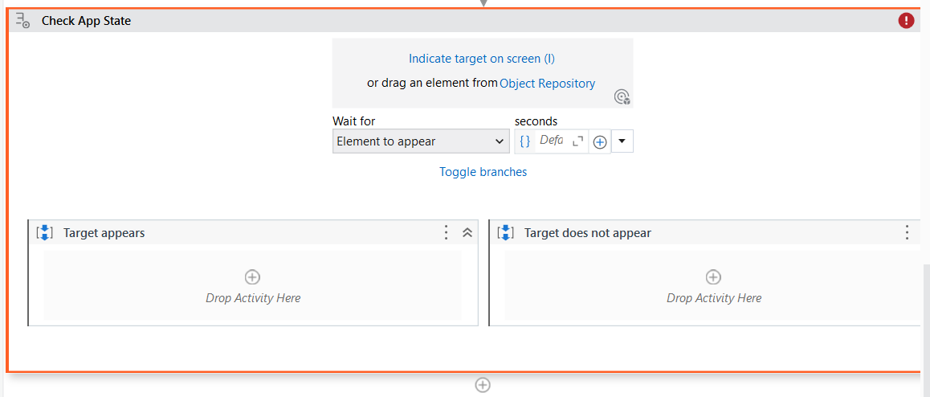

If target is there on screen, then it will execute target appears section.

If not there then it will execute target does not appear section.

**UI Automation with The Classic Experience:**

**Input methods**

Input methods are properties that provide the input activities with the means to input data. Input methods determine the speed of the process when it can run in the background and interact with the application UI.

**Types of input methods:**

1. **Simulate Type/Click/Hover**
2. **SendWindowMessages**
3. **Hardware Events**

By default, the '**Hardware Events**' method is applied. But, we can change the method at any point, from the properties panel, based on the compatibility of the selected activity or based on the automation requirement.

**Hardware Events**

**How does it work?**

* Clicks: the mouse cursor moves across the screen.
* Typing: the keyboard driver is used to type individual characters.

**What are the implications?**

* The attended User cannot touch the mouse or keyboard during the automation.
* It has a lower speed and load times can impact accuracy.

**What are the strong points?**

* Supports special keys like 'Enter', 'Tab', and other hotkeys.
* 100% compatibility.

**What are the limitations?**

* It won't be able to erase previously written text automatically.
* It won't work in the background.

**Send Window Messages**

**How does it work?**

* Replays the window messages that the target application receives when the mouse/keyboard is used.
* Clicking and typing occur instantly.

**What are the implications?**

* Works in the background.
* Comparable to the Default method in terms of speed.

**What are the strong points?**

* Supports special keys like 'Enter', 'Tab', and other hotkeys
* Users can work on other activities during the execution of the automated processes

**What are the limitations?**

* It won't be able to erase previously written text automatically.
* Works only with applications that respond to Window Messages.

**Simulate**

**How does it work?**

* Uses the technology of the target application (the API level) to send instructions.
* Clicking and typing occur instantly.

**What are the implications?**

* Works in the background.
* Actions are a lot faster, but there are some compatibility limitations.

**What are the strong points?**

* Will automatically erase previously written text.
* Users can work on other activities during the execution of the automated processes.

**What are the limitations?**

* Does not support special keys like 'Enter', 'Tab', and other hotkeys
* Compatibility is lower than the other two methods

**Input activities and their properties:**

1. **Click Activity:**

The Click activity is used to click a specified UI element. It offers below options:

* **AlterIfDisabled:** if enabled, the click action is executed even if the specified UI element is disabled.
* **CursorMotionType:**It specifies the type of motion performed by the mouse cursor. There are two options:
  + **Instant:**the cursor jumps to the destination. This is the default option.
  + **Smooth:** the cursor moves in increments.
* **CursorPosition:**It describes the starting point of the cursor to which offsets from OffsetX and OffsetY properties are added. The following options are available: TopLeft, TopRight, BottomLeft, BottomRight and Center. The default option is Center.
  + **OffsetX:** Horizontal displacement of cursor position.
  + **OffsetY:**Vertical displacement of cursor position.
* **KeyModifiers:** enables users to add a key modifier so that the specific key is pressed while performing the action. The following options are available: Alt, Ctrl, Shift, Win.
* **SendWindowMessages:** if enabled, the click action is executed by sending a specific message to the target application. This input method can work in the background.
* **SimulateClick:**if enabled, it simulates the click action by using the technology of the target application. This input method can work in the background.

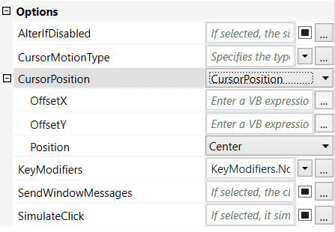

1. **Type Into activity:**

The Type Into activity sends keystrokes (text) to a specified UI element. It also supports special keys. It offers below options:

* **Activate:** if enabled, the specified UI element is brought to foreground and activated before the text is written. If this is not enabled, then the activity will type into the current active window. This property is enabled by default.
* **AlterIfDisabled:** if enabled, the action is executed even if the specified UI element is disabled.
* **ClickBeforeTyping:** if enabled, the specified UI element is clicked before the text is written.
* **DelayBetweenkeys:**the delay (in milliseconds) between each key is typed.
* **Deselect at end:**It adds a Complete event after the text entry to trigger certain UI responses.
* **EmptyField:**If enabled, all previously-existing content in the UI element is erased before writing the text.
* **SendWindowMessages:** if enabled, the type into action is executed by sending a specific message to the target application. This input method can work in the background.
* **SimulateType:**if enabled, it simulates the type action by using the technology of the target application. This input method can work in the background.

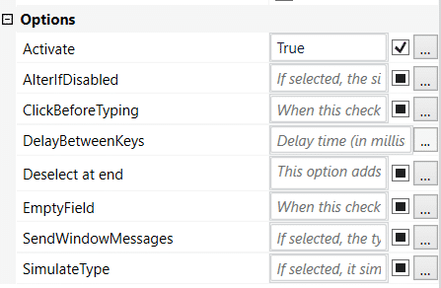

1. **Send Hotkey activity:**

The Send Hotkey activity is used to send keyboard shortcuts to a UI element. It offers below options:

* **Activate:** if enabled, the specified UI element is brought to foreground and activated before the text is written.
* **ClickBeforeTyping:**if enabled, the specified UI element is clicked before the text is written.
* **DelayBetweenKeys:** the delay (in milliseconds) between each key is typed.
* **EmptyField:** If enabled, all previously-existing content in the UI element is erased before writing the text.
* **KeyModifiers:**enables users to add a key modifier so that the specific key is pressed while performing the action. The following options are available: Alt, Ctrl, Shift, Win.
* **SendWindowMessages:**if enabled, the type into action is executed by sending a specific message to the target application. This input method can work in the background.
* **SpecialKey:** indicates if users are using a special key in the keyboard shortcut.  Examples: back, tab, enter, and so on.

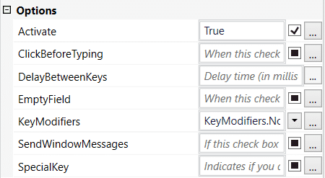

**All the input actions share several properties such as:**

**1) Delay**: This can be used to set a delay before or after the click.

**2) WaitForReady**: can be configured to wait for the target to become ready by verifying certain application tags.

**Output Methods and Activities:**

**Output activities**are used to extract data (in general, as text) from a UI element.**The output method** is the technology behind **output activities**, which enables the extraction of data from UI elements.

**Output methods:**

* 1. FullText
  2. Native
  3. OCR

**Get Text Activity**

Extracts a text value from a specified UI element.

**Get Full Text Activity**

Extracts a string and its information from an indicated UI element using the FullText screen scraping method. Thus, the hidden text is also captured by default (although it provides the option to ignore hidden text). This activity is automatically generated when performing screen scraping with the FullText method, along with a container.

**Get Visible Text Activity**

Extracts a string and its information from an indicated UI element using the Native screen scraping method. This activity is automatically generated when performing screen scraping

with the Native method chosen, along with a container.

**Get OCR Text Activity**

Extracts a string and its information from an indicated UI element using the OCR screen scraping method. This activity can also be automatically generated when performing screen scraping, along with a container. By default, the UiPath Screen OCR engine is used.

**Data Scraping Wizard**

Data scraping is a functionality of UiPath Studio that allows the extraction of structured information from an application, browser or document to a DataTable variable. The functionality can be accessed directly from the Design ribbon of UiPath Studio, the ‘Data Scraping’ button.

The first element chosen is used to populate the first column, and the option to extract the URL (where these exist) is also presented. The user may change the order of the columns and specify the maximum number of entries to be extracted (the default is 100 and leaving 0 means extracting all the results). In the Preview stage, the ‘Extract Correlated Data’ option can be used to extract other fields of data, by indicating the first and the second entry, just like for the main field.

**Extract Attributes Activities**

This is actually a category of activities that can be used when you don’t want to extract the text out of the UI element, but maybe the color, the position or an ancestor. There are three different UiPath activities to do this:

* **Get Ancestor**: UI elements are in parents-children’s structures (a text document has the Notepad app as a parent, who has the category of apps as a parent, and so on). Get Ancestor retrieves the ancestor (or the parent) of an UI element.
* **Get Attribute**: UI elements have plenty of attributes. Think of a button on a website – it definitely has a color, a name, a state, and so on. Get Attribute allows the user to indicate an attribute, and the activity retrieves the value of that specific attribute.
* **Get Position**: this activity retrieves the actual position on the screen of a specific element. This can be very useful when there are many similar elements on a screen; without having their actual position, it would become very difficult to identify each of them.

**What is UI element synchronization?**

UI synchronization helps us to handle complex situations encountered in UI Automation scenarios through specific activities**.**

**When can I use UI synchronization activities?**

* Input and output actions can be viewed as a succession of two micro-steps: first, recognizing UI elements, and second inputting (or extracting) data.
* In many cases, including most of the examples that we covered in the previous lessons, the first step is easily sorted out either by including it in the activity or by using the delay option. This is why, in many cases, one activity is enough.
* In some business scenarios, however, building reliable workflows means accommodating situations in which UI elements move or become visible only at various times.
* Moreover, some solutions that seem handy, like setting up a big delay before executing a Click activity, may trigger a significant increase in the overall duration of automation (if, for example, there are 50 Click activities). These kind of situations can overcome using Synchronization activities.

**UI synchronization activities:**

**Find Element**

Waits for the specified UI element to appear on the screen (to be in the foreground) and returns it as a UiElement variable. This is useful when a certain action needs to be performed on the Ui Element found.

**Element Exists**

Enables you to verify if a UI element exists, even if it is not visible. It returns a Boolean variable, which makes it very useful in ‘If statement’ activities.

**Wait Element Vanish**

Waits for the specified UI element to disappear from the screen. It’s an alternative to Find Element. For example: when the disappearance of an element (a loading sign) is more reliable than the appearance of another element.

**On Element Appear**

A container that waits for a UI element to appear and enables you to perform multiple actions within it.

**On Element Vanish**

A container that enables you to perform one or multiple actions after a specified UI element vanishes.

**Text Exists**

Checks if a text is found in a given UI element. There’s an alternative version of this that uses OCR technology to check for a given UI element. This is useful when UI elements are not accessible other than images.

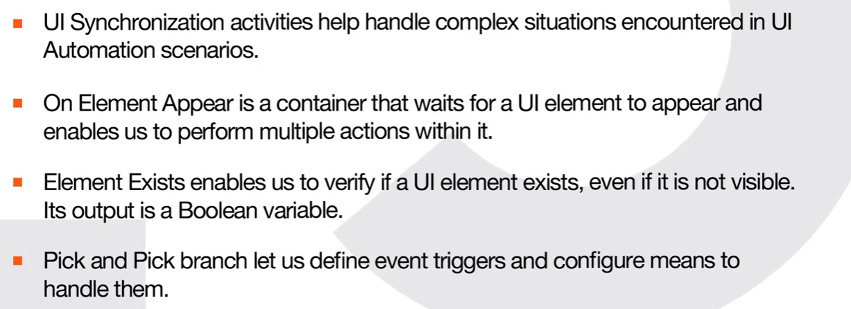

**DataTables and Excel Automation With Studio:**

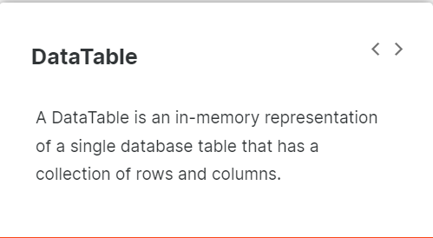

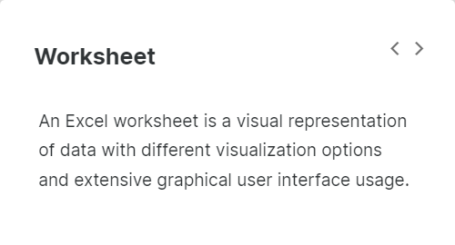

**How are DataTables created?**

**1) The Build Data Table Activity**

By using this activity, you choose the number of columns and the data type of each of them. Moreover, you can configure each column with specific options like allow null values, unique values, auto-increment (for numbers), default value and length (for strings).

2) **The Read Range Activities**

This activity gets the content of a worksheet (or a selection from that worksheet) and stores it in a DataTable variable, which can be created from the Properties panel using Ctrl + K.

3) **The Read CSV Activity**

This activity captures the content of a CSV file and stores it in a DataTable variable. Although not commonly used anymore, there are still legacy or internal-built applications that work with this kind of documents.

4) **The Data Scraping Action**

This functionality of UiPath Studio enables you to extract structured data from your browser, application or document to a DataTable.

5) **The Generate Data Table From Text Activity**

Can be used to create a DataTable from structured text, by letting the user indicate the row and column separators.

**UiPath offers a broad range of activities that can be used to work with DataTable variables:**

**Build Data Table**

Is used to create a DataTable using a dedicated window. This activity allows the customization of number of columns and type of data for each column.

**For Each Row in Data Table**

Is used to perform a certain activity for each row of a DataTable (similar to a For Each loop).

**Filter Data Table**

Allows filtering a DataTable through a Filter Wizard, using various conditions. This activity can be configured to create a new DataTable for the output of the activity or to keep the existing one and filter (delete) the entries that do not match the filtering conditions.

**Add Data Row**

Adds a new row to an existing DataTable variable. The input data can be of DataRow type or can be entered as an Array Row, by matching each object with the data type of each column.

**Add Data Column**

Adds a column to an existing DataTable variable. The input data can be of DataColumn type or the column can be added empty, by specifying the data type and configuring the options (allowing null values, requesting unique values, auto-incrementing, default value and maximum length).

**Clear Data Table**

Clears all the data in an existing DataTable variable.

**Generate Data Table From Text**

Can be used to create a DataTable from structured text, by letting the user indicate the row and column separators.

**Join Data Tables**

Combines rows from two tables by using values common to each other using the **Join Wizard**, according to a Join rule that answers the question "What to do with the data that doesn't match?". It is one of the most useful activities in business scenarios, where working with more than one Data Table is very common. This is why we'll cover the topic more in-depth in the next lessons.

**Lookup Data Table**

It is similar to vLookup in Excel. You can search for a provided value in a specified DataTable, and the RowIndex returns its value.  Or it can be configured to return the value from a cell with the given coordinates (RowIndex and Target Column).

**Merge Data Table**

Is used to append a specified DataTable to the current DataTable. The operation is more simple than the Join Data Type activity, as it has 4 predefined actions to perform over the missing schema.

**Output Data Table**

Writes a DataTable to a string using the CSV format.

**Remove Data Column**

Removes a certain column from a specified DataTable. The input may consist of the column index, column name or a Data Column variable.

**Remove Data Row**

Removes a row from a specified DataTable. The input may consist of the row index or a Data Row variable.

**Remove Duplicate Rows**

Removes the duplicate rows from a specified DataTable variable, keeping only the first occurrence.

**Sort Data Table**

Can sort a DataTable ascending or descending based on the values in a specific column.

**Get Row Item**

Retrieves a value from a row in a DataTable according to a specified column.

**Update Row Item**

Assigns a specified value to the indicated column of a DataTable row.

**Focus: Joining DataTables**

**How does it work?**

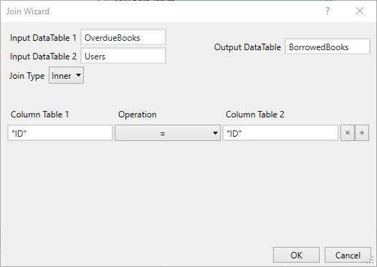

1) Three Data Table variables have to be specified - two Input DataTables and one Output DataTable. Please note that the order of the first two is very important, as there is one option that keeps the values from Data Table 1 and it cannot be changed.

* 2

2) The Join Type has to be chosen - there are three options:

* + Inner: Keep all rows from both tables that meet the Join rule. Any rows that do not meet the rule are removed from the resulting table.
  + Left: Keep all rows from DataTable1 and only the values from DataTable2 which meet the Join rule. Null values are inserted into the column for the rows from DataTable1 that don't have a match in the DataTable2 rows.
  + Full: Keep all rows from DataTable1 and DataTable2, regardless of whether the join condition is met. Null values are added into the rows from both tables that don't have a match.
* 3

3) The Join rules have to be configured (there can be one or more rules):

* + One column from each DataTable has to be specified by their names (String), by their index (Int32) or by ExcelColumn variables.
  + The operator has to be chosen: = (Equal to), != (Not equal to), > (Greater than), < (Less than), >= (Greater than or equal to), <= (Less than or equal to).

**Workbooks and Common Activities:**

In many business scenarios, databases are stored in workbooks (generally known as Excel files or spreadsheets).

UiPath offers two types of design experience (Modern and Classic) each with two separate ways of accessing and manipulating workbooks:

**Workbook** or File Access Level (works the same for both Modern and Classic).

**Excel** or Excel App Integration (offers different options depending on whether you are using the Modern or Classic design experience).

**Workbook - File Access Level**

All workbook activities will be executed in the background.

(+) Doesn't require Microsoft Excel to be installed, can be faster and more reliable for some operations just by not opening the file in the Excel application.

(!) Works only for .xls and .xlsx files.  
(!) Doesn't work with .xlsm files.

(!) The file should not be open in Excel at runtime.

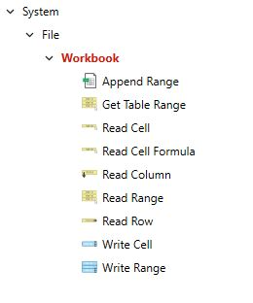

**Excel - Excel App Integration**

UiPath will open Excel just like a human would.

(+) Works with .xls, .xlsx and .xlsm, and it has some specific activities for working with .csv. All activities can be set to either be visible to the user or run in the background. The file can be open in Excel at runtime.

(!) Microsoft Excel must be installed even when the 'Visible' box is unchecked. If the file isn't open, it will be opened, saved, and closed for each activity.

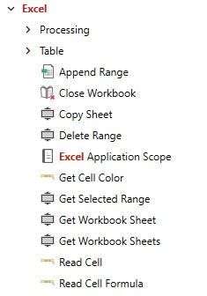

**Append Range**

Adds the information from a DataTable to the end of a specified Excel spreadsheet. If the sheet does not exist, it creates it.

**Get Table Range**

Locates and extracts the range of an Excel table from a specified spreadsheet using the table name as input.

**Read Cell**

Reads the content of a given cell and stores as a String.

**Read Cell Formula**

Reads the formula from a given cell and stores it as a String.

**Read Column**

Reads a column starting with a cell inputted by the user and stores it as an IEnumerable <object> variable.

**Read Range**

–

Reads a specified range and stores it in a DataTable. If 'Use filter' is checked in the Read Range activity under 'Excel Application Scope', it will read only the filtered data. This option does not exist for the Read Range activity under 'Workbook'.

**Read Row**

Reads a row starting with a cell input from the user and stores it as an IEnumerable <object> variable.

**Write Cell**

Writes a value into a specified cell. If the cell contains data, the activity will overwrite it. If the sheet specified doesn't exist, it will be created.

**Write Range**

Writes the data from a DataTable variable in a spreadsheet starting with the cell indicated in the StartingCell field.

**Excel Application Scope and Specific Activities:**

**The Excel Application Scope**

In the Classic Design Experience, the integration with Excel is enabled by using an Excel Application Scope activity. It is a container and all the other Excel activities used to work with the specified Excel file have to be placed inside the container. When the execution ends, the specified workbook and the Excel application are closed.

The Excel Application Scope can be configured to write the output of the activities in the container in a different file.

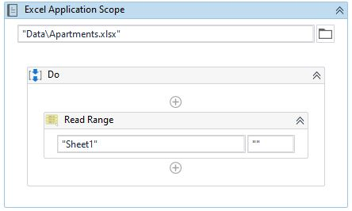

* + **read range activity in workbook can interact with .xls and .xlsx files**
  + **excel activities can interact with .xls, .xlsx and .xlsm files**
  + **we need to use excel application scope activity for .xls files from classic mode.**

**The Excel App Integration specific activities: (Classic Mode)**

**CSV Activities**

–

These activities can read from and write to CSV files, using DataTable variables. Although found under Excel App Integration, they work even if they are not placed inside an Excel Application Scope container.

* **Append to CSV**: add the info from a DataTable to a CSV file, creating it if it doesn't exist. The activity does not overwrite existing data.
* **Read CSV**: reads all entries from a CSV file and store them in a DataTable .
* **Write CSV**: overwrites a CSV with the information from a DataTable.

**Range Activities**

–

These activities can read data, insert and delete rows and columns, and even copy/paste entire ranges. They are similar to the corresponding activities under DataTable, but they work directly in the Excel file.

* **Delete Column**: removes a column from an Excel file based on the name.
* **Insert Column**: inserts a blank column in an Excel file, at a certain position.
* **Insert/Delete Columns**: either adds blank columns or removes existing columns, based on the specified change type.
* **Read Column**: Reads the values from a column beginning with the cell specified in the StartingCell property field, and stores them in an IEnumerable<Object> variable.
* **Insert/Delete Rows**: either adds blank rows or removes existing rows, based on the specified change type.
* **Select Range**: selects a specific range in an Excel file. In general, it is paired with another activity that performs a certain manipulation over the selected data.
* **Get Selected Range**: outputs a given range as String.
* **Delete Range**: removes a specified range from an Excel file.
* **Auto Fill Range**: applies a given formula over a given range in an Excel file.
* **Copy Paste Range**: copies and pastes an entire range (values, formulas and formatting) from a source sheet to a destination sheet.
* **Lookup Range**: searches for a value in all the cells in a given range.
* **Remove Duplicate Range**: deletes all duplicate rows from a given range.
* **Read Range**: Reads the value of an Excel range and stores it in a DataTable variable. If the range isn't specified, the whole spreadsheet is read. If the range is specified as a cell, the whole spreadsheet starting from that cell is read.
* **Append Range**: Adds the information stored in a DataTable variable to the end of a specified Excel spreadsheet. If the sheet does not exist, a new one is created with the name indicated in the SheetName field.
* **Write Range**: Writes the data from a DataTable variable in a spreadsheet starting with the cell indicated in the StartingCell field. If the starting cell isn't specified, the data is written starting from the A1 cell. If the sheet does not exist, a new one is created with the value specified in the SheetName property.

**Table Activities**

–

These activities create, filter and sort tables directly in Excel files.

* **Filter Table**: applies a filter on all the values from a column in a table inside an Excel file. Once the file is saved, only the rows that meet the filter will be displayed. Please note that this activity does not remove the rows that do not meet the criteria, but only hides them. A good use of this method involves using a Read Range activity after this one, with 'Use filters' box checked. The output will be a DataTable containing only the entries that met the given criteria.
* **Sort Table**: sorts a table in an Excel file based on the values in a given column.
* **Create Table**: it creates a table (with name) in a range specified in the Properties panel.

**File Activities**

–

These activities work directly with the Excel files, either by saving or closing them.

* **Close Workbook**.
* **Save Workbook**.

**Cell Color Activities**

–

These activities are able to capture and modify the background color of cells in Excel files.

* **Get Cell Color**: reads the background color or a given cell in an Excel file and stores it as color variable output.
* **Set Range Color**: changes the background color of all the cells in a given range. The input is a color variable.

**Sheet Activities -**

These activities can perform various actions over the sheets in an Excel file.

* **Get Workbook Sheet**: reads the name of a sheet by its index.
* **Get Workbook Sheets**: extracts the sheet names and stores them ordered by index.
* **Copy Sheet**: copies a sheet in an Excel file and pastes either in the same Excel file or in a different one specified.

**Pivot Table Activities -**

These activities facilitate working with pivot tables in Excel files.

* **Refresh Pivot Table**: refreshes a pivot table in an Excel file. This is useful when pivot table source data changes, as the refresh is not automatic.
* **Create Pivot Table**: creates a pivot table using a specified sheet and given parameters.

**Macro Activities -**

These activities can execute macros that where already defined in the Excel file, or can invoke macros from other files. Please note that these activities work with .xslm files.

* **Execute Macro**.
* **Invoke VBA**: macro from another file.

**Modern Design Excel Activities:**

In the Modern Design Experience, all activities specially tailored for Excel need to be **nested within a parent**"**Use Excel File**" activity.  
  
The Use Excel File replaces the Classic Experience "Excel Application Scope" activity.

**Use Excel File**

–

Lets you select an Excel file to use in the automation and enables Studio to integrate with Excel. The data in the file is available for all the activities added inside the Use Excel File.  
  
This means that when you configure child activities, you can select data from the file directly from Studio.  
  
- If the Excel file doesn't exist at the time you design the automation, you can define an existing Excel file with the same structure as a template for use at design time.  
  
- You can also add UIAutomation activities directly in the Use Excel File activity to quickly automate the interface of Excel. For this to work, you need to have the Excel file open on our machine.

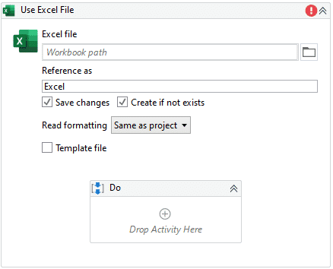

**Auto Fill**

–

Fills cells with data based on data in other cells using the AutoFill feature in Excel. Similar to double-clicking the Fill Handle in Excel to copy the formula from one or more adjacent cells down to the cells in the rows with data.

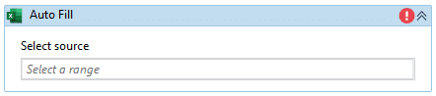

**Create Pivot Table**

–

Creates a pivot table from a specified range or table to help you calculate, summarize, and analyze data. Once added, you can add pivot table fields as rows, columns, filters, or summary fields.

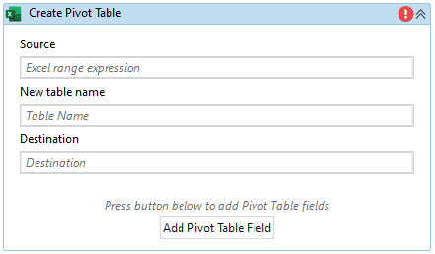

**Delete Column**

–

Deletes one or more columns from a sheet, table, or range in an Excel file.

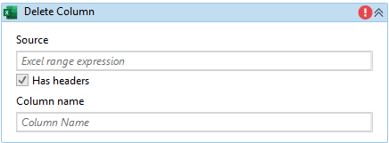

**Delete Sheet**

–

Deletes a specified sheet from an Excel file.

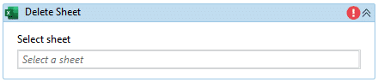

**Export to SCV**

–

Exports the data in an Excel range, table, or sheet to a specified CSV file.  
If the CSV file does not exist, it is created when the automation is executed.  
If the file already exists, it is replaced by the automation.  
  
When the data is exported, column headers are exported as follows:  
  
- for tables, the headers are exported if visible in Excel.  
- for pivot tables, headers and the total row are exported if visible in Excel.  
- for sheets and ranges, only the data visible in Excel is exported. No headers are added by default.

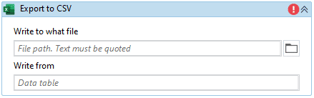

**Filter**

–

Creates a filter in a range, table, or sheet based on the values in a single column. Can also be used to clear existing filters.  
  
To filter for multiple columns across a single range/sheet/table, you must use multiple Filter activities targeting the same source range.

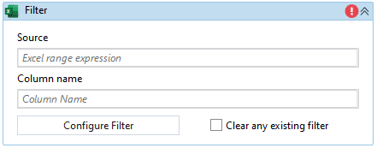

**For Each Excel Row**

–

Iterates through each row in a given Excel file, sheet or specific range.

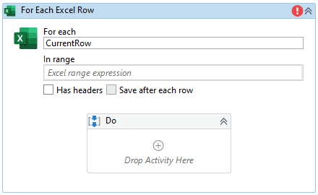

**Format as Table**

–

Formats a range of cells as a table with a specified name.  
After the table is created, you can reference it later in your automation using its name.

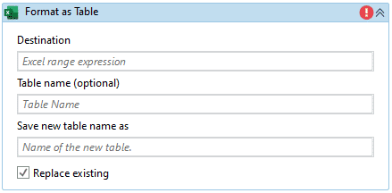

**Get Chart**

–

Copies an Excel chart to the clipboard for use in other activities. You can paste a chart later in the automation in a Word document using the Paste Chart/Picture into Document activity or in a PowerPoint slide using the Paste Item into Slide activity.

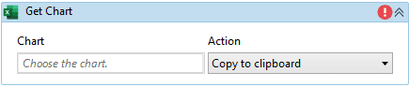

**Insert Rows**

–

Inserts one or more rows in a table, range, or sheet at the specified location. Specify where to insert the rows, how many rows to insert, and at what position to insert the rows in the specified range.

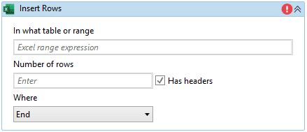

**Read Cell Value**

–

Copies the value from a spreadsheet cell.

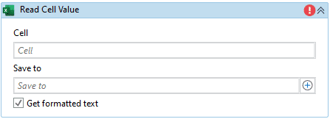

**Read Range**

–

Reads the value of an Excel range as a DataTable.

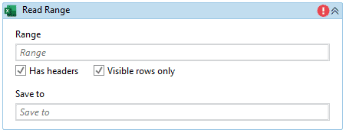

**Remove Duplicates**

–

Deletes duplicate rows in a specified range.

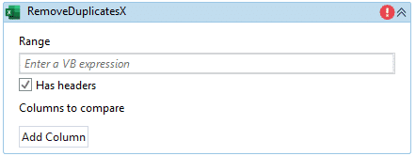

**Save Excel File As**

–

Saves a workbook added to the project or the Project Notebook as a different file. You can specify the file name and the Excel file type to save as.

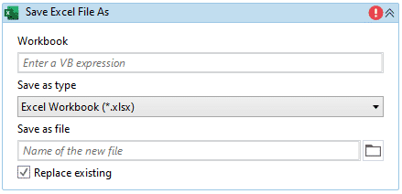

**Sort Range**

–

Sorts the data in a specified sheet, table, or range by one or more columns.

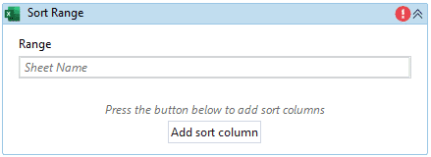

**VLookup**

–

Finds data in a range or sheet using the VLOOKUP function.

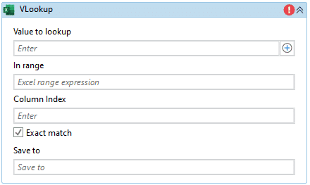

**Write Cell**

–

Enters a text or a formula in a cell.

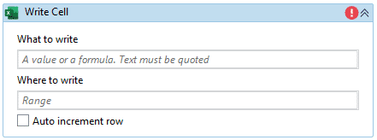

**Write DataTable to Excel**

–

Writes a data table that was saved for later to an Excel file.

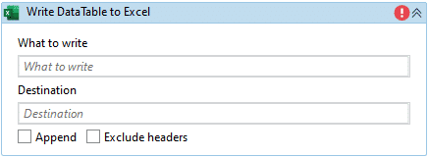

Let's check out the activity's properties in more detail:

**Common:** DisplayName - The name displayed for the activity in the Designer panel.

**File:**

* Edit password - The password required for editing the Excel workbook, if the file is password-protected.
* Password - The password required for opening the Excel workbook, if the file is password-protected.
* Workbook path - The path to the Excel file. If the file doesn't exist and you select the CreateNewFile option, StudioX creates the file.

**MISC:** Private - If selected, the data used in the activity is not logged by StudioX.

**Options:**

* Create if not exists - See the description in the body of the activity.
* Keep Excel file open - If the file isn't open at the time the project runs, it keeps the workbook open after the project has finished running instead of closing it. This can be used to review the file afterward.
* Read Formatting - See the description in the body of the activity.
* Read-only - If selected, the specified workbook is opened in Read-Only mode. Selecting this check box enables you to perform data extraction operations in an Excel file that is locked for editing or has an edit password. This option isn't selected by default.
* Save changes - See the description in the body of the activity.

**Important note:**If the same workflow deals with information from two or more Excel files, a Use Excel Activity has to be used for each file.

**Note:** Excel Rows start counting at 1, whereas DataTables start at an index of 0.

#### [**DataTables and Excel Automation With Studio**](javascript:void(0)) 🡪 Assignment/ Practice remaining plz complete

**Data Manipulation with Strings in Studio**

### What is data manipulation?

Data manipulation is the process of modifying, structuring, formatting, or sorting data in order to facilitate its usage and increase its management capabilities.

### What are some business scenarios in which I will use data manipulation?

1) Data manipulation methods are frequently employed by website owners to extract and view specific information from their web server logs. That allows for watching their most popular pages, as well as their traffic sources.

2) Consider the process of interrogating public financial or legal databases. Data manipulation provides the means for the credit analysts to extract only the relevant data and use it in other documents or correlate it with information from other sources.

### Objects, Methods and Properties

To understand data manipulation, we need to understand what objects, methods and properties are.

**Objects** are the fundamental building blocks of Visual Basic; almost everything that you do in Visual Basic involves modifying objects. A variable holds an object. For example, if Username = "John Doe", then the Username variable holds the "John Doe" String object.

**Properties** are attributes of an object or an aspect of its behavior. For example, the string class contains two properties: Chars (returns the Char object at a specified position in the current String object) and **Length** (returns the number of characters in the current String object). For example, based on the previous example, Username.Length returns 8.

**Methods**are actions that an object can perform. Methods often have parameters that qualify how the action is performed. For example, Username.Replace("John","Jack") returns "Jack Doe".

**String Methods and Properties:**

### What are they?

Strings are the data type corresponding to text. It is difficult to imagine an automation scenario that doesn’t involve the use of strings.

Anytime a text needs to be captured, processed, sent between applications, or displayed, strings come in handy (unless the data is structured - like a table).

### What are some business scenarios in which you will most likely encounter strings?

* + Getting the status of an operation.
  + Extracting the relevant piece from a larger text portion.
  + Displaying information to the human user.

**String methods:**

Below are some of the most common methods used in RPA.

**String.Concat**

–

Concatenates the string representations of two specified objects.  
Expression: String.Concat (VarName1, VarName2)

Output datatype: String

**Contains**

–

Checks whether a specified substring occurs within a string. Returns true or false.  
Expression: VarName.Contains (“text”)

Output datatype: Boolean

**String.Format**

–

Converts the value of objects to strings (and inserts them into another text).  
Expression: String.Format(“{0} is {1}”, VarName1, VarName2)

Output datatype: String

**IndexOf**

–

Returns the zero-based index of the first occurrence of a specified Unicode character or string within this instance.  
Expression: VarName1.IndexOf(“a”)

Output datatype: Int32

**LastIndexOf**

–

Reports the zero-based index position of the last occurrence of a specified Unicode character or string within this instance.

Expression: VarName1.LastIndexOf("author")

Output datatype: Int32

**String.Join**

–

Concatenates the elements in a collection and displays them as String.  
Expression: String.Join(“|”, CollVarName1)

Output datatype: String

**Replace**

–

Replaces all the occurrences of a substring in a string.  
Expression: VarName.Replace (“original”, “replaced”)

Output datatype: String

**Split**

–

Splits a string into substrings using a given separator.  
Expression: VarName.Split(“|“c)(index)

Output datatype: Array of String

**Substring**

–

Extracts a substring from a string using the starting index and the length.  
Expression: VarName1.Substring(startIndex, length)

Output datatype: String

**The RegEx Builder:** (regular Expression)

### What is it?

Regular Expression (REGEX, or regexp) is a specific search pattern that can be used to easily match, locate and manage text. However, creating RegEx expressions may be challenging.

UiPath Studio contains a RegEx builder that simplifies the creation of regular expressions.

Typical uses of RegEx include:

* + Input validation.
  + String parsing.
  + Data scraping.
  + String manipulation.

### What are some business scenarios in which I will use RegEx?

Retrieving pieces of text that follow a certain pattern, for example:

* + extracting phone numbers that start with a certain digit.
  + collecting all the street names from a bulk text, even if they don't follow a specific pattern - some of them contain "Street", others "Rd.", and so on.

It would take much longer to build the same expression using the regular String methods – for example, RegEx has a predefined expression to locate all the URLs in a string.

**Methods in UiPath that use the RegEx builder:**

**Matches**

–

Searches an input string for all occurrences and returns all the successful matches.

Output datatype: System.Collections.Generic.IEnumerable<System.Text.RegularExpressions.Match>

**IsMatch**

–

Indicates whether the specified regular expression finds a match in the specified input string.

Output datatype: Boolean

**Replace**

–

Replaces strings that match a regular expression pattern with a specified replacement string.

Output datatype: String

**Data Manipulation With, Lists and Dictionaries in Studio:**

### What is data manipulation?

Data manipulation is the process of modifying, structuring, formatting, or sorting data in order to facilitate its usage and increase its management capabilities.

**Lists:**

### What are they?

Lists (or List<T>, as you will encounter them) are data structures consisting of objects of the same data type (for example string or integer). Each object has a fixed position in the list; thus, it can be accessed by index. While arrays are fixed-size structures for storing multiple objects, lists allow us to add, insert and remove items.

Lists can store large numbers of elements - names, numbers, time coordinates and many others. Lists provide specific methods of manipulation, such as:

* + Adding and removing items.
  + Searching for an element.
  + Looping through the items (and performing certain actions on each).
  + Sorting the objects.
  + Extracting items and converting them to other data types.

### What are some business scenarios in which you will most likely encounter lists?

* + Storing the computer names of the members of a project team for a certain configuration that needs to be made.
  + Collecting and storing the numbers of invoices that meet certain criteria.
  + Keeping track of the ticket numbers created in a certain period on a certain issue.

**The Invoke and String Conversion Method:**

**Invoke Method:**

The Invoke Method activity is another way to implement a code which is outside of the standard built-in activities. You can use this activity to invoke a method of a class.

The class does not need to be part of the workflow or use any of the workflow base classes. The Invoke Method calls a public method of a specified object or type.

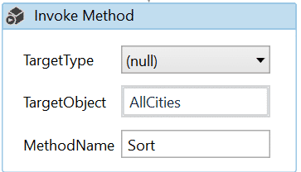

**String Conversion Method:**

This method actually converts the first letter of every word in a string to uppercase and the following letters to lowercase.  
  
The arguments are as follows: the string to be converted, followed by the conversion settings, Visual Basic String Convert dot ProperCase.

**StrConv(City,VbStrConv.ProperCase)**

* **What works in Windows-Legacy projects:**  
  StrConv(City, VbStrConv.ProperCase)  
  System.Globalization.CultureInfo.CurrentCulture.TextInfo.ToTitleCase(City.ToLower)
* **What works in Windows projects:**  
  System.Globalization.CultureInfo.CurrentCulture.TextInfo.ToTitleCase(City.ToLower)  
    
  The reason why the **StrConv(City, VbStrConv.ProperCase)** expression doesn't work in **Windows**projects is because **.Net Core** doesn't support Windows-1252 encoding out of the box.

**List and Arrays:**

* The **array** variable is a type of variable which enables you to store multiple values of the same type. UiPath Studio supports as many types of arrays as it does types of variables. This means that you can create an array of numbers, one of strings, one of Boolean values and so on.
* If you want to work with a collection that doesn’t have fixed number of elements you can use a **list** instead of any array.
* The difference between Arrays and List is, array is a fixed size, but the size of the list can vary.

**Enumerable.Concat Method** 🡪 This method is used for merge the two lists

Eg. Enumerable.Concat(List1.AsEnumerable ,List2.AsEnumerable).ToList

**Reference type initialization:**

To initialize a variable is to specify an initial value to assign to it. All variables are given an initial value when they are declared. However, this process is a bit different depending on whether the new variables are of the **value** or **reference** type.

**Value type** - For numeric, Boolean, DateTime and other value types, the compiler will give them a valid value if we do not explicitly do so. For example, Ints initialize to zero by default, DateTimes initialize to DateTime.MinValue by default. In Studio, Strings are also assigned a blank default value, even though they are of the reference type.

**Reference type**- Reference type variables, like Lists and Dictionaries, initialize to the object we provide. The compiler will not assign a value if we don't. This means we need to instantiate an object and assign it to the variable we've just declared.

To start using reference types like Lists and Dictionaries, we need to go through three steps: **declare, instantiate, and assign** the object.

We **declare** a reference variable, say a List of type String. We provide the name, select the type System.Collections.Generic.List<T> and indicate String.

We **instantiate** an object to be assigned as the initial value for the variable. In our case, we want to start with a List of String object which does not contain values, so we use the expression **new List(of String)**.

We **assign** the object to the new variable (or initialize the variable) either by using the Default value in the Variables panel or by using an Assign activity.

**UiPath methods applicable to collections**

Manipulating lists can be done using .NET methods or using the collection methods that UiPath Studio offers.

**Add to Collection**

–

Adds an item to a specified collection. It is equivalent to List.Add(). It can be used, for example, to add a new name to a list of company names.

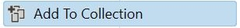

**Remove from Collection**

–

Removes an item from a specified collection and can output a Boolean variable that confirms the success of the removal operation. This activity can be used, for example, to remove an invoice number from a list of invoices to be processed.

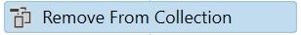

**Exists in Collection**

–

Indicates whether a given item is present in a given collection by giving a Boolean output as the result. We can use this activity to check whether a list of clients contains a specific name.

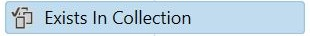

**Clear Collection**

–

Clears a specified collection of all items. One possible use is to empty a collection before starting a new phase of a process that will populate it again.

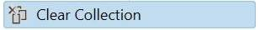

**Dictionaries:**

### What are they?

Dictionaries (or Dictionary<TKey, TValue>, as you will encounter them) are collections of (key, value) pairs, in which the keys are unique. Think of the Address Book in your mobile phone, where each name has corresponding data (phone number(s), email).

The data types for both keys and values have to be chosen when the variable is declared. Data types in Dictionaries can be any of the supported variables (including Dictionaries, for example).

The operations that are most often associated with Dictionaries are:

* + Adding and deleting (key, value) pairs.
  + Retrieving the value associated with a key.
  + Re-assigning new values to existing keys.

### What are some business scenarios in which you will most likely encounter dictionaries?

* + Storing configuration details or other information that needs to be accessed throughout a process.
  + Storing the job titles or other relevant information of employees.
  + Storing the bank accounts of suppliers.

**Methods for working with Dictionaries:**

**Initialization**

–

Just like in the example of Lists, Dictionary variables need to be initialized with instantiated objects. In the previous example, the instantiation and initialization were done inside an ‘Assign’ activity. However, as you may remember from the Lists chapter, they can also be done from the Variables panel.

**Adding Key-Value Pairs**

–

VarName.Add(Key, Value) – adds an item to an existing Dictionary. Because Add does not return a value, we use the Invoke Method activity.

**Removing Keys**

–

VarName.Remove(Key) – removes an item from the Dictionary. It can be used in an ‘Assign’ activity.

**Retrieving**

–

* VarName.Item(Key) – returns the Dictionary item by its key.
* VarName.Count – returns an Int32 value of the number of Dictionary items.
* VarName.ContainsKey(Key) – checks if the item with the given key exists in the Dictionary and returns a Boolean result.
* VarName.TryGetValue(Key, Value) – checks if an item with a given key exists in the Dictionary and returns a Boolean result and the value if found.

**Note:**

**we need to instantiate the object using the New key word when working with list and dictionary.**

Like below,

**new List(Of String) From ("Seattle, "New York", "San Francisco")**

**Selectors in Studio**

**Explain selectors and its structure:**

### What are Selectors?

A selector in UiPath Studio is a feature that enables the identification of a specific User Interface element through its address and attributes. These are stored as XML fragments.

The element identification is done to perform specific activities in an automation project. Selectors are generated automatically every time we use an activity that interacts with graphical user interface elements.

We can think of the **element identification process** achieved through selectors as a postman that delivers letters to a certain address. In order for the postman to deliver the letters, a specific path is required and must contain **structured and hierarchized details** such as Country > City > Zip Code > Street Name > Street Number > Apartment Number. Similarly, UiPath Studio requires the detailed path to a specific element within the user interface.

**What are some business scenarios in which selectors are useful?**

Most of the times when an automated process involves working with UI elements, selectors are used. Typical activities include:

* Clicking buttons.
* Inputting or scraping text in/from a field on a website.
* Choosing an option from a drop-down list.

**The structure of a selector:**

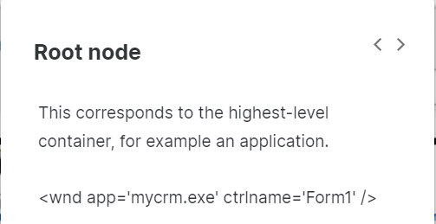

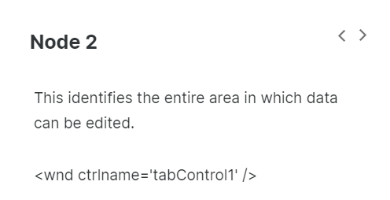

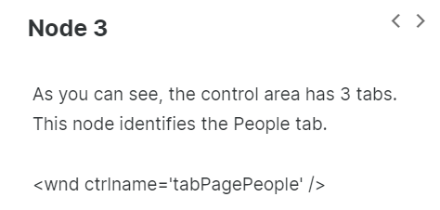

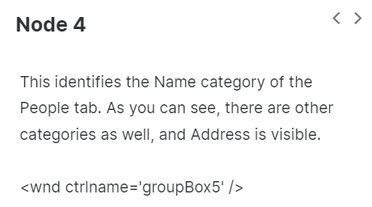

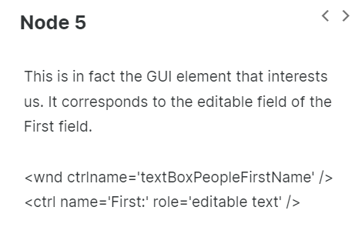

**Tags & Attributes of Selectors**

Selectors are made of nodes. And each node is made of tags and attributes. Let's take an example to explain the two. Below is a selector node.

<webctrl parentid=‘slide-list-container’ tag=‘A’ aaname=‘Details’ class=‘btn-dwnl’ />

**Tags**

–

* Nodes in the selector XML fragment.
* Correspond to a visual element on the screen.
* First node is the app window.
* Last node is the element itself.

For example:

* **wnd** (window)
* **html** (web page)
* **ctrl** (control)
* **webctrl**(web page control)
* **java** (Java application control)

**Attributes**

Every attribute has a name and a value. You should use only attributes with constant or known values.

For example:

* parentid=‘slide-list-container’
* tag=‘A’
* aaname=‘Details’
* class=‘btn-dwnl’

**The UI Explorer:**

### What is it?

The UI Explorer is the functionality in UiPath Studio that allows you to analyze and edit selectors. It contains a status button showing users the state of the selector, a visual tree panel that displays a navigable UI of each application running at that moment, as well as the selected UI element. The UI Explorer displays all the available tags and attributes and gives you the option to check them in or out.

**What are some business scenarios in which I will use the UI Explorer?**

The UI Explorer can be used whenever the selectors that were automatically generated are not stable or reliable enough. For example, when:

* The selectors change from one execution to another.
* The selectors might change following product updates.
* The selectors use unreliable info, such as index.

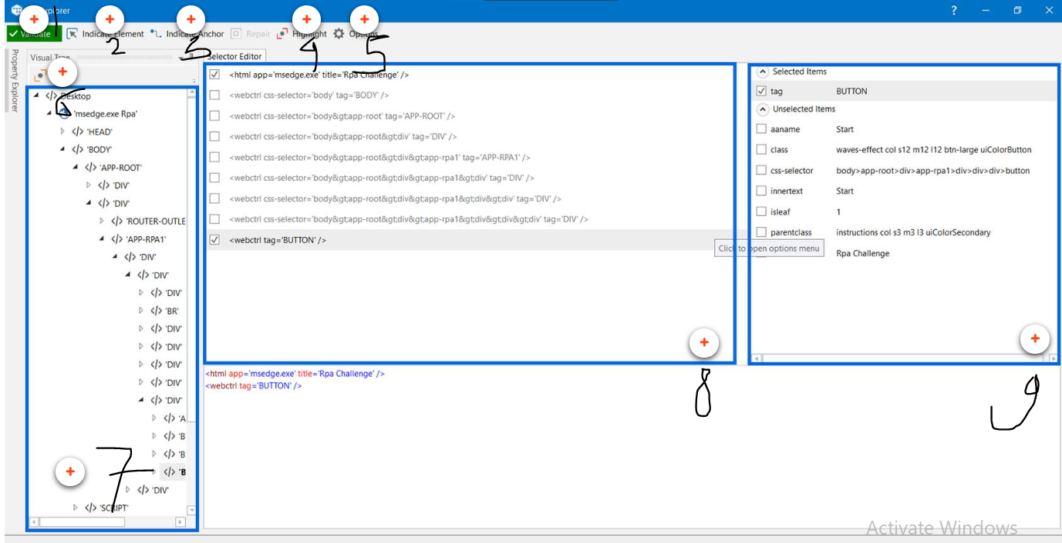

Below explained one bye one. Validate is a index 1 and others are respectively.

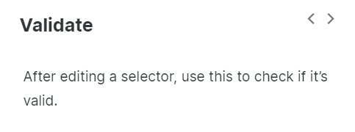

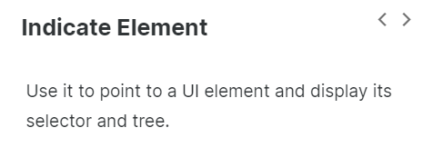

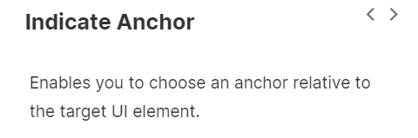

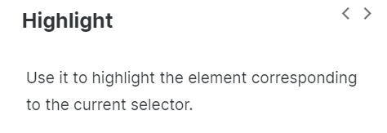

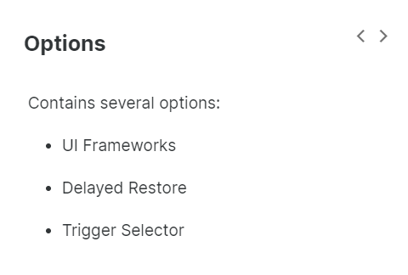

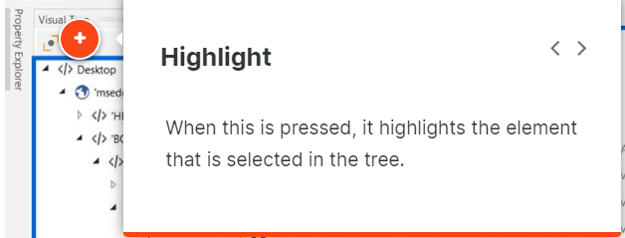

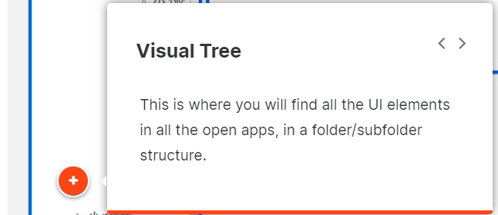

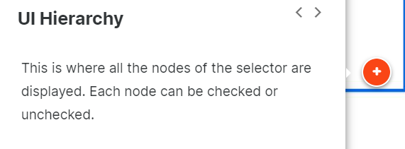

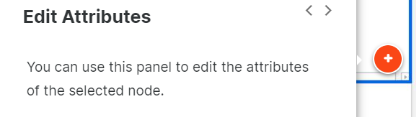

**The UI frameworks**

In order to return the best selector for the element of interest, we can switch between the different UI frameworks available in UiExplorer. You can find the UI frameworks option in the Options tab of the UiExplorer.

**Default**

–

This is the proprietary method which usually works correctly with all types of user interfaces.

**Active Accessibility**

–

This represents an earlier solution from Microsoft that makes apps accessible. It is recommended when using legacy software, if the default framework does not work as expected.

**UI Automation**

–

This is the improved accessibility model from Microsoft, which is recommended when using newer applications in case the default framework does not work as expected.

**The Property Explorer:**

### What is it?

The Property Explorer is a functionality of the UI Explorer that displays all the attributes of a certain UI element, including those that are not displayed in the selector, like position, visibility, innertext, and so on.

**What are some business scenarios in which I will use the Property Explorer?**

* When you want to start an activity after a certain attribute changed its value (using the Wait Attribute activity).
* When you want to change the value of an attribute on a webpage, like its visibility (using the Set Attribute activity).
* When you want to check the state of a certain UI element by checking on an attribute (using the Get Attribute activity).

**Types of Selectors:**

**Explain various selector types and their settings when automating:**

As previously presented, selectors are automatically generated when UI elements are indicated inside activities or when the recorder is used. Knowing the difference between full and partial selectors is very important when activities generated inside containers are moved outside, or the other way around.

The UI automation classic experience containers are Attach Window, Attach Browser and Open Browser.

**Full selectors**

–

* Contain all the tags and attributes needed to identify a UI element, including the top-level window.
* Generated by the Basic Recorder.
* Best suited when the actions performed require switching between multiple windows.

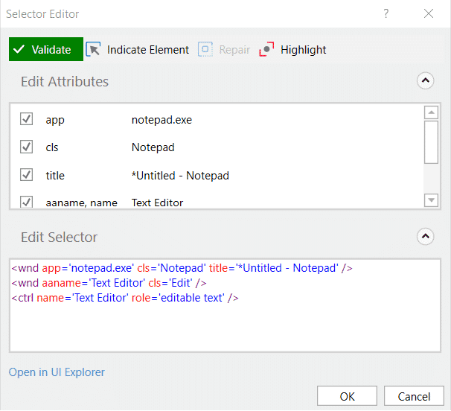

**Partial selectors**

–

* Don’t contain the tags and attributes of the top-level window, thus the activities with partial selectors must be enclosed in containers.
* Generated by the Desktop Recorder.
* Best suited for performing multiple actions in the same window.

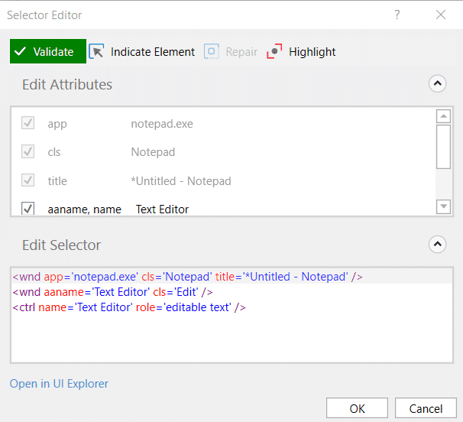

**When are partial and full selectors used?**

The best example of using a partial selector would be a simple automation where the deployed workflow only performs actions in the **same application** without shifting through multiple windows, like a simple CRM.

On the other hand if the workflow would actually be required to interact with **multiple windows**, like the CRM in the example above and a document. This would make the UI elements dispersed in multiple windows, so full selectors would be required.

**Note:** In classic design mode Basic recorder will generate full selector and Desktop recorder generates partial selector.

**Fine-tuning Selectors:**

**What is fine-tuning?**

Fine-tuning is the process of refining selectors in order to have the workflow correctly executed in situations in which the generated selector is **unreliable**, **too specific** or **too sensitive** with regards to system changes.

It mainly consists of small simple changes that have a larger impact on the overall process, such as adding wildcards, using the repair function or using variables in selectors.

**What are some business scenarios in which fine-tuning is required?**

* The workflow uses files that have timestamp in the name.
* The environment in which a workflow was built has different parameters than the production environment (for example, the application version).
* The use of dynamic selectors would improve the reliability and robustness of the automation.

**When exactly is fine-tuning of selectors required?**

**Dynamically generated selectors**- As it happens with some websites, the values of the attributes change with each visit.

**Selectors being too specific** - Some selectors are automatically generated with the name of the file or with a value that changes. Here, placeholders are very useful.

**System changes** - Some selectors contain the version of the application or another element that changes when the application is updated.

**Selectors using IDX** - The IDX is the index of the current element in a container with multiple similar elements. This might change when a new element appears in the same container.

**How can we fine-tune selectors?**

**Using wildcards**

Wildcards are symbols that enable you to replace zero or multiple characters in a string. These are useful when dealing with dynamically-changing attributes in a selector.

* Asterisk (*) – replaces zero or more characters
* Question mark (?) – replaces a single character

### Using variables

Variables are used as a property for the attribute of your target tag. This allows selectors to easily identify a target element based on the value of the variable or argument, and not an exact string, which might change.

The variable can be changed to interact with a different element, without changing the selector itself.

Now working with variables is made easier with the **nicer variable support**. To add a variable to a field's value, right-click the value and choose **'Use variable'**. Next, choose the variable from the drop-down and confirm to use the variable.

### Using index variables

Index variables are used to access UI elements based on their numerical position in the list or to access specific UI elements in an array or structure. They work by identifying the attributes of the UI elements which are numeric values that are consecutive.

When data is stored in a list structure and you want to refer to them based on their position or numeric value, we use Index Variables. They are stored in defined variable with specific numeric value. For example:  
webctrl tableCol='6' tag='TD'tableRow='{{int_Index}}'/>

**Managing Difficult Situations:**

**Fine-tune selectors to improve element identification precision.**

In many cases, the selectors that are automatically generated are not reliable enough, fine-tuning these will solve the issue. However, there are some other situations, that we call difficult. Consider the example of a UI element that changes state, position or ID every time the workflow is run.

For these, there are other approaches:

**Anchor base**

–

This is very useful in cases in which the attribute values are not reliable (are generated at each execution, for example), but there is a UI element that is stable and is linked to the target UI element.

The Anchor Base activity has two parts, one to locate the anchor UI element (like ‘Find Element’), and the second to perform the desired activity

**Relative selector**

–

This activity will basically incorporate the information about the anchor’s selector in the selector of the target UI element. However, the new selector will probably need additional editing, as some nodes of the first selector will still be in the new one. The solution is to have that part (like a dynamic ID) removed, and the selector will stabilize using the anchor’s selector.

**Visual tree hierarchy**

–

The hierarchy in the Visual Tree can improve the reliability of a selector by including the tags and attributes of the element that is above in the hierarchy.

This is very useful when the target UI element’s selector is not reliable, but the selector of the UI element right above in the hierarchy is. However, again, the selector needs further editing and validation, as the dynamic part needs to be removed and, at the same time, you need to make sure that the target element can be identified with a unique attribute.

**Find children**

–

This activity can identify all the children of an element that is more stable. Since its output is the collection of children, you will need to come up with a mechanism to identify only the target UI element (using one of its attributes, that makes is unique between the children, but wouldn’t be enough to identify it universally).

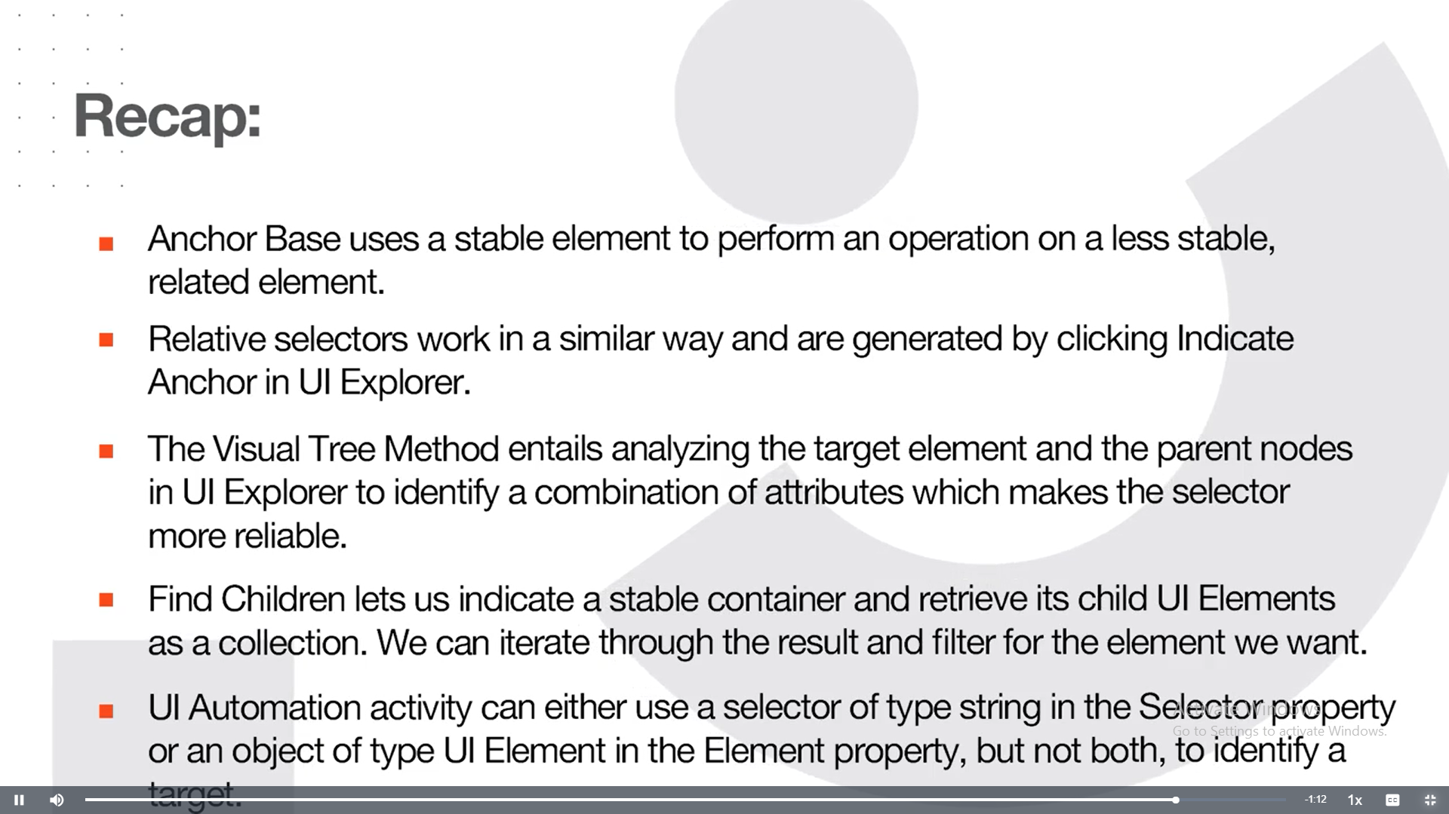

**Descriptors In Studio:**

**Descriptor 🡪** It is a pair of Target and Anchor

**Advanced Options**

Modern Design's aim is to create more reliable UI automation that needs to be adjusted and fixed less often in production.

Selection Option window provides Advanced option such as Enforce visibility, Dynamic Text Target, Native text Target and Image selection mode.

You can use these functionalities and configure them based on the application you are automating or the kind of UI element you are selecting.

These options help in configuring the very reliable descriptor while indicating the target itself.

Let's learn in detail about these following Advanced options:

1.Enforce Visibility

2. Dynamic Text Target

3.Native Text Target

4.Image Selection mode

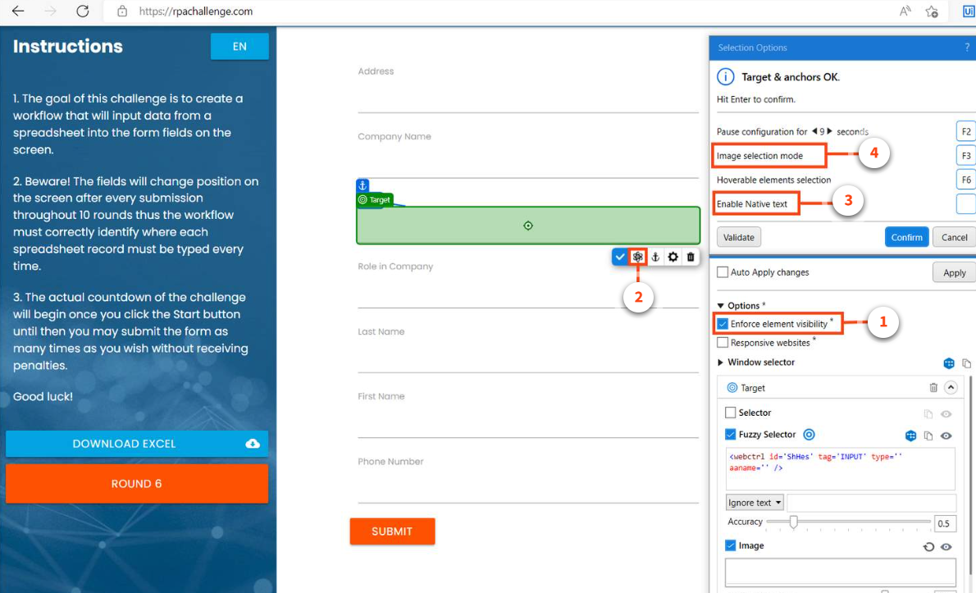

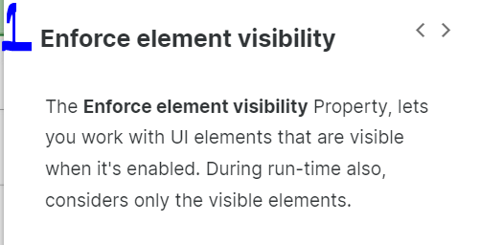

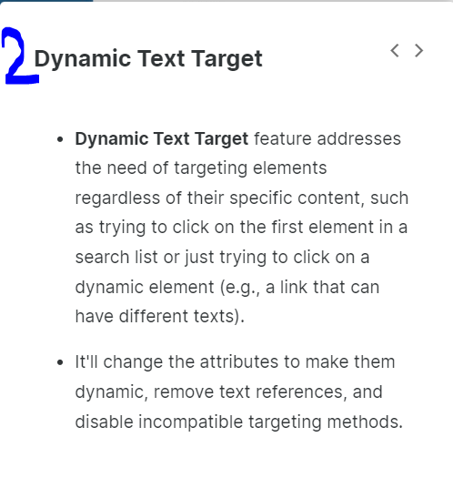

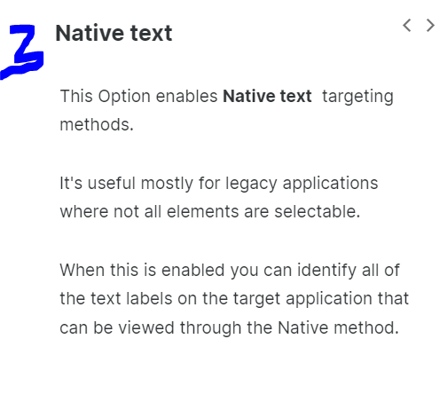

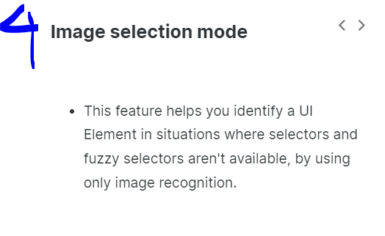

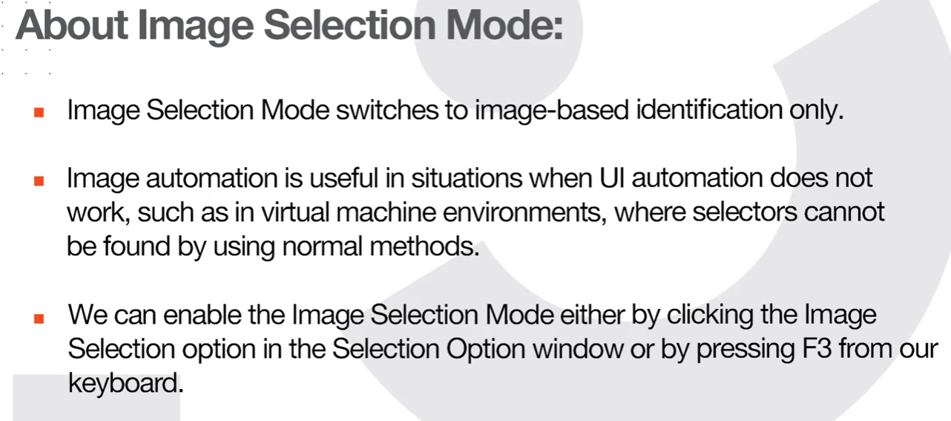

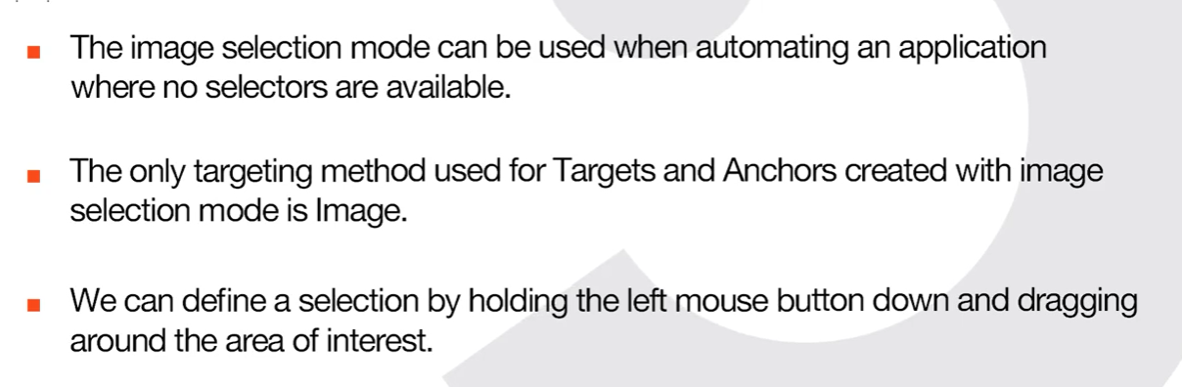

**Introducing the Descriptors:**

**What's Target?**

* A target is a UI element, you want to interact with to perform some actions on it.  
    
  For example, a button to click, a text box to type into. Here, the **Button** and the **Textbox** are the target.
* UI elements refer to all graphical user interface pieces that construct an application.
* UI elements can be any windows, check boxes, text fields or drop-down lists, and so on.

**How does a robot identify the correct target?**

Targeting methods help identify the correct target element. Modern UI Automation activities use multiple targeting methods to identify the UI Element you want the process to interact with.

The key targeting methods are:

1. **Selectors**
2. **Fuzzy Selectors**
3. **Image**
4. **Native Text**

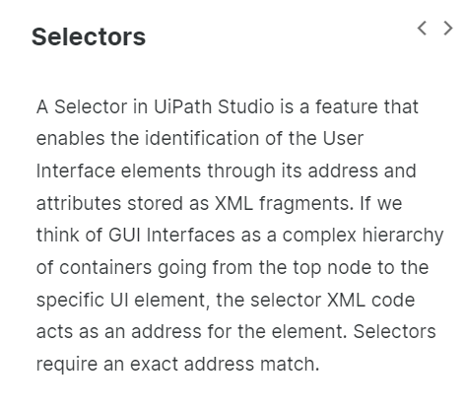

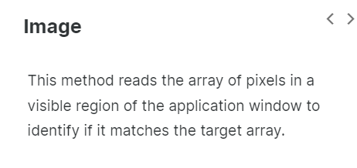

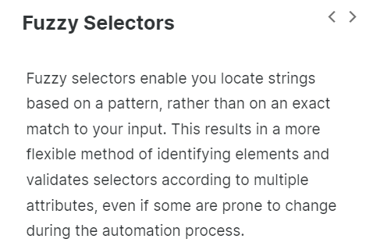

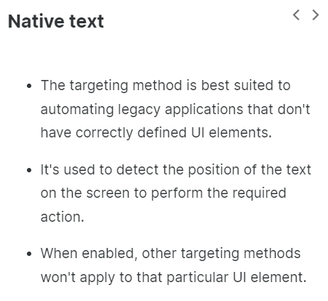

Target Elements may have changing attributes, screen locations, or images.  For an increase in precision we use Anchors.

Anchors help us identify the unstable elements we need to work with relative to more stable elements.

**What is an anchor and when should I use it?**

An anchor is another UI element that helps to uniquely identify the target.

* When you indicate a target using a modern UI automation Activity, UiPath tries to identify and automatically select an anchor.
* You can also manually add up to three anchors to the required target.

**Modern design activities use a Unified Target method to identify UI Elements on the screen.**

**What is the Unified Target?**

Unified Target is the modern framework for UI automation.

There are many technologies or methods out there that facilitate UI interactions, such as Selectors, Fuzzy Selectors, Images, Texts, computer vision, and so on. By using a unified framework, all the methods are backing each other up for higher **reliability,**and this way you can ensure that your Robot will overcome any roadblock caused by weak points in selecting the UI element.

Additionally, another advantage of using a single framework for a similar set of activities is that you can use it throughout your workflows as an out-of-the-box solution. Therefore, you don't need to spend time configuring and considering the particularities of each method used as it is **easy to use**running in the background.

The unified target uses a couple of frameworks to identify UI elements.

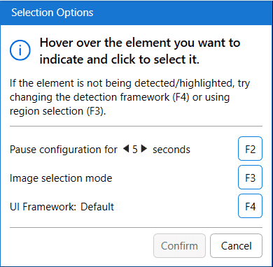

**UI Frameworks:**

By **default**, a proprietary framework is used to access the target application window, however, if a target is not detected, Studio comes with two alternatives:

* **AA(Active Accessibility)** - for older applications.
* **UIA (Microsoft UI Automation)** - for newer applications.

After you select a target, the option to change the UI Framework is no longer available.

* A**Unified Target** is made up of at least one target, with optional anchors. So basically one or more UI Elements.
* Each UI element is found using a stack of targeting methods: **Selectors**, **Fuzzy Selectors**, **Images**.
* These three targeting methods are redundant to one another. Which means that they all try to identify the target element simultaneously, and whichever finds the target first, that targeting method will be considered.

The project Settings determine which targeting methods to use in target detection.

If you want to change targeting method then you can change. refer below image

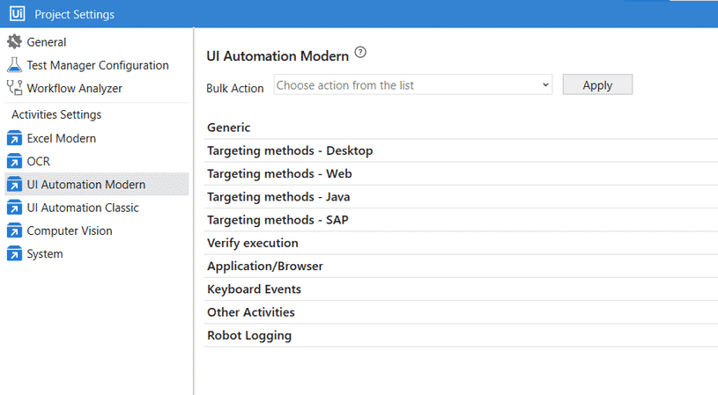

Refer to the below table to get a quick glance at the important Default Settings regarding targeting methods for some of the important target applications.

| **Target Application type** | **Deafult Targeting method used** |
| --- | --- |
| Web - applies to web browsers. | 1. Fuzzy Selectors 2. Image |
| Desktop (UIA) - applies to desktop applications that use the Microsoft UI Automation technology. | 1. Selectors 2. Fuzzy Selectors 3. Image |
| Desktop (AA) - applies to desktop applications that use Microsoft Active Accessibility technology. | 1. Fuzzy Selctors 2. ImageFuzzy Selctors 3. Image |
| Desktop (Win32) - applies to native desktop applications. | 1. Fuzzy Selctors 2. ImageFuzzy Selctors 3. Image |

* The under-the-hood process of finding a UI element uses all three methods of targeting available: Selector, Fuzzy Selector, and Image.
  + The robot tries to find a UI element (either a target or anchor). It searches with all three targeting methods in parallel.
  + The method that finds the UI Element first will be the one used to identify the respective target or anchor.

Note: the targeting process happens again at runtime, with all three methods searching in parallel for the target. The targeting method that seems to be the fastest at design time might change at runtime.

**How does a descriptor get generated?**

### Scenario

* + Let's think of a Type into activity.
  + We have Indicated the UI element to enter the data in **Cash In input field**.
  + Also, we added an anchor to the '**Cash In**' Label.

As part of the selection, we have a Target and an Anchor. Please refer to the below image.

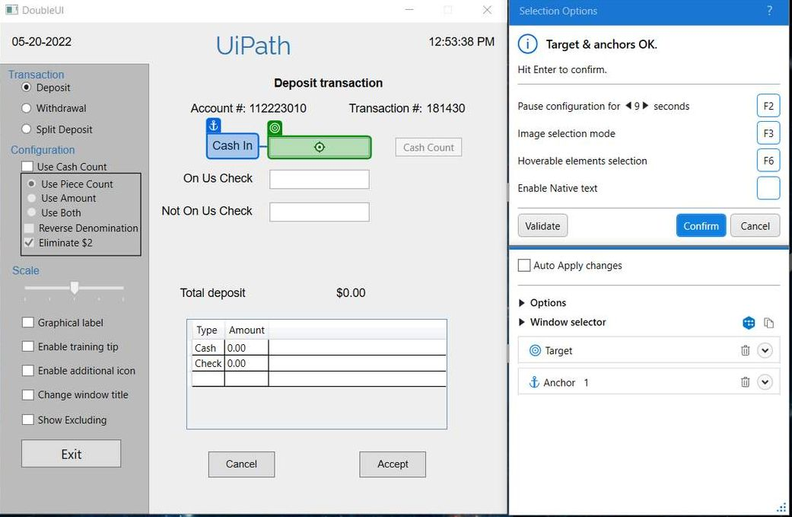

### During Runtime

We know, at runtime, that targeting methods work in redundance.

The Robot tries with three targeting methods (**Selector, fuzzy Selector, and image**) to identify the Target (Cash In input field).

Similarly, it tries to identify the Anchor (**Cash In label**).

Three targeting method to identify a **Target** X Three targeting method to identify the **Anchor** (**3X3**).

Here, the robot generates nine ‘Target – Anchor’ combinations under the hood.

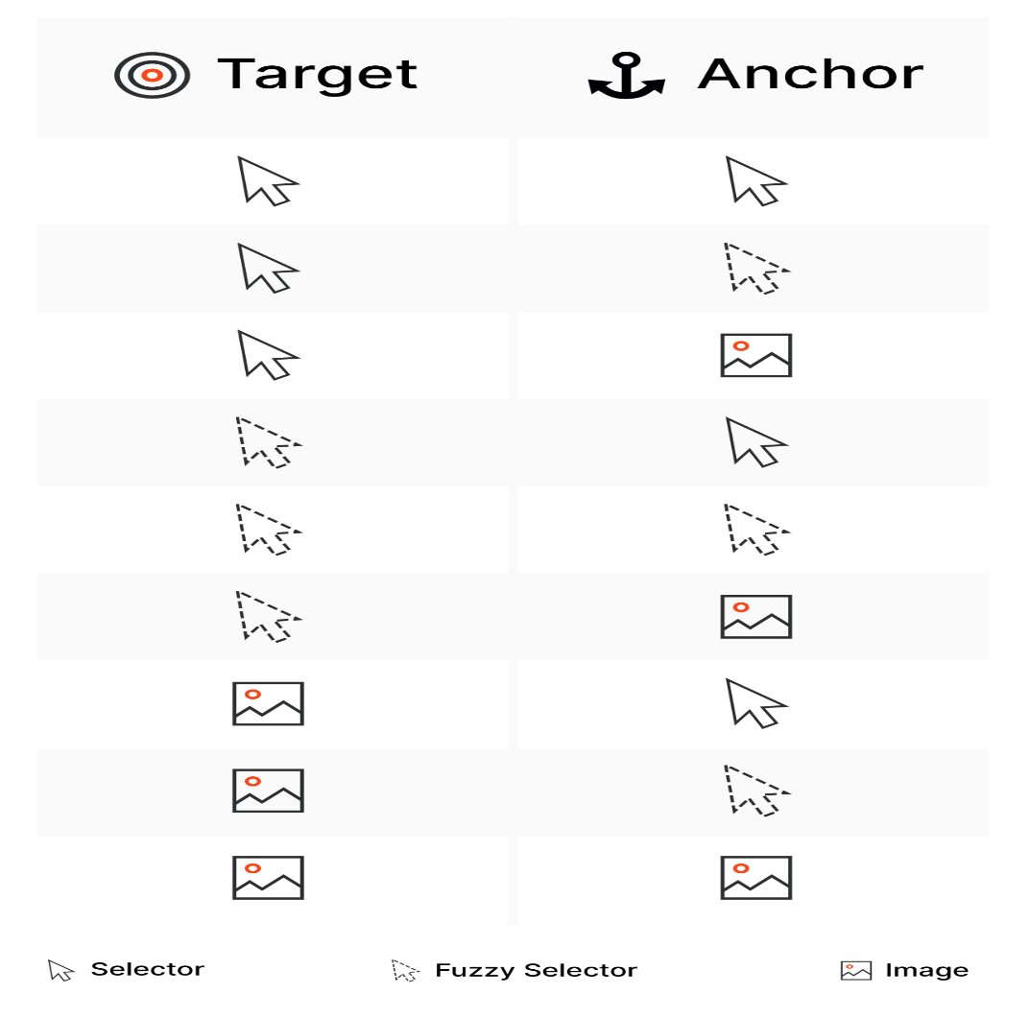

* The robot runs all these nine possible combinations, in parallel.

When an **anchor-target** PAIR is found, with whichever method for each one, then the type into Activity is executed.

Note: The number of combinations is dependent on the number of anchors. A target can have a maximum of three anchors.

**Validating the Descriptor:**

Business processes use a variety of applications and technologies. There's a high chance that you'll encounter difficulties there. Therefore, UI automation should be checked for reliability during the building process. Show all matches and validation options allow you to check the reliability of your UI automation based on its current configuration.

Based on the outcome, you can take the required actions to improve the reliability of identifying the UI element or Target.

1. Show All Matches

2. Target element validation

**Show all matches:**

This feature helps to find all the matches for the selected element that can be found in the automated application. You can use this option to debug your UI descriptors or selections.

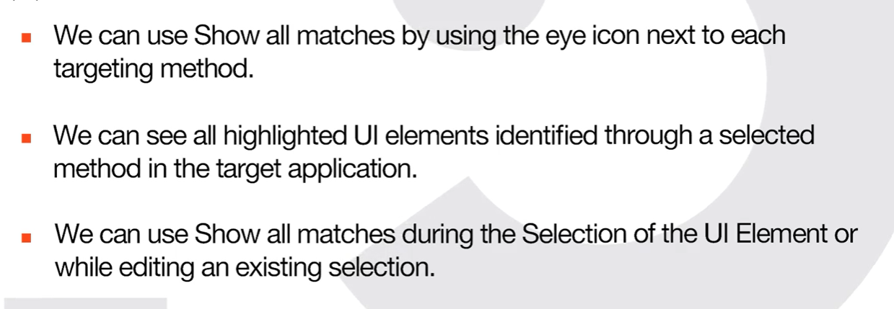

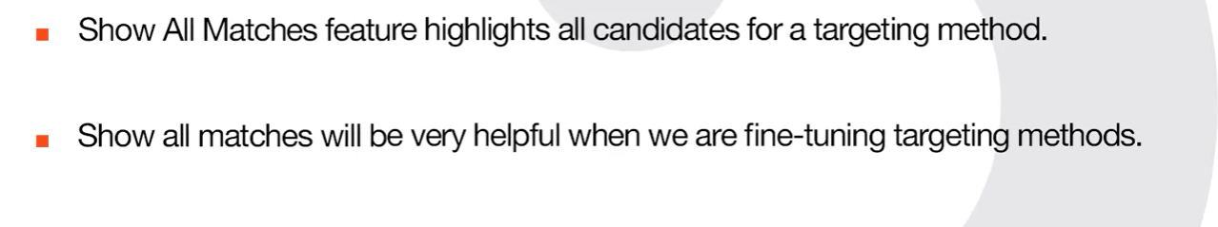

**Target element validation**

Target element validation enables you to check how effective the current selection is in identifying the target by inspecting it with all selected methods and anchors.

The result of the validation is displayed at the top of the Selection Options window. If adjustments are needed, a message is displayed with information on how to improve the selection.

The performance of each method is displayed in the Advanced Settings section of the Selection Options window using one of the following icons:

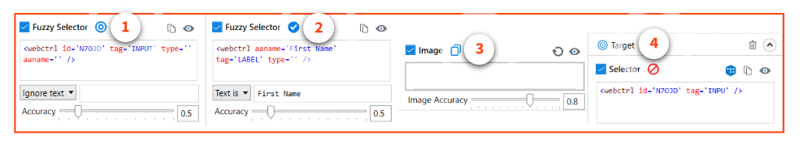

1)

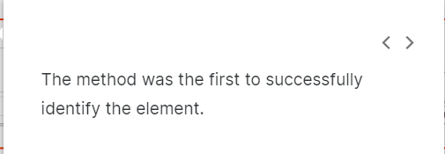

2)

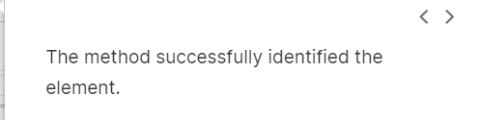

3)

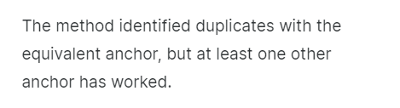

4)

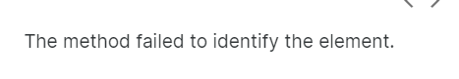

**Fine tuning the Descriptors:**

**Key Actions to Fine-tune the Unified Target for Descriptor**

Unified Targeting method uses a stack of three targeting methods Selector, Fuzzy selector, and Image, to find the required UI element. These three targeting methods are redundant to one another, which means that they all try to identify the target element simultaneously and whichever finds the target first is used.

You can fine-tune the Unified targeting method by fine-tuning the **Target** and **Anchor** **selectors**, **fuzzy selectors**, and **images**, based on the application UI or criteria to identify the UI element.

From the **Selector in Studio**course, you've learned the ways to fine-tune the Selectors. Also, you've learned how to fine-tune the selectors using different ways.

In this lesson, let's learn how to fine-tune the **Fuzzy Selectors** and **Image**Targeting methods.

**Fine-tuning of the Fuzzy Selector Trageting method.**

The Fuzzy Selector is very similar to a Selector. But, Fuzzy Selector identifies the UI element even with fuzzy match instead of perfectly matched like in Selector. As a result, the **Fuzzy Selector** can output multiple elements. Wherein Selector identifies the single UI element.

The Fuzzy Selector can be edited from its dedicated section in the Selection Options window.

You can fine-tune the Fuzzy selector in the following ways:

* By adjusting the matching accuracy of the Fuzzy Selector from the Accuracy slider.
* By using **wildcards (?,*)** in the fuzzy selector generated for the required target.  
  '**?'** replaces **one character**, and **'*'** replaces **zero or more characters**.
* By using **Variable and Argument** in the Fuzzy Selector for the required target. You can create a **new variable/Argument** or use the existing variable from the context menu of the Fuzzy selector.

If the indicated element contains text, the text is displayed in the input box below the Fuzzy Selector edit window.

The drop-down menu next to the input box enables you to select between the two option **Text is** and **Ignore text**.  
For the UI element to be considered as a match when Text is selected in the input box, the mentioned text must be present in the UI element at runtime.

You can use wildcards (?,*) when editing it.  
Selecting **Ignore text**, ignores the text specified in the input box.

**Fine-tuning of the Image Targeting method.**

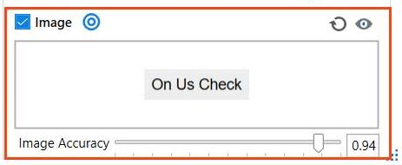

You can fine-tune the Image targeting method by adjusting the Image Accuracy with its corresponding slider.

**Introducing the Object Repository:**

**Let's take a scenario,**

The "XYZ" company adopted Automation last year, for their product. A team of RPA developers has created the required workflows and deployed them. All these processes are running.

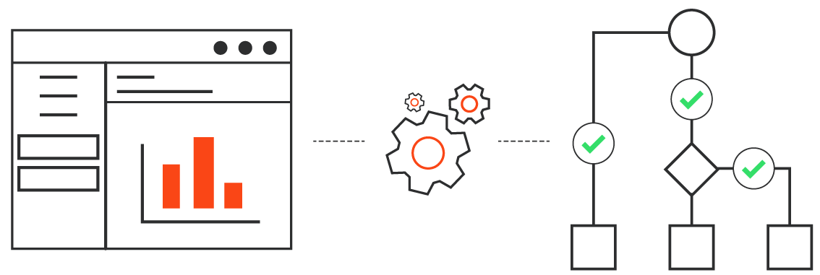

Meanwhile, the XYZ company's product team decided to change the interface of the product.  
This change will impact all of the automation projects. They won't work as expected because of the interface changes!

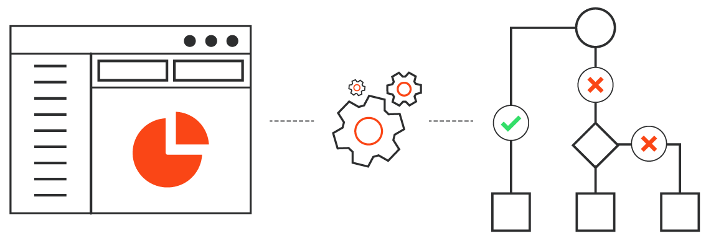

**According to you, what'll be the solution for the scenario discussed?**

* Adjust each activity's descriptor in all of the impacted workflows and deploy them again.
* Create a new workflow for all the processes?

**Will the above-mentioned solutions work in complex automation scenarios?**

Thinking about what could be the solution!

There's a much better solution than doing that.  
The **Object Repository.**

**What is the Object Repository?**

The Object Repository allows for creating and reusing UI taxonomies inside and across automation projects. With Object Repository you can build a UI API for your application and share it with your team within minutes.

**The key features of the Object Repository are:**

**Reliability**

–

* Capture Elements recorder captures elements, together with their anchors. With the help of anchors, objects keep their reliability in case the application receives a slightly new UI.

**Easy to Update**

–

* UI elements across the project are managed, updated, and modified from a centralized place.
* Upgrade application and process UI elements in one go with UI libraries.

**Reusability**

–

* All locally stored elements can be reused at project level.
* Descriptors for all the UI elements across the project/application are managed, updated, and modified from a centralized place.
* Extract elements into UI libraries and install them as a dependency into your projects when you want to reuse at a global level. You can also take a reusability-first approach and start by creating UI Libraries with the elements you'll need across all your automation projects.

**Key Concepts:**

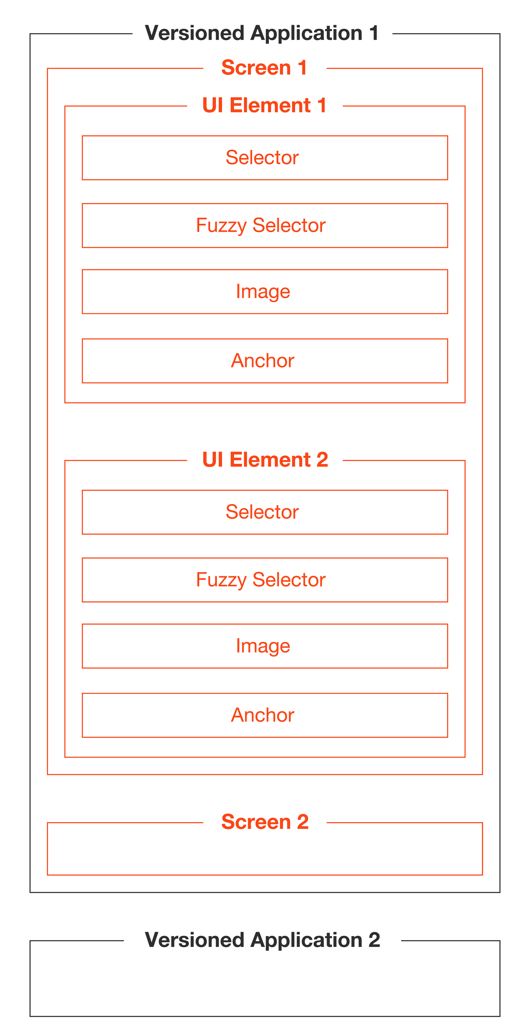

**UI Descriptors**

UI Descriptors are extracted directly from an app using the Capture Elements recorder or from activities in the workflow and added to a structured schema that groups them by Applications, Application Versions, Screens, and UI Elements. Out of this taxonomy structure, only Screens and Elements hold descriptor information. The rest are used for grouping and their role is to ensure upgrades between versions of an application.

**UI Applications**

A UI Application is a targeted application that can have multiple versions and each version can have multiple screens. Versioned applications are used to group Screens and UI Elements. They do not contain Descriptor information.

**Screens**

Screens are UI Scopes that are either extracted from activities inside the workflow or are generated at element capture time. A Screen groups together multiple UI Elements belonging to the same screen.

**UI Elements**

A UI Element is the encapsulation of a UI Descriptor, needed to identify the element on the screen, and additional metadata needed to describe the element.

**UI Libraries**

A UI Library is an encapsulation of elements grouped by applications, application versions, and screens. The elements you define can be extracted as a UI Library, and after publishing, can be installed in other projects as a dependency.

See all the elements depicted below in the process of capturing elements using the Capture Elements recorder in the Object Repository.

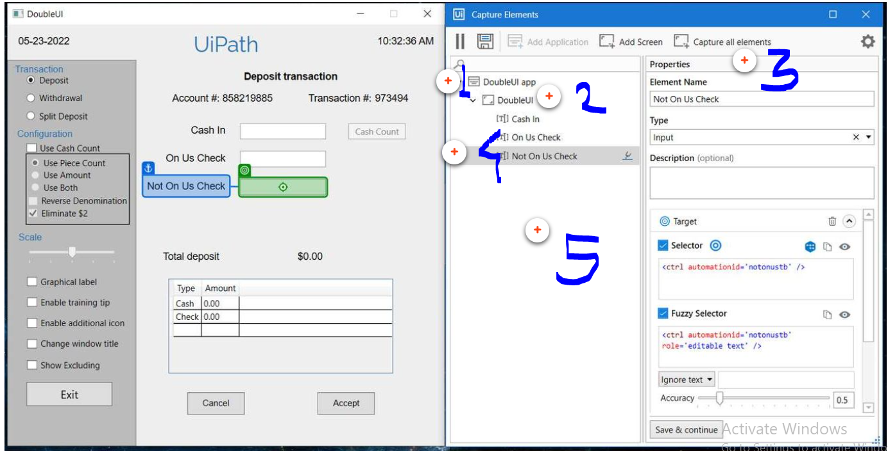

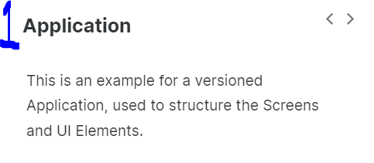

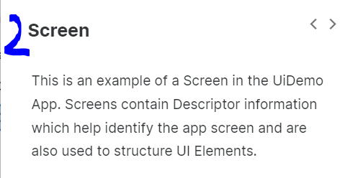

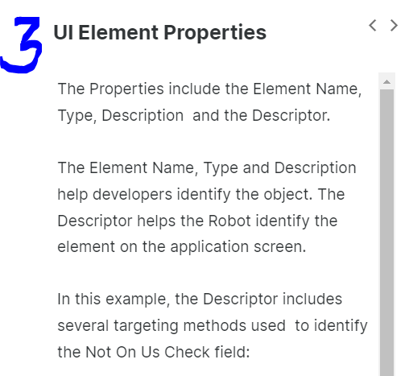

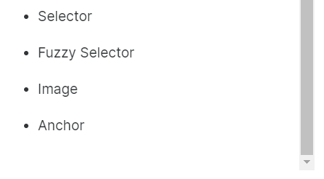

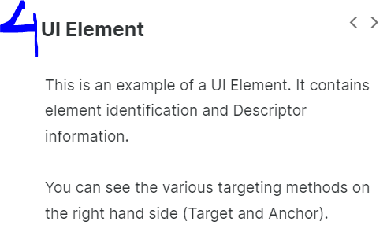

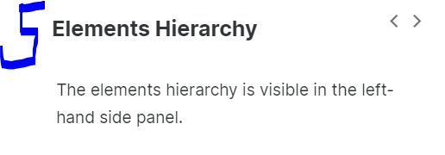

**How do you use the Object Repository?**

**Creating, publishing and updating projects using UI Libraries**

To understand how to make the best use of the Object Repository in your team, let's consider an implementation scenario. Your team is tasked with developing several processes using UI Automation on the same target application. It is expected that the target application will be upgraded in the future and your team needs a method to quickly update the projects when it happens.

Let's take a look at the key steps you would need to take:

* 1

1. **Create and publish a UI Library**

In this step, you capture all relevant UI objects identifying the app, screens and UI elements in the target application. There are two ways of doing this: you can start from an empty Library project and capture the objects or you can export them from a pre-existing Process type projectwhich uses Modern UI Activities.  
  
After you've extracted the needed elements, you can fine-tune them for increased reliability and then publish the UI Library locally or to Orchestrator.

* 2

2. **Import and use the UI Library**

Next, your team can import the new UI Library into their Process type projects and quickly develop UI Automation using the elements from the Object Repository.

* 3

3. **Update the UI Library**

At this point, your team has several processes in production developed using the same target app and UI Library. However, the target app has been upgraded and the Descriptors need to be updated.

To easily do this, you can open the UI Library project in Studio, edit the existing UI Descriptors to capture the new targets and publish a new version of the Library.

* 4

**4. Import and update the UI Library**

Your team can now update the UI Library in their Process type projects to the latest version. The UI Descriptors in the Activities will be updated automatically.

Your team can even update multiple projects at the same time by using the [Project Dependencies Mass Update Tool](https://docs.uipath.com/studio/v2021.10/docs/project-dependencies-mass-update)from the Studio Backstage view -> Tools.

**The key Features of the Object Repository are:**

* 1. Use Capture Elements wizard to record and capture the elements you need in your automation.
  2. Application, Different screen in the application, and each UI elements can be captured and managed in the Object Repository Panel.
  3. Drag-and-drop required captured elements from the Object Repository panel to your automation and choose the required action to it.
  4. View a list of all your UI activities used inside your process by using the UI Activities tab inside Object Repository panel.

**Project Organization in Studio:**

**Choosing the Workflow Layout:**

For small processes automated or parts of a larger automation project, there are three options of layout – Sequence, Flowchart and State Machine.

**Sequence**

–

**When to use it?**

* When there’s clear succession of steps, without too many conditions (for example, a UI automation).
* Usually, sequences are used to nest workflows and the high-level logic is handled through flowcharts or state machines.

**What are the advantages?**

* Easy to understand and follow, having a top to bottom approach.
* Great for simple logic, like searching for an item on the internet.

**What are the disadvantages?**

* Nesting too many conditions in the same sequence makes the process hard to read.
* Not suitable for continuous flows.

**Flowchart**

–

**When to use it?**

* When you have a complex flow with several conditions, a flowchart is at least visually much easier to understand and follow.
* When you need a flow that terminates only in one of several conditions.

**What are the advantages?**

* Easy to understand, as it is similar to logic diagrams in software computing.
* The most important aspect of flowcharts is that, unlike sequences, they present multiple branching logical operators, that enable you to create complex business processes and connect activities in multiple ways.

**What are the disadvantages?**

* Flowcharts should be used only as the general workflow (with sequences nested inside), not for individual parts of projects (nested inside other workflows).

**State Machine**

–

**When to use it?**

First of all, let’s understand what a state machine is. It is an abstract machine consisting of a finite number of pre-defined states and transitions between these states. At any point, based on the external inputs and conditions verified, it can be in only one of the states.

State machines can be used with a finite number of clear and stable states to go through. Some examples from your daily life include vending machines, elevators or traffic lights.

**What are the advantages?**

* Can be used for continuous workflows that are more complex.
* Transitions between states can be easily defined and offer flexibility.
* Can accommodate processes that are more complex and cannot be captured by simple loops and If statements.
* It is easier to cover all the possible cases/transitions with state machines.

**What are the disadvantages?**

* Longer development time due to their complexity: splitting the process into logical "states", figuring out transitions, and so on.

**Note**: State machines are not to be overused - they should define only the skeleton of the project.

In fact, there are templates built upon state machines especially designed to build large enterprise automations. The most commonly used is the Robotic Enterprise Framework - we have a separate course to cover it in the RPA Developer Advanced learning plan.

**Organizing Projects in Workflows:**

Breaking an automation process down into smaller workflows ensures speed of development and reliability, by allowing independent testing of components while encouraging team collaboration. Both are paramount for the success of such initiatives. Moreover, in complex automations (like most of the enterprise projects are), the question is not if it should be broken down, but how to do it.

There are multiple ways in which the workflows can be split and at least 3 factors should be considered as breakdown criteria:

* 1
  1. The application that is being automated.
  2. The purpose of a certain operation (login, processing, reading a document using OCR, filling in a template, and so on).
  3. Complexity of each workflow.
  4. Workflow reusability in other projects.

For example, a complex process can be split into workflows for each application, and for each of those applications, split on input, processing or output. If any of these workflows are too complex, they can be further split, having in mind also a purpose to do it.

**Handling data in projects with multiple workflows**

Splitting a project into smaller workflows has an influence on how data is handled. Since variables work only inside the same workflow, having more than one workflow requires arguments.

As you probably know from the **Variables, Data Types, and Control Flow in Studio**course, Arguments are very similar to variables – they store data dynamically, they have the same data types, and they support the same methods. The main difference is the ‘Direction’ property, signifying the direction from/to which the data is passed. The direction can be In, Out and In/Out:

* **In**- if we want to pass a value to be used only inside the invoked workflow.
* **Out** - if we want to pass a value to be used outside of the invoked workflow, in the parent workflow.
* **In/Out** - if we want to pass a value from the parent workflow to the invoked workflow, modify it in the invoked workflow and then pass the new value back to the parent workflow.

Consider an invoked workflow that subtracts all the taxes from a gross salary. You will need at least two arguments:

* An 'in' argument mapped to the variable containing the gross salary.
* An 'out' argument to pass the value of the net salary to a variable in the parent workflow.

**Note:**When the ‘Extract as Workflow’ action is used, variables are automatically turned into arguments.

**Best practices on using arguments**

* **Naming:** Use the direction as a prefix when naming arguments – e.g. in_ArgumentName1, out_ArgumentName2, io_ArgumentName3.
* **Directions:** Be specific with argument directions. Avoid using In/Out unless you need to.

**Setting the project compatibility**

To create a new project in the Studio, you should select the compatibility based on the environment on which the project will be executed:

* **Windows - Legacy:** Uses .NET Framework 4.6.1. the compatibility used in releases prior to 2021.10. This is the default option.
* **Windows:** Uses .NET 6 with Windows support.
* **Cross-platform:** Uses .NET 6 with cross-platform support.

**Designing cross-platform projects**

Cross-platform projects enable you to create automations that don't require user interaction, including web browser automations using Chrome. Cross-platform automations can be executed on Windows and Unix-like operating systems such as Linux and macOS.

Linux environments allows you to run unattended automations and provides a faster experience and an easier way of scaling up your deployment. When using Linux environments, use Linux robots to run unattended automations. When creating an automation, make sure to select the Cross-platform compatibility.

**Libraries:**

Extracting workflows and reusing them across an automation project is a good habit for keeping a project organized, readable, and sustainable. At the same time, there are cases in which workflows can be reused in different projects. Consider the sequence of logging into SAP. Every time an automation project deals with SAP, the same sequence of steps will be needed.

Storing and reusing components in separate projects is done through **process libraries**. A process library is a package that contains multiple reusable components, which consist of one or more workflows that act as individual activities. Libraries are saved as .nupkg files, and then installed in different projects using the Package Manager.

How do we identify if a part of a project is a reusable? Consider what sequences of activities can be used in several processes. For example: login, logout, starting multiple applications common to several processes, data entry sequences.

**Best Practices - Libraries**

In libraries, each workflow can be set as public or private. Public items can be used as activities in projects where the libraries are added, while the private ones can be used only inside the libraries.

**Project Templates:**

The speed of developing automation projects can be improved by creating project templates in Studio and sharing them with the team. Studio lets you create and publish custom templates or use one from the available built-in templates.

Note: VB means Visual Basic in studio.

**Exception Handling:**

Consider an automation where the input data comes from a web form, and the application tries to match the data with the list of existing clients using the last name. But what if the user makes a mistake when spelling the name? Naturally, the name won't be recognized.

A good project design will include ways of recognizing and identifying the exception, and also patterns of action that are executed only when exceptions are caught. These can be simply stopping the execution, or explicit actions executed automatically within the workflow, or even escalating the issue to a human operator.

Predicting and treating exceptions can be done in two ways:

* At activity level, using **Try/Catch**blocks or **Retry Scope**.
* At a global level, using the **Global Exception Handler**.

Both will be covered in depth in the **Error and Exception Handling in Studio** course. At this point, it is important to be able to choose the correct type of exception, as the information will be used at a higher level later in the development to make other decisions. The categories of

**Types Of Exception:**

**Application exception**

–

The Application Exception describes an error rooted in a technical issue, such as an application that is not responding.

Consider a project extracting phone numbers from an employee database and inserting them into a financial application. If, when the transaction is attempted, the financial application freezes, the Robot cannot find the field where it should insert the phone number, and eventually throws an error. These kinds of issues have a chance of being solved simply by retrying the transaction, as the application can unfreeze.

In managing application exceptions, it is extremely important to have good naming conventions for activities and workflows. This will help with tracking the activity that caused the exception.

**Business rule exception**

–

The Business Exception describes an error rooted in the fact that certain data which the automation project depends on is incomplete, missing, outside of set boundaries (like trying to extract more from the ATM than the daily limit) or does not pass other data validation criteria (like an invoice amount containing letters). Business Rule Exceptions do not occur "naturally", they need to be defined using a Throw activity.

Consider a robot that processes invoices, with a business rule set by the process owner that only invoices with the amount below $1000 must enter the automated process. For the others, a different flow is applicable, involving a human user to process them.

In this case, retrying the transaction does not yield any chance of solving the issue, instead the business user should be notified about the pending invoice and the case should be treated as a business exception - because is an exception from the usual process flow and the validation is made explicitly by the developer inside the workflow.

As a recommended practice, the text in the exception should contain enough information for a human user (business user or developer) to understand what happened and what actions need to be taken.

**Version Control Systems Integration:**

Source control systems are particularly useful in larger projects, where multiple teams and individuals contribute in each stage. Source control systems allow users in different teams and locations to access the same resources and work on the same project. They are also used for versioning the code and maintaining the history of all the changes made during development.

Through the Teams page in the backstage view, Studio supports the following source control systems:

### Git

With the Git integration you can:

* + Clone a remote repository.
  + Add a project.
  + Commit and push.
  + Copy a project to Git.
  + Create and manage branches.
  + Solve conflicts with File Diff option.

### TFS

* + The following versions are supported:
    - 2012
    - 2013
    - 2015
    - Express 2012
    - Express 2013
    - Express 2015
  + First, you need to setup TFS in Studio.
  + Then you can open a project or add a new project to the TFS.

### SVN

With the SVN integration you can:

* + Open a project from SVN.
  + Add a project to SVN.

**Best Practices:**

**Let’s recap the main points to follow when aiming for a good project organization:**

### Design before building

Analyze the process thoroughly, identify the requirements and plan what the solution should look like before starting the actual development.

### Use Remove Unused button

Remove unused Workflows, Variables, Arguments, Dependencies, Imports, Screenshots before publishing the project.

### Break the process down into components

Break the process down into smaller workflows for a better understanding of the code, independent testing, and reusability. This can also impact the effectiveness, as different team members can work on different (smaller) workflows.

### Reuse components

Use libraries for creating and storing reusable components for your projects.

### Use folders in your project

Group the workflows of your project into different folders based on the target application.

### Follow a naming convention

Keep a consistent naming convention across the project.

### Configure arguments correctly

Use the right type of argument (In/Out/InOut) when invoking a workflow based on the direction of information. For naming, our recommendation is PascalCase with the direction of the argument as a prefix (in_/out_/io_).

### Handle sensitive data with care

Handle sensitive data responsibly: no credentials should be stored in the workflow directly, but rather loaded from safer places like the Windows credential store or Orchestrator assets and used with the Get Secure Credentials, Get Credentials and Type Secure Text activities.

### Handle specific exceptions

Use Try/Catch blocks to predict and handle exceptions. At the same time, remember that simply using Try/Catch will only identify the error, not solve it. Thus, make sure you develop error handling mechanisms and integrate them.

### Handle global exceptions

Use the Global Exception Handler for situations that are global and/or less probable to happen (for example, a Windows Update pop-up).

### Make your projects easy to read

Add annotations to your workflows to clarify the purpose of each workflow.

### Use logging

Use logs in production to get relevant information regarding critical moments or anytime specific data is needed. You can read more about the types of logs [here](https://docs.uipath.com/studio/docs/types-of-logs).

### Use the Workflow Analyzer

Before sending your project to peer review, run the Workflow Analyzer to see how compliant it is with the development rules defined by UiPath and your organization.

**Debugging in Studio**

**Debugging Features Overview:**

**What debugging is**

Debugging is a process of detecting and resolving errors in a project that would cause it to behave unexpectedly or crash. It is usually recommended to perform debugging during the design stage of the automation project, at activity, file, and project level.

**The debugging actions and panels:**

**Debugging actions:**

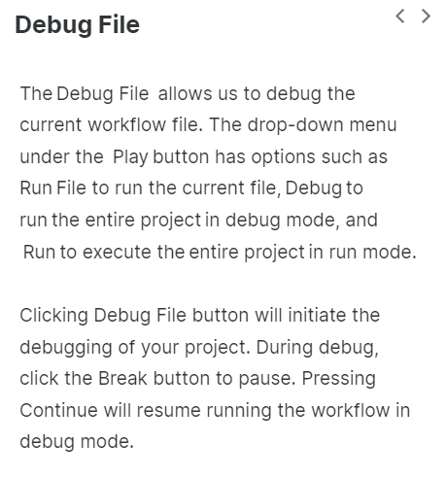

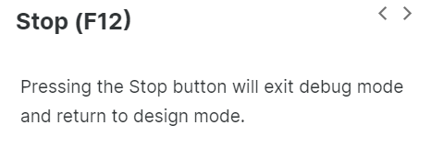

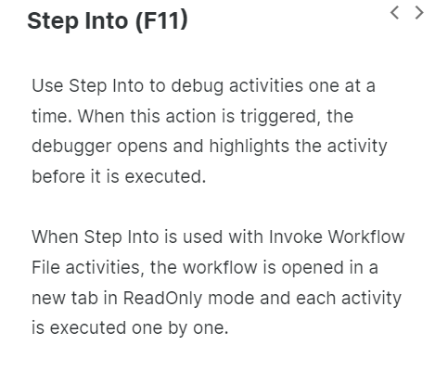

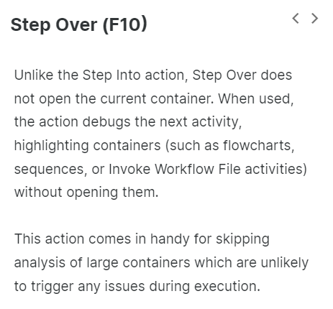

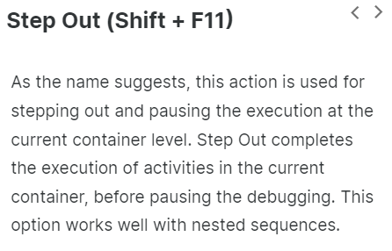

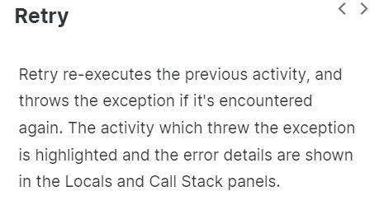

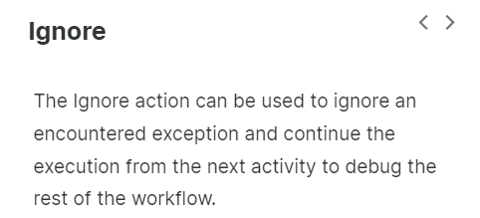

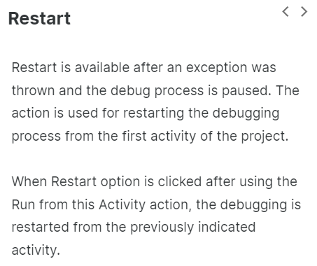

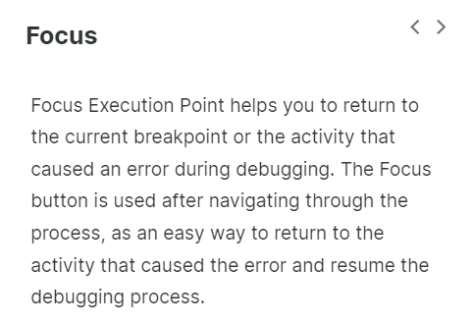

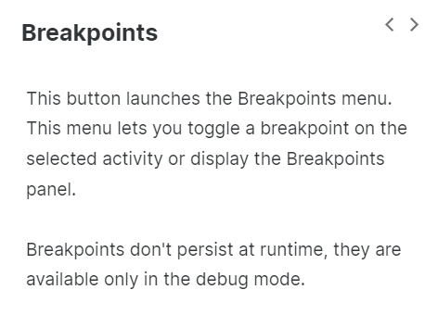

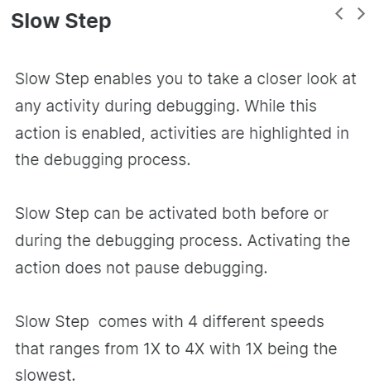

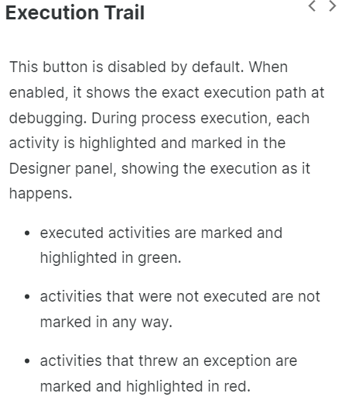

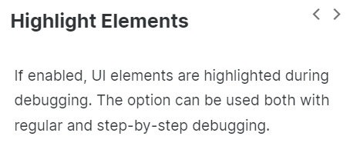

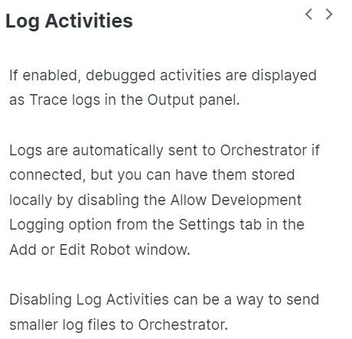

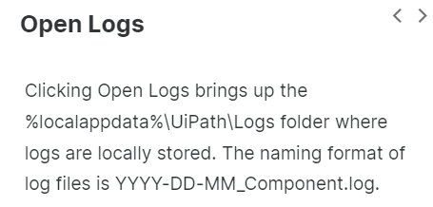

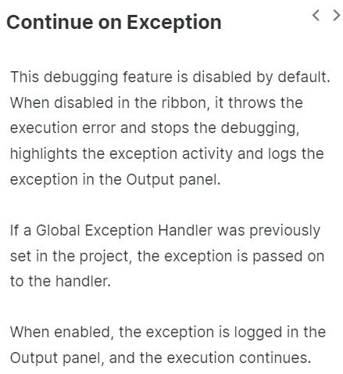

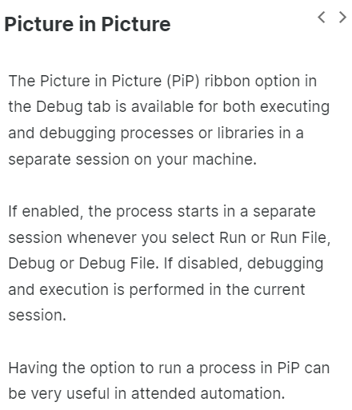

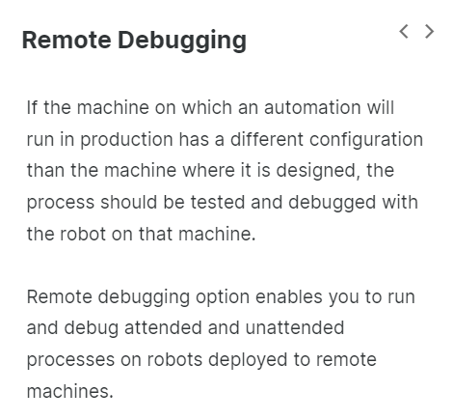

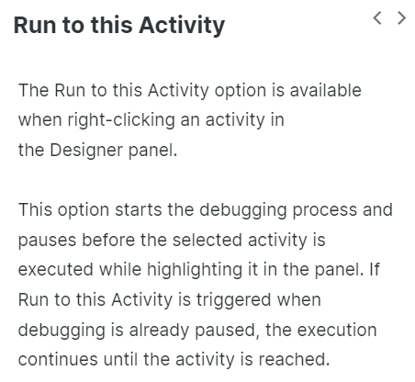

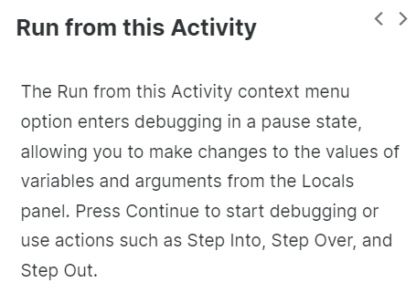

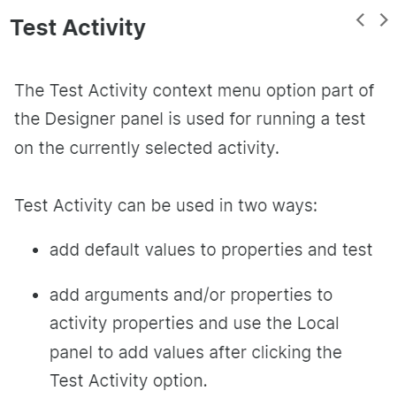

**Debugging panels:**

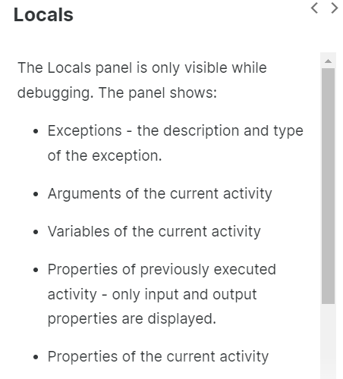

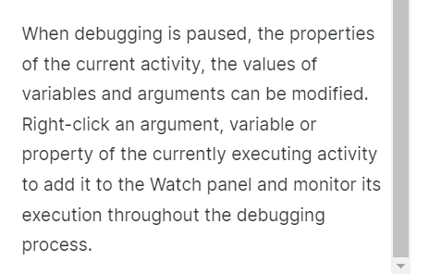

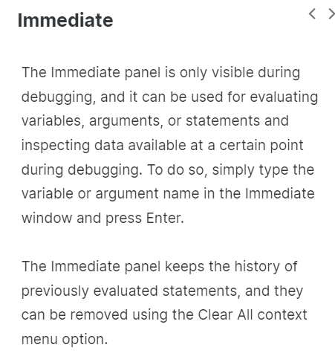

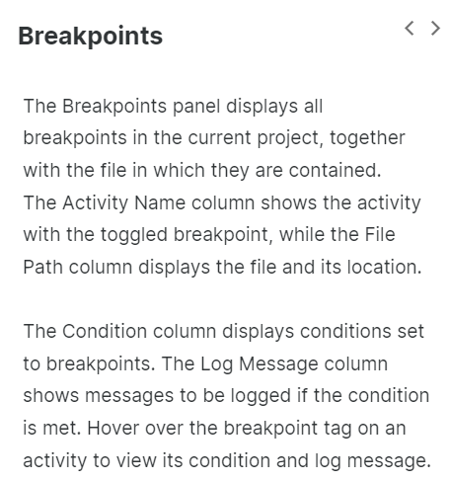

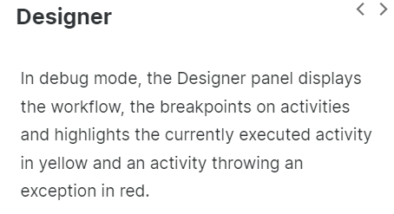

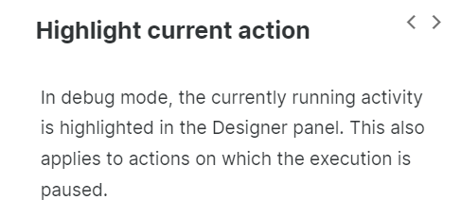

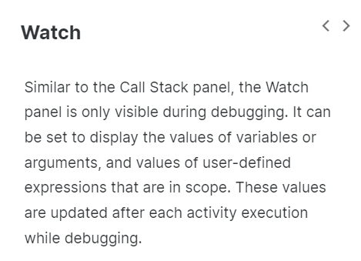

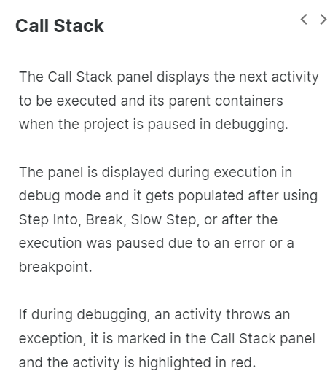

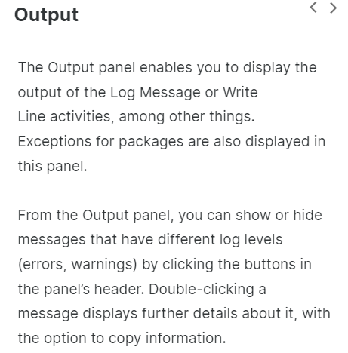

**Basic Debugging Features**: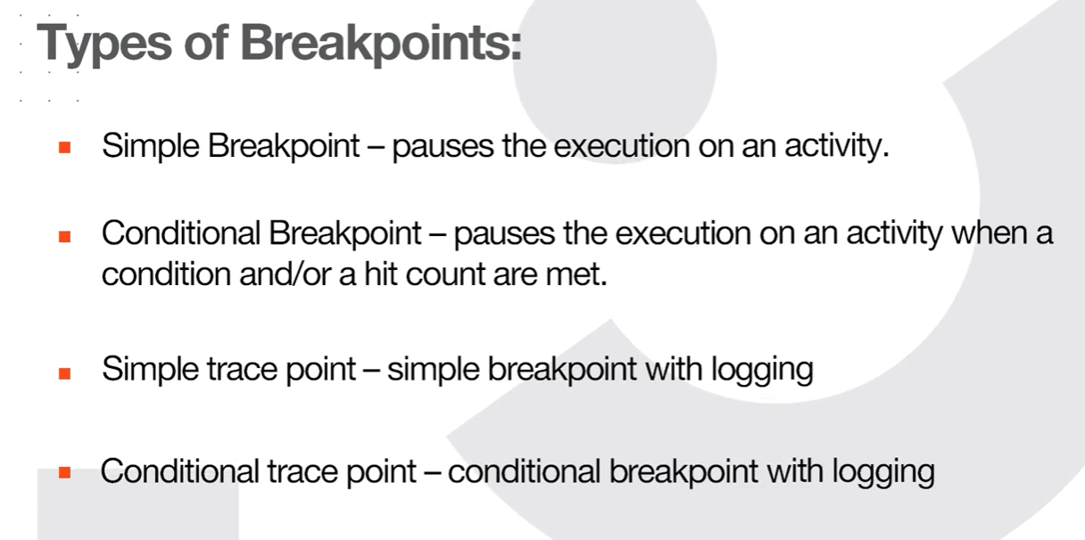

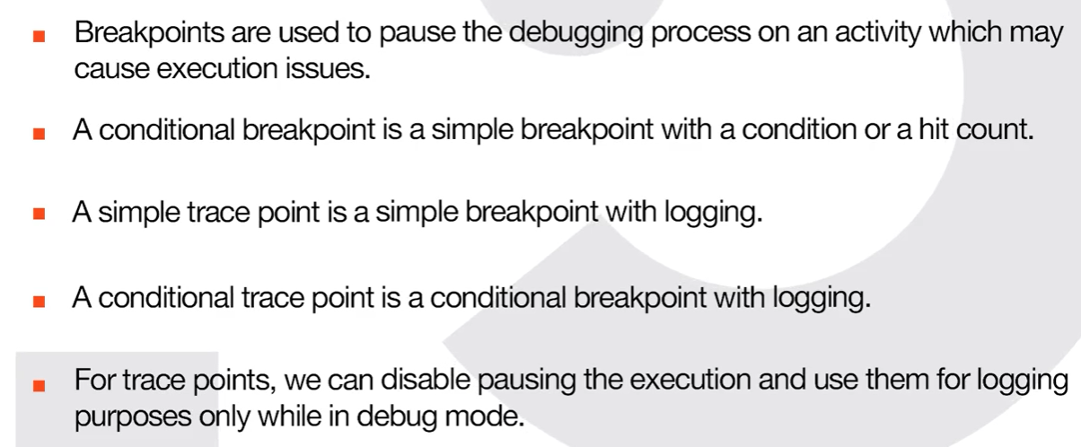

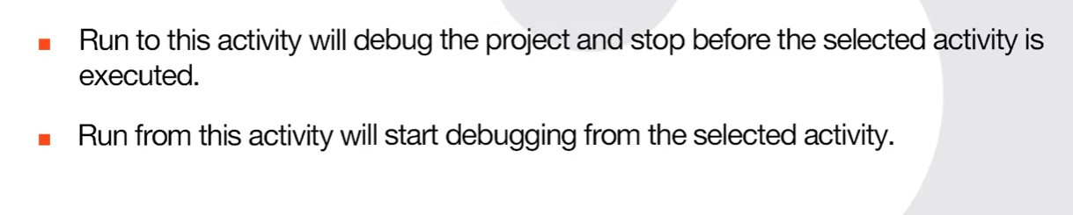

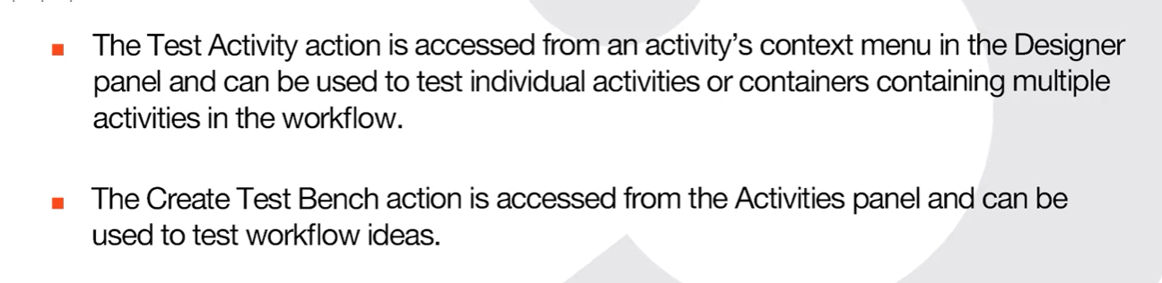

**Advanced Debugging Features:**

**Watch panel**

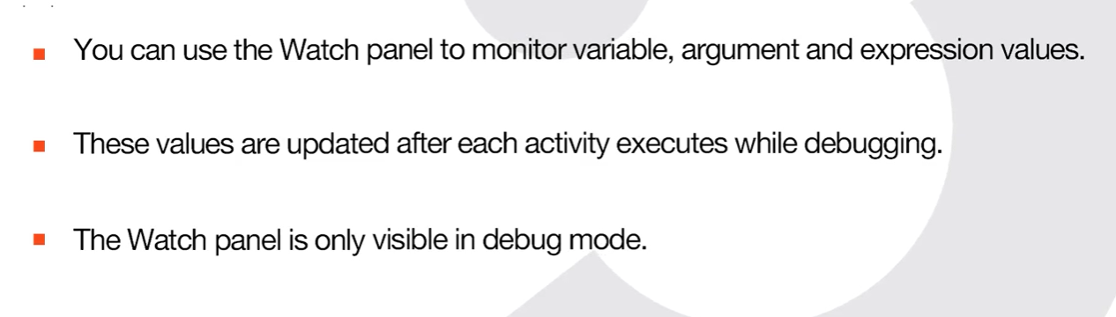

**The Immediate panel**

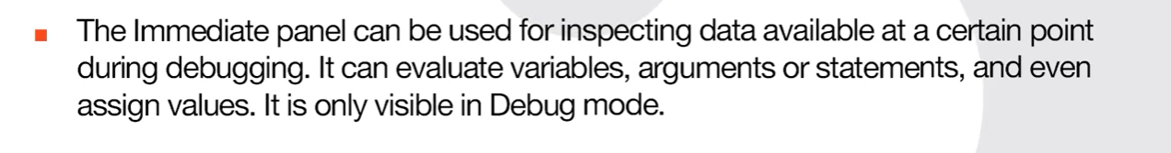

**The Call Stack panel**

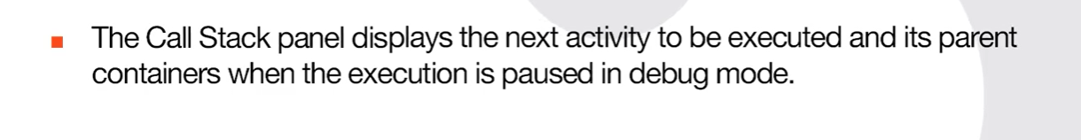

**Error and Exception Handling in Studio**

**System and Business Exceptions:**

**Errors**

–

Errors are events that a particular program can’t normally deal with. There are different types of errors, based on what's causing them - for example:

* **Syntax errors,** where the compiler/interpreter cannot parse the written code into meaningful computer instructions.
* **User errors,** where the software determines that the user’s input is not acceptable for some reason.
* **Programming errors**, where the program contains no syntax errors but does not produce the expected results. These types of errors are often called bugs.

**Exceptions**

–

Exceptions are events that are recognized (caught) by the program, categorized, and handled. More specifically, there is a routine configured by the developer that is activated when an exception is caught. Sometimes, the handling mechanism can be simply stopping the execution.

Some of the exceptions are linked to the systems used, while others are linked to the logic of the business process.

**Business exceptions**

A business exception mainly refers to information used in an automated process. Either it may be incomplete or incorrect from a business perspective.

When business exceptions occur, robots stop the process, and it requires human intervention to address a thrown exception.

Some of the examples of business exceptions are: certain pieces of data which the automation project depends on are incomplete, missing, outside set boundaries (like trying to extract more from the ATM than its daily limit), or don't pass other data validation criteria.

Business rule exceptions aren't automatically generated as system exceptions. They must be defined by a developer by using the **Throw** Activity and handled inside a **TryCatch**.

**System exceptions**

Below is the list of the most common exceptions that you can encounter in projects developed with UiPath.

As a general note, all of these exception types mentioned below are derived from**System.Exception**, so using this generic type in a TryCatch, for example, will catch all types of errors.

* **NullReferenceException** - Occurs when using a variable with no set value (not initialized).
* **IndexOutOfRangeException** - Occurs when the index of an object is out of the limits of the collection.
* **ArgumentException** - Is thrown when a method is invoked and at least one of the passed arguments does not meet the parameter specification of the called method.
* **SelectorNotFoundException** - Is thrown when the robot is unable to find the designated selector for an activity in the target app within the TimeOut period.
* **ImageOperationException**- Occurs when an image is not found within the TimeOut period.
* **TextNotFoundException** - Occurs when the indicated text is not found within the TimeOut period.
* **ApplicationException** - Describes an error rooted in a technical issue, such as an application that is not responding.

**TryCatch, Throw and Rethrow:**

TryCatch activity catches a specified exception type in a sequence or activity and either displays an error notification or dismisses it and continues the execution.

As a mechanism, TryCatch runs the activities in the **Try** block and, if an error takes place, executes the activities in the **Catches** block. The **Finally** block is only executed when no exceptions are thrown or when an exception is caught and handled in the Catches block (without being re-thrown).

### Try:

The activities performed which have a chance of throwing an error.

### Catches:

The activity or set of activities to be performed when an exception occurs.

**Note**: You can add multiple exceptions and corresponding activities to this block.

What can you do whenever an exception occurs, and if the catch block is unable to handle the particular exception it has caught?

You can **rethrow** the exception. Rethrow causes the initially thrown exception to be rethrown to handle the exception on an upper level.

### Finally:

The activity or set of activities to be performed after the Try and Catches blocks are executed. This section is executed only when no exceptions are thrown or when an error occurs and is caught in the Catches block (without being re-thrown).

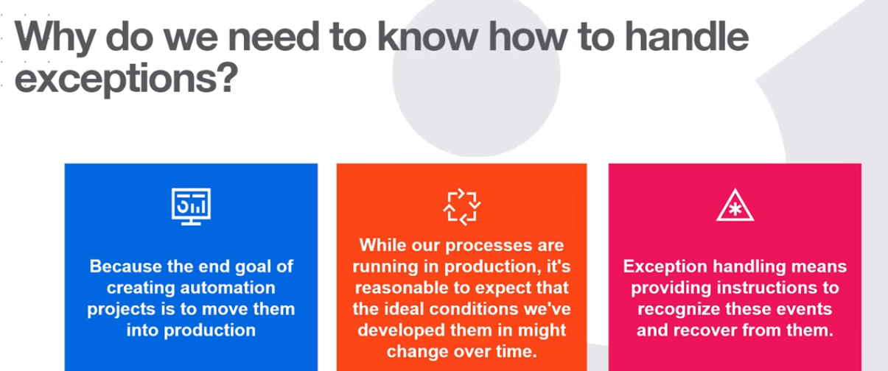

**Retry Scope:**

The Retry Scope activity retries the contained activities as long as the condition is not met or an error is thrown.

This activity is used for catching and handling an error, which is why it’s similar to TryCatch. The difference is that this activity simply **retries the execution** instead of providing a more complex handling mechanism.

The activity has two main sections **Actions** and **Conditions.**

It can be used without a termination condition, in which case it'll retry the activities until no exception occurs or the provided number of attempts is exceeded.

Retry scope has two additional properties **NumberOfRetries** and **RetryInterval.**

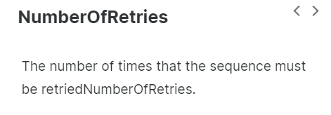

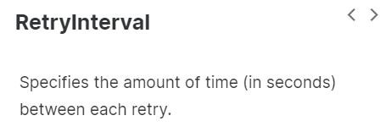

**The ContinueOnError Property:**

The ContinueOnError is a property that specifies if the execution of the activity should continue even when the activity throws an error.

This field only supports Boolean values (True, False). The default value is False, thus, if the field is blank and an error is thrown, the execution of the project stops. If the value is set to True, the execution of the project continues regardless of any error.

Keep in mind that, if the ContinueOnError is set to True on an Activity that has a scope such as (**Attach Window** or **Attach Browser**, in the classic, and **Use Application Browser**in the modern), then error thrown by all the activities inside the DO container of respective scope Activity will also be ignored.

Setting this property to True is not recommended in all situations. But there are some in which it makes sense, such as:

* While using data scraping - So that the activity doesn't throw an error on the last page when the selector of the 'Next' button is no longer found.
* When we are not interested in capturing the error but simply in the execution of the activity.

**The Global Exception Handler:**

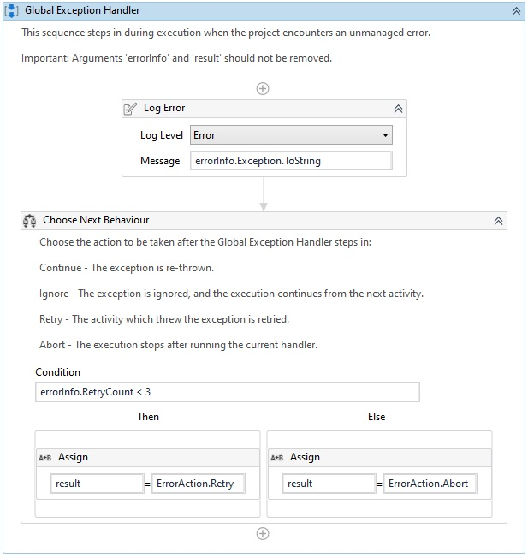

The Global Exception Handler is a type of workflow designed to determine the process' behavior when encountering an unexpected exception. This is why only **one** Global Exception Handler can be set per automation project.

In its default configuration, the Global Handler catches the exceptions thrown by any activity in the process at runtime and executes a standard response - ignore, retry, abort or continue, as predefined at design time. For attended scenarios, it can be configured to let the user select the action.

A Global Exception Handler can be created by adding a new workflow file with this type. It can also be created by setting an existing workflow as Global Exception Handler from the Project panel.

**How does it work?**

The Global Exception Handler has 2 predefined arguments, that shouldn't be removed:

* **errorInfo**with the In direction - contains the information about the error that was thrown and the workflow that failed.
* **result** with the Out direction - used for determining the next behavior of the process when it encounters the error.

The Global Exception Handler contains the predefined activities below. If required, we can also add other activities in our Handler.

**Log Error**

This part simply logs the error. The developer gets to choose the logging level - Fatal, Error, Warn, Info, Trace, and so on.

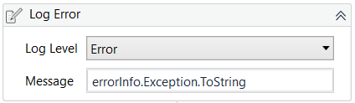

**Choose Next Behavior**

Here the developer can choose the action to be taken when an error is encountered during execution:

* **Continue**- The exception is re-thrown.
* **Ignore** - The exception is ignored, and the execution continues from the next activity.
* **Retry** - The activity which threw the exception is retried.
* **Abort** - The execution stops after running the current handler.

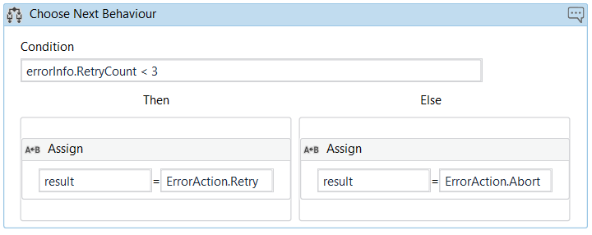

**The Global Exception Handler is not available for library projects, only processes.**

Only uncaught exceptions will reach the exception handler. If an exception occurs inside a TryCatch activity and is successfully caught and handled inside the Catches block (and not re-thrown), it will not reach the Global Exception Handler.

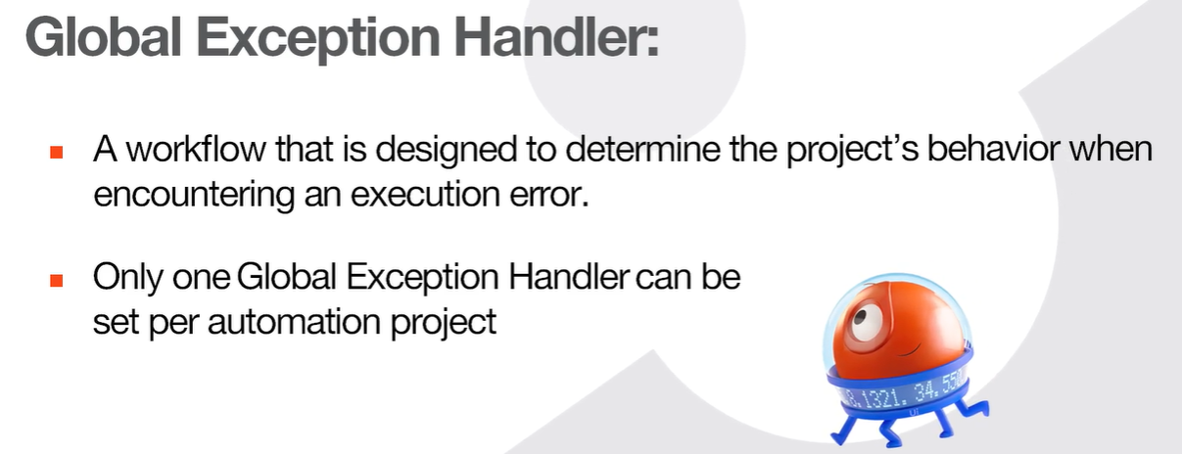

**Introduction to Logging in Studio:**

**Logging Overview:**

**Types of logs in UiPath**

In the beginning, we've mentioned that the focus of this lesson is setting up useful logging when developing a project. For a bit of context, let's first start by checking out the main types of logs generated by the UiPath Platform:

* Studio logs.
* Setup logs.
* Orchestrator diagnostic logs.
* Robot logs.

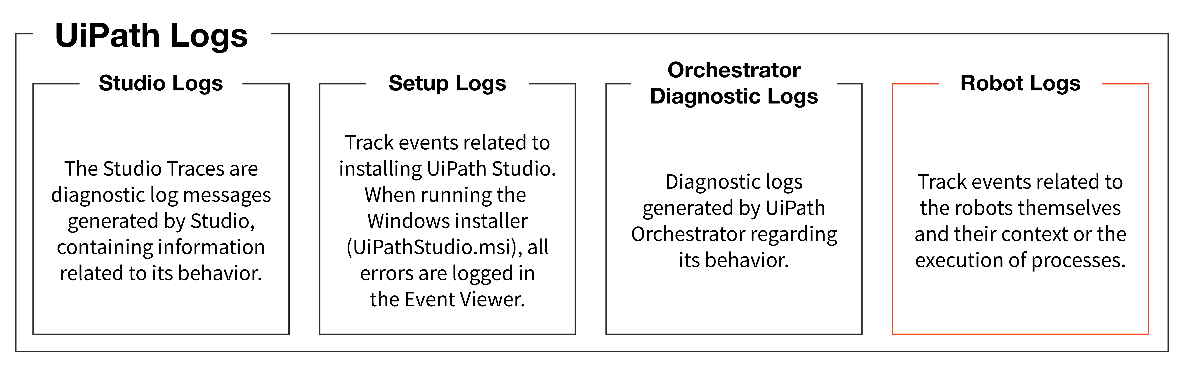

**Robot logs**

During process execution, the Robot generates a message (Log) for each step along the way. These are gathered and stored in a Log File. The overall operation of gathering and storing Logs is called Logging.

There are two types of Robot logs:

* **Robot execution logs:**they're messages generated by the execution of a process and typically contain information related to its behavior and user-defined messages.
* **Robot diagnostic logs:**they provide information related to the Robot itself and its context.

Why is the focus on robot execution logs?Well,**robot execution logs** can be used to supervise, diagnose, and debug processes in production, gather process performance data, or even track business results like the total value of transactions processed. They can be either default logs or user-defined logs.

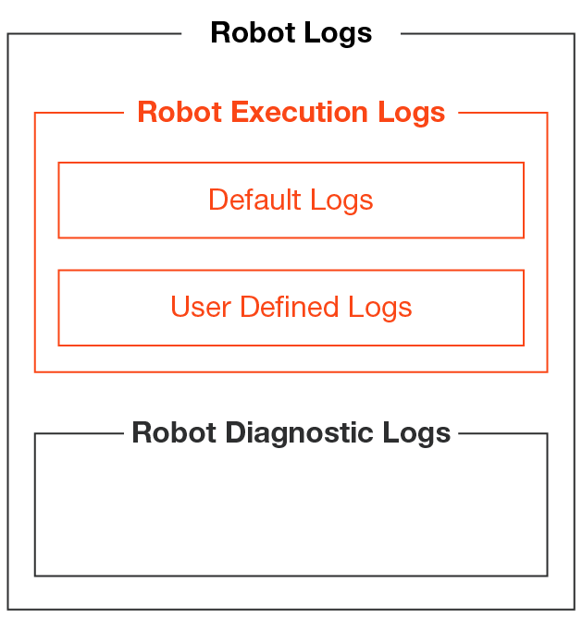

**Default logs** are generated automatically when certain events take place. The events logged by this category are:

* **Execution start** is generated every time a process is started (Level = Information).
* **Execution end** is generated every time a process is finalized (Level = Information).
* **Transaction start** is generated every time a transaction within a process is started (Level = Information).
* **Transaction end** is generated every time a transaction within a process is finalized (Level = Information).
* **Error log** is generated every time the execution encounters an error and stops (Level = Error).
* **Debugging log**is generated if the Robot Logging Setting is set to Verbose, and contains, Activity names, types, variable values, arguments, etc. (Level = Trace).
* **User-defined logs** are generated according to the process designed by you in Studio, when using **Log Message** Activity or **Write Line** Activity.

**Logging levels in UiPath**

* Each log has a Log Level that refers to how detailed the generated message is. In other words, logging levels let you sort log messages by severity, or by how important a log message is related to the execution of a process. Log levels are used in Orchestrator to filter out logs below a specific level.

| **Logging Level** | **Meaning** |
| --- | --- |
| **Fatal/ Critical** | The robot cannot or shouldn't recover from this error. Something has gone critically wrong and the process needs to stop.  For example, the robot has no means of handling an exception, or if the process is using Browser UI automation, the website it's interacting with displays a message that it is under maintenance. |
| **Error** | An error has occurred. The robot will try to recover and move on with the next item. |
| **Warning** | Any important data that you need to stand out from the rest of the log information. |
| **Information** | Information about robot progress. Usually includes when you enter/exit a workflow, when data is read from an external source, etc. |
| **Trace** | Information that's useful while developing/debugging, however not useful and needed in production. |
| **Debugging/Verbose level** | Verbose level generates default logs for the execution of each Activity, allowing a much more in-depth diagnosis by giving more information about the values of variables and arguments.  You can generate verbose logs by enabling the '**Log Activities**' option in Studio. |

**Verbose level logs**

The verbose level logs a message for both the activities — start and end, plus the values of the variables and arguments that are used. The verbose level is used for debugging.

By default, the Verbose level includes:

* **Execution started log entry** - generated every time a process is started.
* **Execution ended log entry** - generated every time a process is finalized.
* **Transaction started log entry** - generated every time a transaction item is obtained by the robot from Orchestrator.
* **Transaction ended log entry** - generated every time the robot sets the transaction status to either Success or Failed.
* **Activity information log entry** - generated every time an activity is started, faulted or finished inside a workflow.

By default, running a process in Studio will record trace level logs. To set logging to verbose level locally, access the Debug ribbon, enable the**Log Activities** option, and run the process in debug mode.

**Accessing and Reading Robot Execution Logs:**

**Accessing logs**

There are several places where you can access Robot Execution Logs:

* In the **Output Panel** in UiPath Studio for the previous process execution from Studio.
* In the **%localappdata%\UiPath\Logs\<shortdate>_Execution.log** file for all processes ran on the machine from UiPath Studio. Logs are generated at Trace level and above or Verbose level and above depending on whether the Verbose level is activated or not.
* In the **%localappdata%\UiPath\Logs\<shortdate>_Execution.log** file for all processes ran on the machine from UiPath Assistant. The logs are generated at the level defined in UiPath Assistant and above.
* In **Orchestrator,**in the Logs section when running processes while connected to Orchestrator. The logs are generated at the defined level and above.

To learn how to write effective log messages and interpret the log files, the logs that you should be interested in are the ones from the Output panel and %localappdata%\UiPath\Logs\<shortdate>_Execution.log.

**The anatomy of a log entry**

Time to understand how log entries are structured. These entries can be very helpful when checking execution logs to analyze behavior or figure out what caused an exception. Logs are in the form of a **JSON**, pretty much just a **key-value pair** **(“field1:value1,” “field2:value2”)**.

The default log fields are present in all logs:

* **Message**: the log message.
* **Level:**defines the log severity.
* **Timestamp**: the exact date and time the action was performed.
* **FileName**: the name of the .xaml file being “executed".
* **JobId**: the key of the job running the process.
* **ProcessName**: the name of the process that triggered the logging.
* **ProcessVersion**: the version number of the process.
* **WindowsIdentity**: the name of the user that performed the action that was logged.
* **RobotName**: the name of the robot (as defined in Orchestrator).

Aside from default fields, logs can also contain type-specific fields and user-defined fields.

* **Type-specific** fields are present depending on the log type, like **totalExecutionTimeInSeconds** and **totalExecutionTime** for **Execution End**.
* **User-defined** fields are defined in Studio (by using the Add Log Fields Activity) and appear in all resulting logs after the activity is generated unless they are (programmatically) removed by the activity Remove Log Fields.

**Identify the key log fields generated at the Trace level and above.**

**1)**

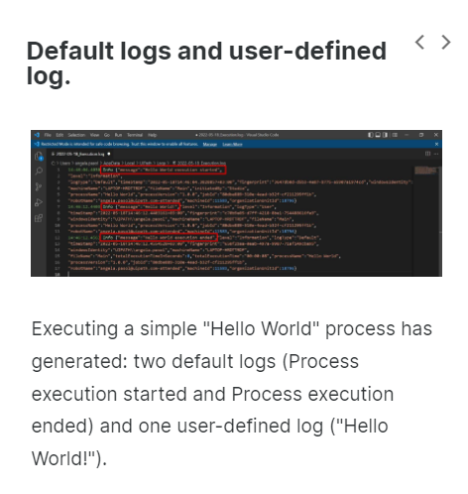

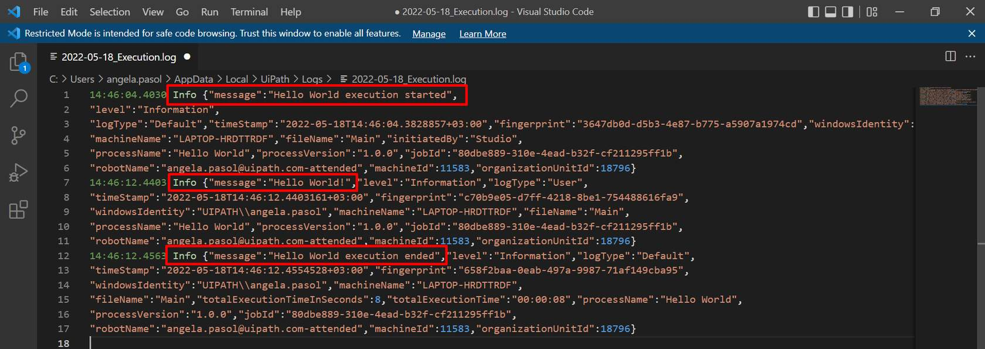

2)

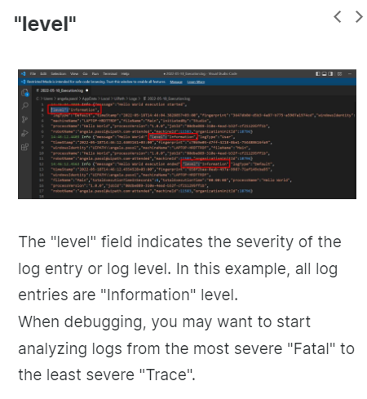

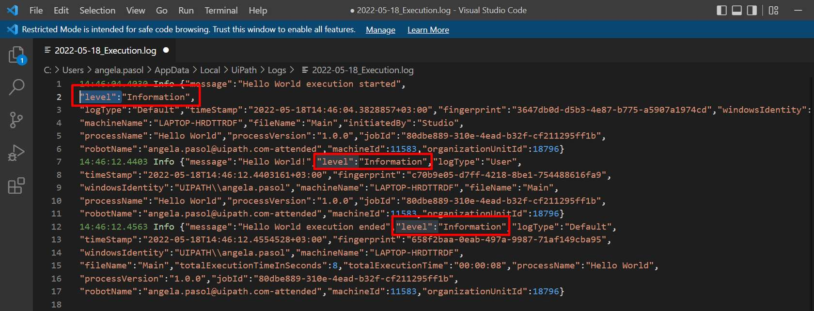

3)

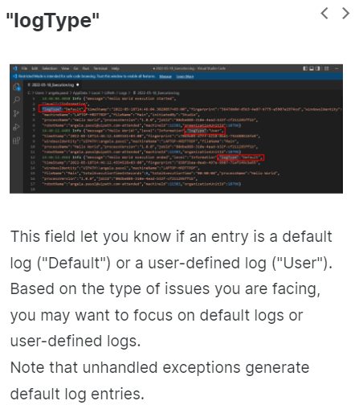

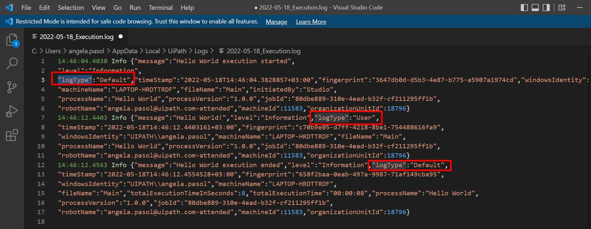

4)

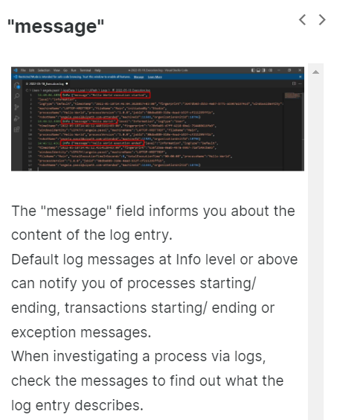



5)

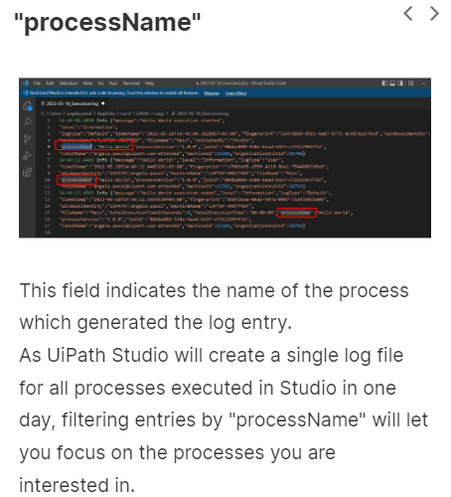

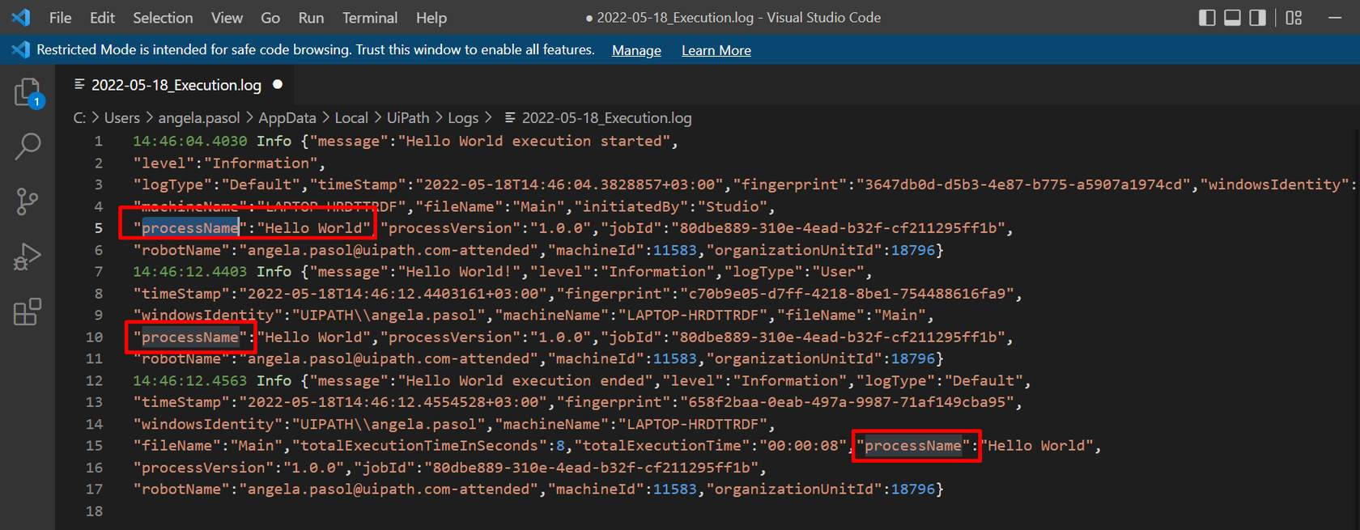

6)

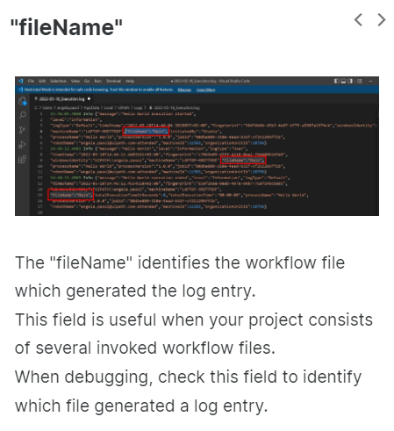

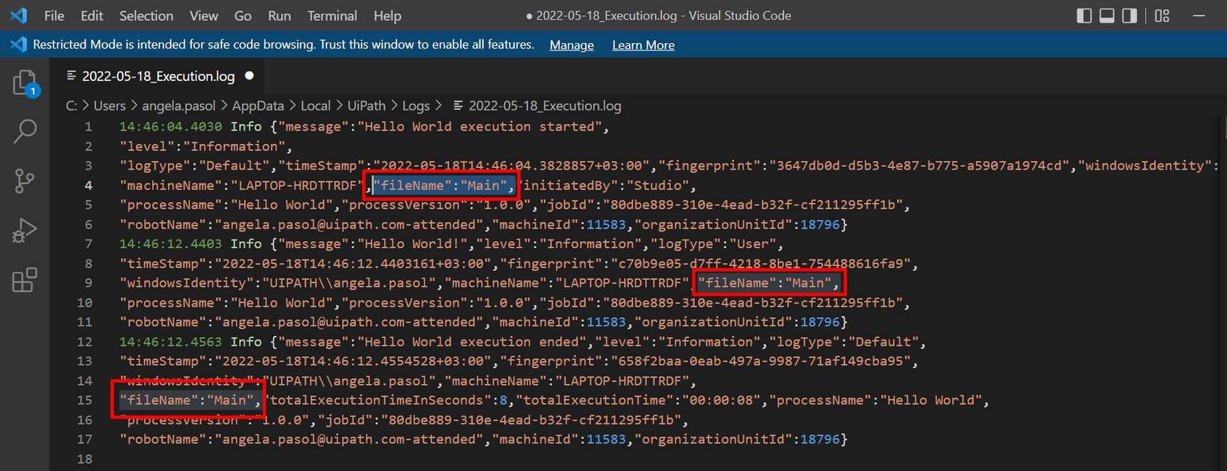

**Identify log entries generated at the Verbose level and their key fields.**

**1)**

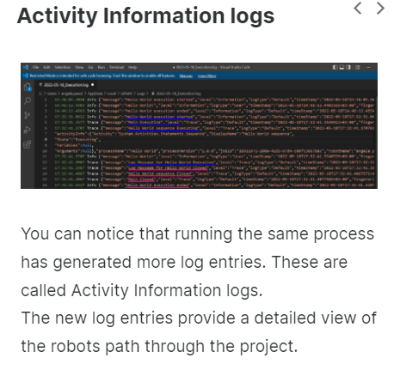

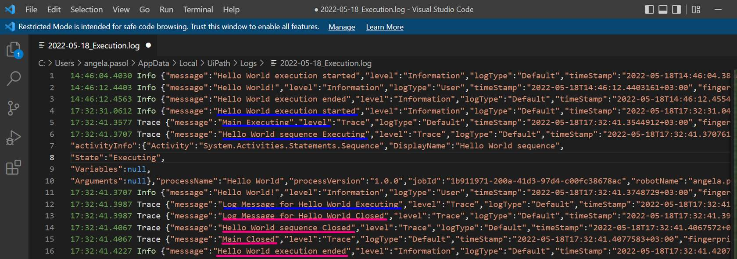

2)

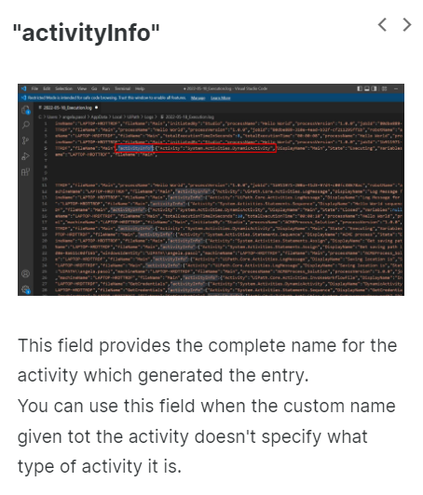

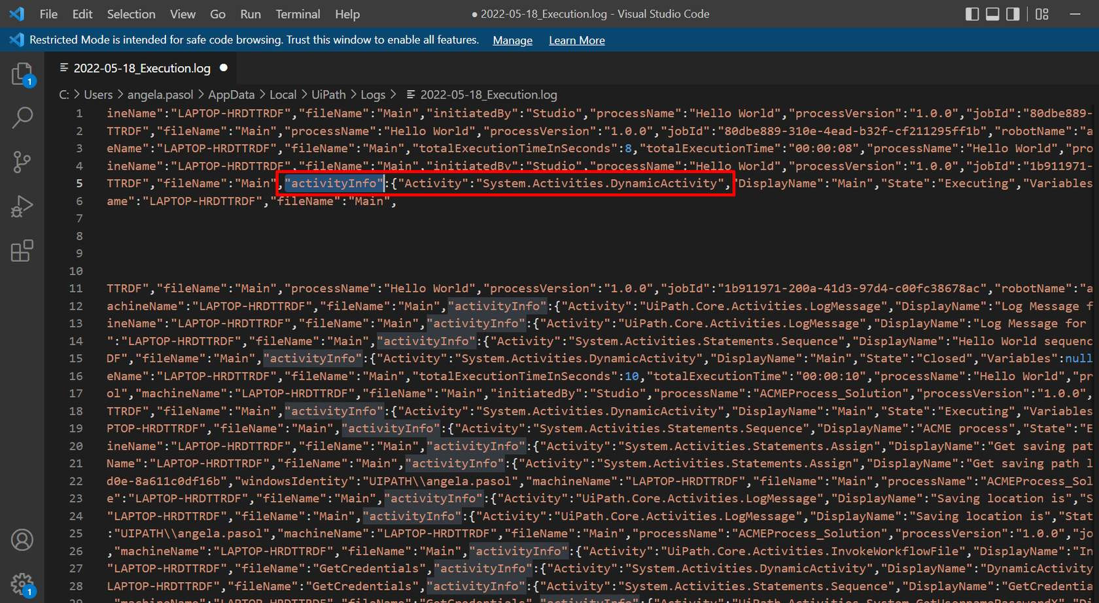

3) State

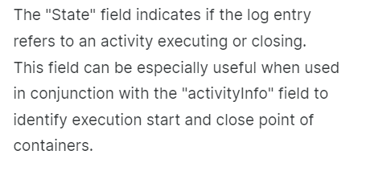

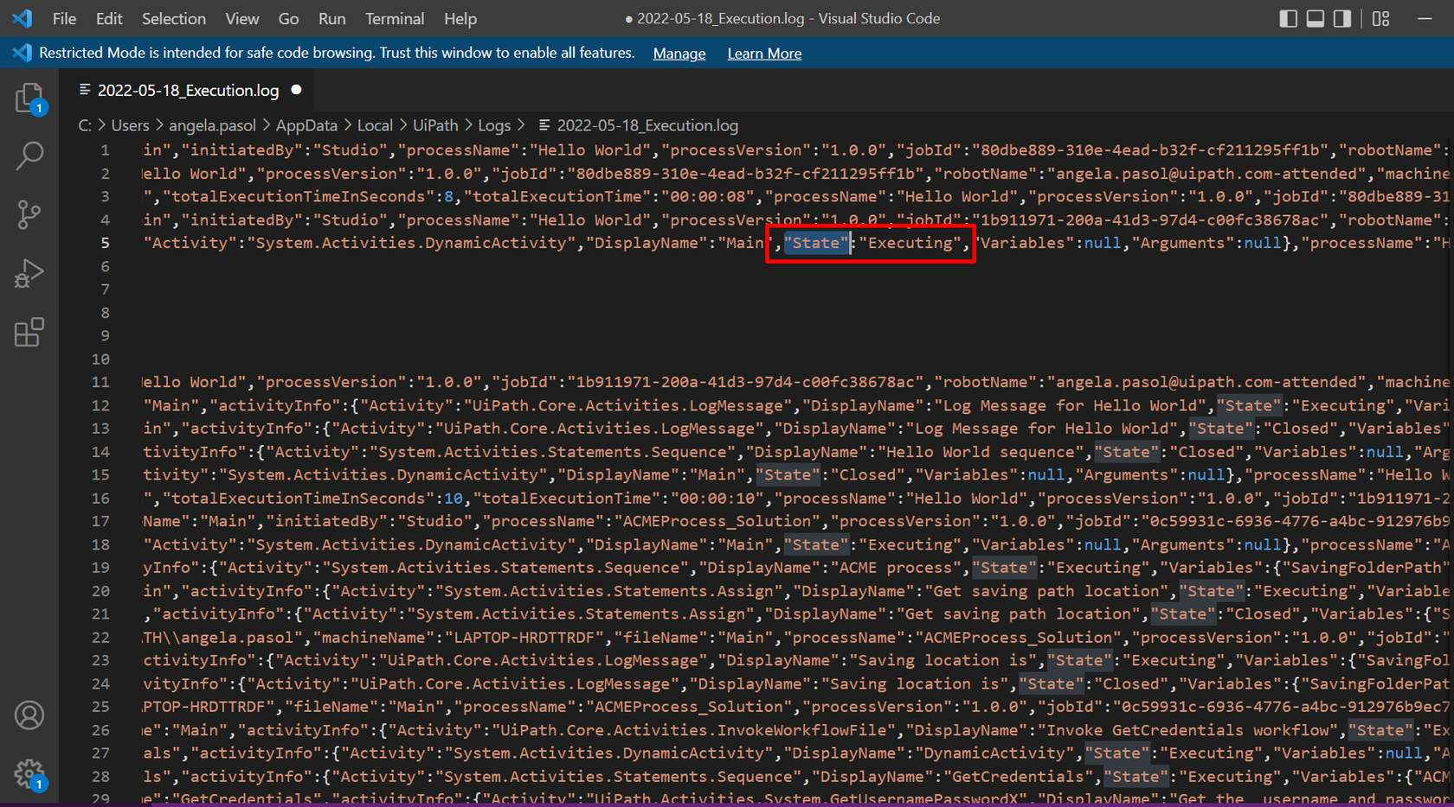

4)Variables and Arguments:

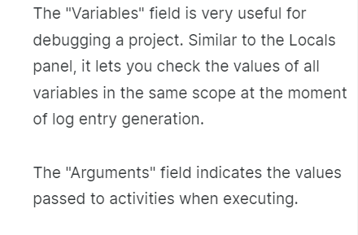

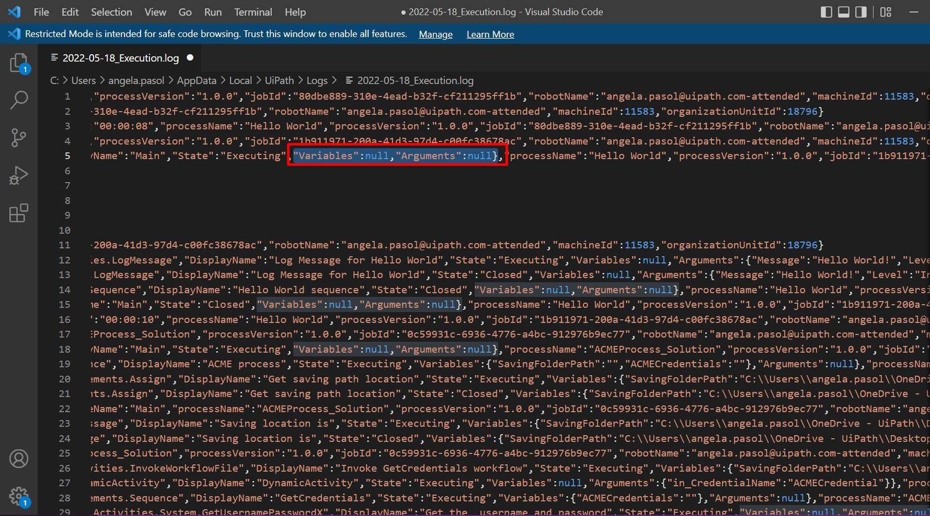

**Setting the log level for UiPath Assistant**

Running a process from UiPath Assistant will send the logs to Orchestrator if connected, but also generate logs in **%localappdata%\UiPath\Logs\<shortdate>_Execution.log**.

The log entries are generated at the level set in **UiPath Assistant**and above. For example, if the level is set to Error, it'll only generate the logs at the **Error** and **Fatal** levels.

**Logging Recommendations**

The solution is to define the right log messages at strategic points in your project. The recommendations below cover some healthy uses for identifying events that could lead to issues.

* Log message activities should ideally be used:
* each time an exception is caught in a Catch block (**Log level = Error**).
* each time a Business Rule Exception is thrown (**Log Level = Error**).
* when data is read from external sources. For example, log a message at Information level when an Excel file is read (**Log Level = Information**).
* in Parallel or Pick activities, log messages on every branch, to trace the branch is taken (**Log Level = Information**).
* in If/Flowchart Decision/Switch/Flow Switch activities. **Note:** there should not be more than two (maximum three) nested IF statements, so it depends from workflow to workflow if you should add or not log message activities.
* When you invoke a workflow use the two properties Log Entry and Log Exit (**Log level = Information**). These let you specify if you want to log entry into/ exit from an invoked workflow. This is particularly useful for debugging without adding lots of Log Message activities.
* Write meaningful log messages: the message should be clear enough.
* Add context to your log message: include values of meaningful variables in that context.

**Orchestrator Overview for RPA Developers**

**Introducing UiPath Orchestrator:**

**What is Orchestrator?**

Orchestrator is the component of the UiPath Platform for managing automations, robots, and the related entities. Although it comes with different cloud and on-premises delivery options, including persistence, high availability, and disaster recovery, users can access it through a simple web interface.

Orchestrator offers role-based access control and a structure of tenants and folders to replicate organizational structures. Users are able to run the automation workflows developed in Studio and published to Orchestrator using the unattended robot workforce. Furthermore, Orchestrator is used to manage and distribute licenses, as well as to store automation resources.

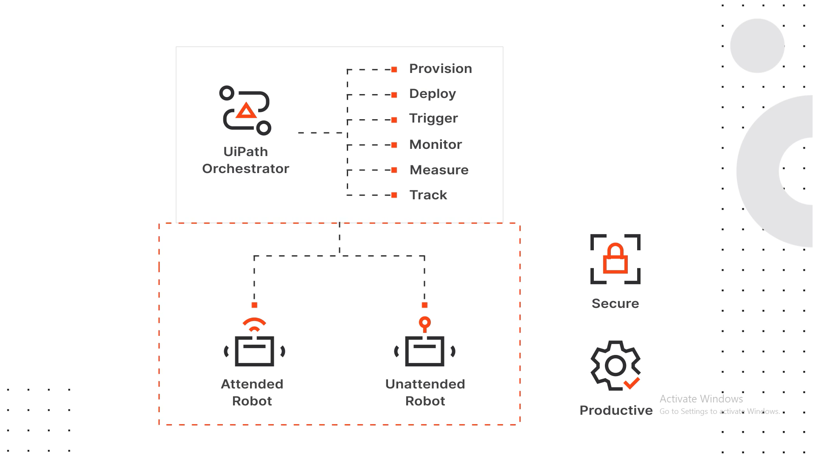

**Main Capabilities of Orchestrator:**

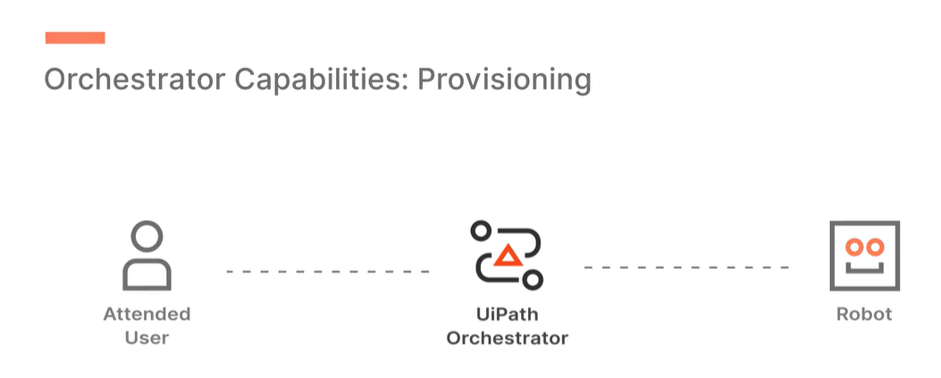

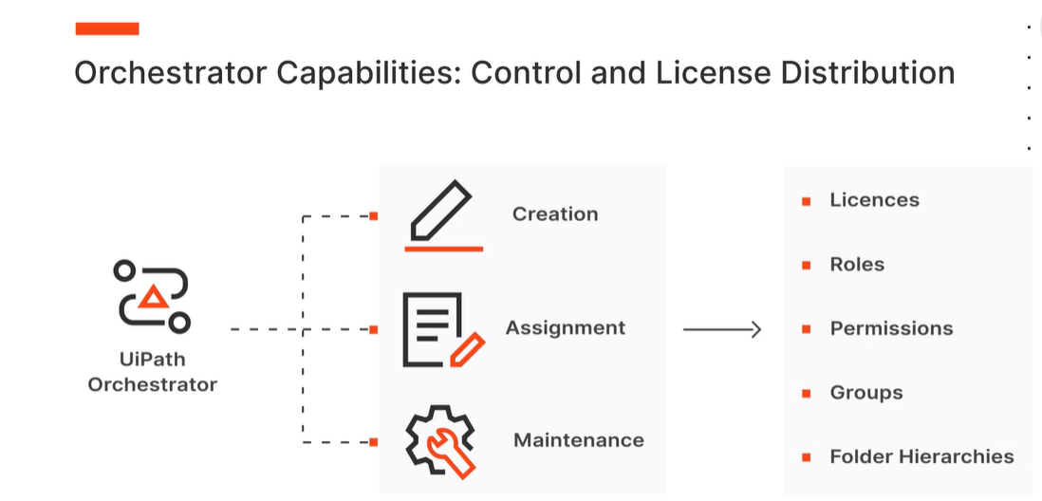

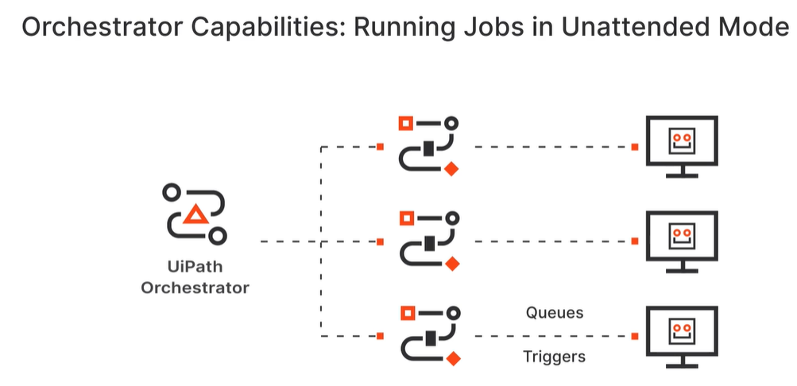

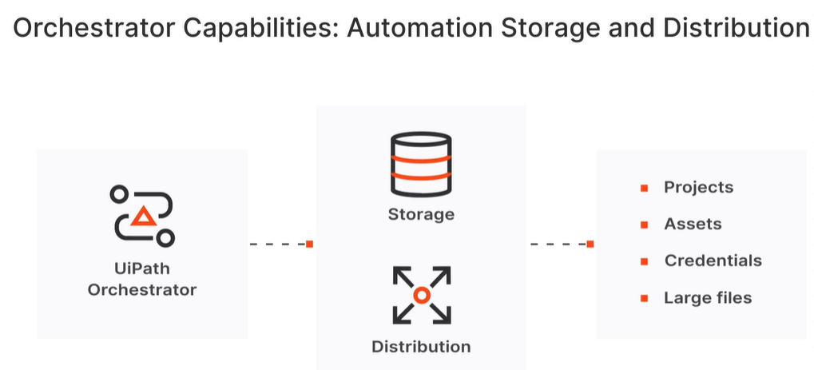

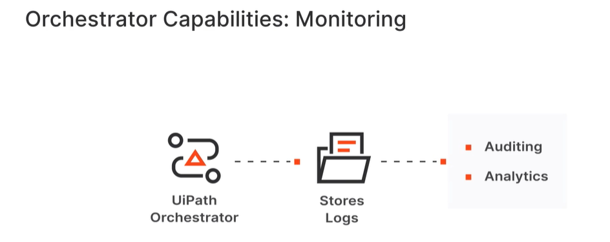

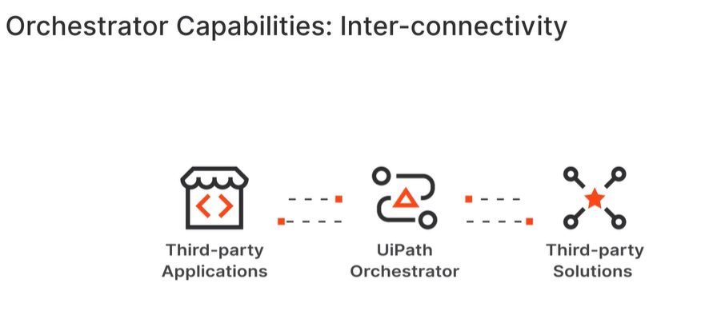

**Main capabilities of Orchestrator:**

**Provisioning:** Orchestrator creates and maintains the connection with robots and attended users.

**Control and license distribution:**Orchestrator also enables the creation, assignment, and maintenance of licenses, roles, permissions, groups, and folder hierarchies.

**Running automation jobs in unattended mode:** as presented earlier, it enables the creation and distribution of automation jobs in various ways, including through queues and triggers.

**Automation storage and distribution:** Orchestrator is the environment enabling the controlled storage and distribution of automation projects, assets, and credentials, as well as large files used in automations.

**Monitoring:** with Orchestrator, admins are able to monitor jobs and robots. It also stores logs for auditing and analytics.

**Inter-connectivity:** finally, Orchestrator acts as the centralized point of communication for third-party solutions or applications.

**why we need Orchestrator?**

-    It allows us to use large deployments of unattended robots.

-    Unattended Robots can do their work in executing automation jobs without the need for a human user to sign in at the start of the day.

-    We get a full view of all the robots and what they are doing at any given time.

-    We have the possibility to catch the logs and use additional software to analyze them and build reporting capabilities.

-    We can develop automation processes in such a way that robots get variable values, like passwords, and even files and assets from Orchestrator. This way our data is secure.

**Orchestrator Entities, Tenants, and Folders:**

**Orchestrator entities:**

**Robot (Orchestrator entity)**

–

By now you are familiar with UiPath Robot, the component of the UiPath Platform. This is an execution host that runs automation processes published in Orchestrator, as jobs.

In Orchestrator, a robot entity represents an image or the Robot component, controlling its connection and capabilities. The robot entity exists only if it is defined in relation to a user in Orchestrator.

**Folder**

–

Folders enable the separation and hierarchical organization of automation entities (processes, queues, assets) and the fine-grained configuration of roles and permissions. The hierarchical structure allows up to 6 sub-folders under each first level folder.

Folders help replicate the organizational hierarchies, with the separation of automated processes between teams, segregation of process data, and access control for users. At the same time, when it makes sense, they allow sharing of the resources and assets.

**Package**

–

A project developed in UiPath Studio that is published to Orchestrator as a NuGet package. Multiple versions of the same project can be stored and used.

Packages can also be manually uploaded to Orchestrator.

Additionally, by viewing the versions for a package you can download it from Orchestrator.

**Process**

–

It is a version of a package that's been allocated to a certain folder.

Given that most processes use a queue, asset, or storage bucket, the Package Requirements tab, for when adding a new process, makes it easy to identify which entities your package is using and if they are missing from your folder.

**Job**

–

A job represents the execution of a process on a UiPath Robot. You can launch the execution of a job in either attended or unattended mode. You cannot launch a job from Orchestrator on attended robots, unless for debugging purposes using personal workspaces, and they cannot run under a locked screen.

**Heartbeat -**

Attended and unattended robots send a heartbeat to Orchestrator every 30 seconds. This signals to Orchestrator that the connection is working.

**Tenants and folders**

Just like folders, tenants are meant to replicate organizational hierarchies within the same instance of Orchestrator.

From a hierarchy perspective, folders are subdivisions of tenants. And while in the folders case it's more about hierarchization and separation, tenants are clearly isolated from one another.

**Tenant entities:**

**User**

–

Both human users and robots are uniquely identified with users in Orchestrator.

**Machine (Orchestrator entity)**

–

These are Orchestrator entities corresponding to the workstations where human users and robots work. Using API keys, they enable the connection between the physical machines and Orchestrator.

**License**

–

The right to use Studio and/or Robots, both attended and unattended, is done through licenses. Licenses exist at tenant level, from where they get distributed to users, and consumed when the machines connect to Orchestrator.

**Webhook**

–

Webhooks facilitate the communication between Orchestrator and other applications at API level. These are mapped at tenant level, which means they cannot be differentiated between folders and will provide information for the entire tenant.

**Folder entities:**

**Asset**

–

An asset is a piece of data stored in Orchestrator for the use of robots. There are four types of assets:

* **Text**- stores only strings (it is not required to add quotation marks).
* **Bool** - supports true or false values.
* **Integer** - stores only whole numbers.
* **Credential** - contains usernames and passwords that the Robot requires to execute particular processes, such as login details.

Assets can have a global value or a value per user. This means that only the designated user will access a certain value stored in that asset.

**Storage bucket**

–

Storage buckets are entities used for storing files which can be used in automation projects.

**Queue**

–

Queues are containers that can hold an unlimited number of items, storing different types of data.

The process of feeding items to a queue is typically different from the process of processing the queue items, and handled by different robots.

**Trigger**

–

Triggers enable the execution of jobs in a structured manner. There are two types of triggers:

* Time triggers: with these, you can schedule the recurrent execution of a process.
* Queue triggers: these enable the execution of a process based on the new items added to a queue.

**Personal Workspaces:**

A personal workspace is a modern folder available for the dedicated use of a particular attended user. Personal Workspaces make it easy to deploy automations to your own robot, for easy regular execution, with the organizational benefits of logging, visibility, and potential reuse.

**Roles**

Roles are sets of permissions used to control the access of human users and robots to tenant and folder entities.

Each permission is defined from the combination of at least an action type (view, edit, create, and delete) and an entity, be it at the tenant or folder level. For example, you can set up the right to view only the queues in a certain folder, but not the queues from other folders.

**Standard roles for modern folders**

The following roles are pre-configured to manage permissions at the tenant level and at the folder level, which is required to work in modern folders.  
They are only available if you choose to create them for your tenant from Tenant > Settings > General. You can find below just an overview and more in-depth by identifying the resource at the end of this lesson.

| **Role** | **Level** |
| --- | --- |
| Tenant Administrator | Tenant |
| Allow to be Folder Administrator | Tenant |
| Folder Administrator | Folder |
| Allow to be Automation User | Tenant |
| Automation User | Folder |

**Logs in Orchestrator**

Logs are time-stamped files that contain informational events, errors, and warning messages relevant to the application. The UiPath Platform has logging capabilities for all of its main components. Logs are created locally of every robot and automation action, then sent to Orchestrator from where they can be filtered, viewed, and analyzed.

There are two types of Orchestrator logs:

**Diagnostic logs**

–

These are diagnostic logs generated by UiPath Orchestrator regarding its behavior.

**Execution logs**

–

These are logs generated by process execution.

The Logs page displays logs generated by Robots in all folders you have access to, including logs generated for jobs started through remote debugging sessions.

To access it, navigate to the Automations tab from a folder context, and select Logs tab.

Messages are logged on the following levels: Trace, Debug, Info, Warn, Error, and Fatal.

**Note:**

The robot in Orchestrator is not the same as the UiPath Robot component. The first one is an image of the latter, connects to it and controls its capabilities, but they are not the same.

**Robot Provisioning and License Distribution:**

**User and Robot accounts**

In Orchestrator, both human users with attended licenses (Robot or Studio) and unattended robots need to have a corresponding Orchestrator user.

Depending on the deployment type and the organizational setup, **users are added and managed** in different ways:

* Users can be added **locally**in on-premises, standalone Orchestrator.
* Users have to be added in **Automation Cloud**, then in cloud Orchestrator to grant them a license.
* Users can be added from **Active Directory**for both on-premises and cloud Orchestrator if the integration was configured beforehand.

**Robot accounts** have to be created in Automation Cloud, and they behave like user accounts regarding permissions. The only differences compared to user accounts are:

* Robot accounts are not allowed to have any interactive-related process configuration.
* No email address is required to create a robot account.

**Automatic robot creation**

To simplify the attended and unattended robot creation, as well as the license provisioning, the automation robot creation can be enabled at user level, for both attended and unattended robots, and at group level for attended robots.

Basically, you enable the Attended Robot or Unattended Robot toggle at the account or group level, configure the various settings (robot execution settings, machine login credentials, if applicable), and a floating robot with those attributes is created.

**Machine templates**

Robots run on physical or virtual workstations. These are mirrored in Orchestrator by entities called machines. The machines in Orchestrator work as API key generators, authorizing the connection between the robots and Orchestrator.

There are two types of machines in Orchestrator:

* **Machine templates**: this allows the connection to multiple workstations with a single API key.
* **Standard machines**: this allows the connection between Orchestrator and a single machine. This is suitable for scenarios in which robots need to run on specific machines.

**License distribution**

In Orchestrator, licenses are also called **runtimes**. They are allocated at machine template level, under Machines in the Tenant menu.

The number of runtimes allocated there should be **matched** with the maximum number of users which can run on a single machine connected using that machine template. On a regular Windows machine, only one user can run. But on a Windows server machine, multiple users can run simultaneously.

Licenses are **consumed**as soon as a machine is connected to Orchestrator, no matter the number of users running on it.

**Unattended Automation With Folders:**

### The use of folders and job priorities

By accurately reflecting the business hierarchies with the help of folders, roles and permissions, we can control the access to automation processes and make sure the effort is spent where it brings the most return. Job priorities can ensure that business priorities are well reflected in the automation process.

### The separation of processes based on UI interaction

Processes in Orchestrator are now differentiated between those that interact with the user interface (known as foreground processes) and those that don't, called background or headless processes.

This has a significant impact on the way automation jobs are executed. An unattended robot can simultaneously run a foreground job and as many headless jobs as available runtimes on a machine.

### The license allocation per machine

Allocating licenses (runtimes) per machine ensures that their consumption is optimized. For example, on a Windows Server machine, multiple robots can open sessions and run unattended jobs up to the maximum number of runtimes.

### Custom job allocation strategies

Unattended automation was designed in Orchestrator to ensure resource optimization and effectiveness. But there are cases in which business logic is more important. Orchestrator offers a couple of features and options to allow the customization of the job allocation process so that certain jobs or resources are available only to certain users.

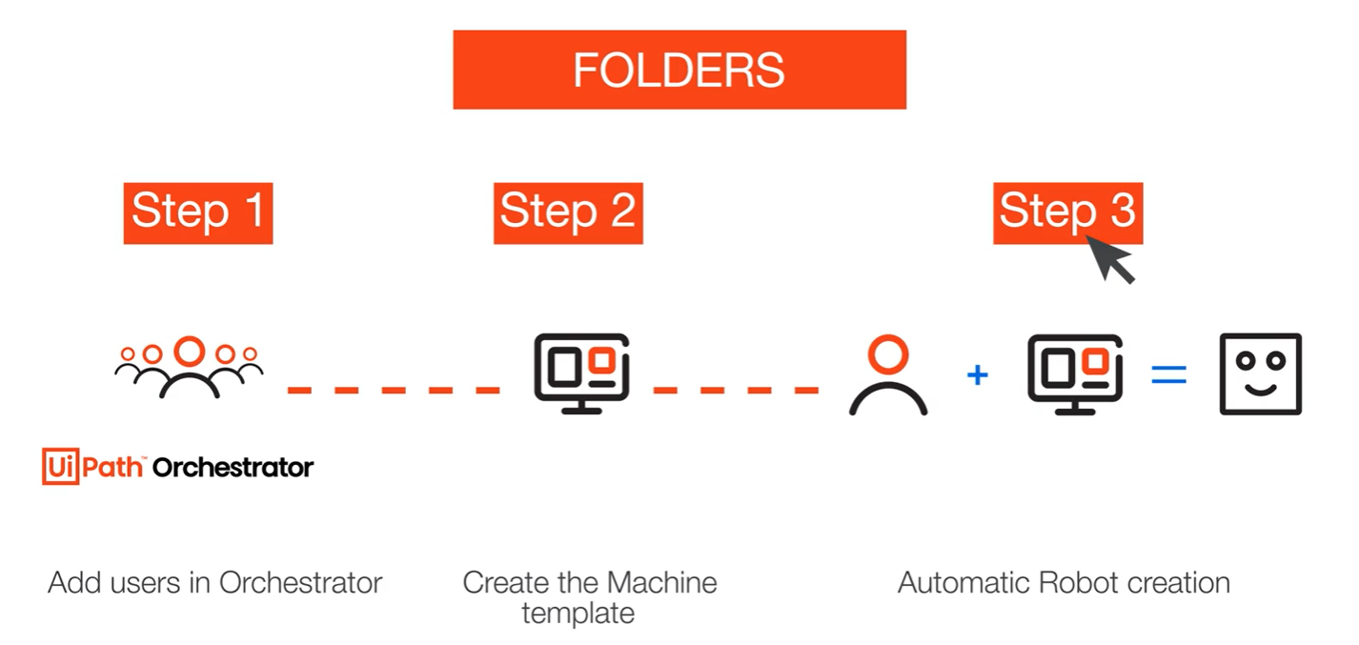

**background and foreground processes**:

**A background process**, also called a headless process, refers to a job that runs without interacting with any sort of UI. When built in UiPath Studio, a process needs to be set to start in the background.

On the other hand, **foreground processes** use graphical UI. Based on this differentiation, a foreground process can run in parallel with one or more background processes in attended automation, for example.

**Working with Orchestrator Resources:**

**Orchestrator Resources in Studio:**

The deep integration between Orchestrator and Studio, through the interactive sign-in feature, allows RPA Developers to work directly with folder entities like queues, assets, and processes.

* 1. **Assets**
  2. **Queues**
  3. **Processes**

**Libraries and Templates in Orchestrator:**

**Publishing and installing libraries with Orchestrator**

Among many other features of automation and robot management, Orchestrator can also be used to store libraries and templates for extra reusability. This way, all the developers in a company can use Orchestrator as a way to share development assets and ensure the right versions are used.

**Storage Buckets:**

## *What are Storage Buckets?*

Storage buckets are Orchestrator entities used for storing files which can be used in automation projects. UiPath Studio offers a set of activities to simplify working with storage buckets. These activities are available in the UiPath.System.Activities pack, under Orchestrator.

Storage buckets can be created using the Orchestrator database or some external providers, such as Azure, Amazon, or MinIO. Each storage buckets is a folder-scoped entity, allowing fine-grained control over storage and content access.

## *Why do you need Storage Buckets?*

UiPath Studio offers many options to work with files in automation projects. In certain contexts, storage buckets may be the best way: for example, when you need to use large files stored in a centralized location or when you need to grant access to multiple robots in a controlled way.

**Queues:**

## *What are queues?*

Queues are containers that can hold an unlimited number of items. Items can store multiple types of data, by default in free form. If a specific data schema is needed, it can be uploaded at queue creation in the form of a JSON file.

Queues in Orchestrator will store items and enable their distribution individually to robots for processing. They also monitor the status of the items based on process outcomes. As soon as the queue items enter processing, they become transactions. Items are meant to be indivisible units of work: a customer contract, an invoice, a complaint, and so on.

## *Why do you need queues?*

Working with queues is very useful in large-scale automation scenarios underlined by complex logic. Such scenarios pose many challenges—bringing items from multiple sources together, processing them according to a unique logic, efficient use of resources, or reporting capabilities at individual item and queue level, including the use of SLAs.

Consider the customer enrollment process through forms for a retail company: customers may come from different sources (online, partners, own shops, call center), thus having a smooth process of adding them to the processing line is crucial. Further on, working with queues will ensure that these are processed within the SLA time constraints.

**Populating and consuming queues**

To ensure an optimal use of the robots, queues are typically used with the Dispatcher-Performer model of running automations. In this model, the two main stages of a process involving queues is separated:

* The stage in which data is taken and fed into a queue in Orchestrator, from where it can be taken and processed by the robots. This is called **Dispatcher**.
* The stage in which the data is processed. This is called **Performer**.

Working with queues and queue items is done using the specific activities from the UiPath. System.Activities official package, under Orchestrator. These are:

**Add Queue Item**

–

When encountering this activity in a workflow, the robot will send an item to the specified queue and will configure the timeframe and the other parameters.

Two of the properties that are worth highlighting are:

* Deadline—add a date until which the items must be processed.
* Priority—select Low, Normal, or High, depending on the importance of the items that are added by this activity and how fast you want them to be processed.

**Add Transaction Item**

–

The robot adds an item in the queue and starts the transaction with the status 'In progress'. The queue item cannot be sent for processing until the robot finalizes this activity and updates the status.

**Get Transaction Item**

–

Gets an item from the queue to process it, setting the status to 'In progress'.

**Postpone Transaction Item**

–

Adds time parameters between which a transaction must be processed.

**Set Transaction Progress**

–

Enables the creation of custom progress statuses for In Progress transactions. This can be useful for transactions that have a longer processing duration, and breaking down the workload will give valuable information.

**Set Transaction Status**

–

Changes the status of the transaction item to Failed (with an Application or Business Exception) or Successful. As a general approach, a transaction failed due to Application Exceptions will be retried, and a transactions failed due to Business Exceptions will not be retried.

Within any given queue the transactions are processed in a hierarchical manner, according to this order:

Items that **have a Deadline**, as follows:

1. in order of **Priority**—**and**
2. according to the set **Deadline** for items with the **same Priority.**

Items with **no Deadline**, in order of **Priority—**and

1. according to the rule **First In**, **First Out** for items with the **same Priority.**

**Queue item statuses**

A queue item can have one of the statuses below. These will be set automatically following human user and robot actions, and/or using the Set Transaction Status activity. Custom sub-statuses can be set for queue items which are 'In Progress', using the Set Transaction Progress activity.

**New**

–

* The item was just added to the queue with Add Queue Item, or
* the item was postponed, or
* a deadline was added to it, or
* the item was added after an attempt and failure of a previous queue item with auto-retry enabled.

**In Progress**

–

The item was processed with the Get Transaction Item or the Add Transaction Item activity.

When an item has this status, the custom progress status is also displayed, in the Progress column.

**Failed**

–

The item did not meet a business or application requirement within the project.

It was therefore sent to a Set Transaction Status activity, which changed its status to Failed

**Successful**

–

The item was processed and sent to a Set Transaction Status activity, which changed its status to Successful.

**Abandoned**

–

The item remained in the In Progress status for a long period of time (approx. 24 hours) without being processed.

**Retried**

–

The item failed with an application exception and was retried (at the end of the process retried, the status will be updated to a final one - Successful or Failed.

**Deleted**

–

The item has been manually deleted from the Transactions page.

Below Diagram for reference:

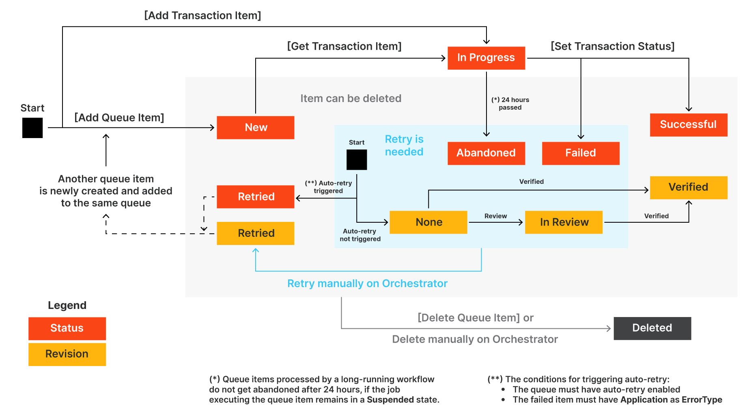

**Transactions and Types of Processes:**

**Linear**

The process steps are performed only once. If the need is to process different data, the automation needs to be executed again. For example, an email request coming in triggers an automation which gathers data and provides a reply to the sender. The process is executed for each individual email.

Linear processes are usually simple and easy to implement, but not very suitable to situations that require repetitions of steps using different data.

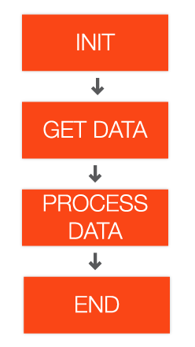

**Iterative**

The steps of the process are performed multiple times, but each time different data items are used. For example, instead of reading a single email on each execution, the automation can retrieve multiple emails and iterate through them doing the same steps.

This process implementation is done with a simple loop. But it has a disadvantage—if a problem happens while processing one item, the whole process is interrupted and the rest of the items remain unprocessed.

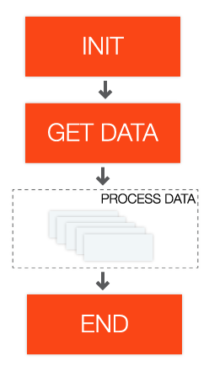

**Transactional**

Similar to iterative processes, the steps of transactional processes repeat multiple times over different data items. However, the automation design is such that each repeatable part processes independently.

These repeatable parts are then called transactions. Transactions are independent from each other because they do not share any data or have any particular order to be processed.

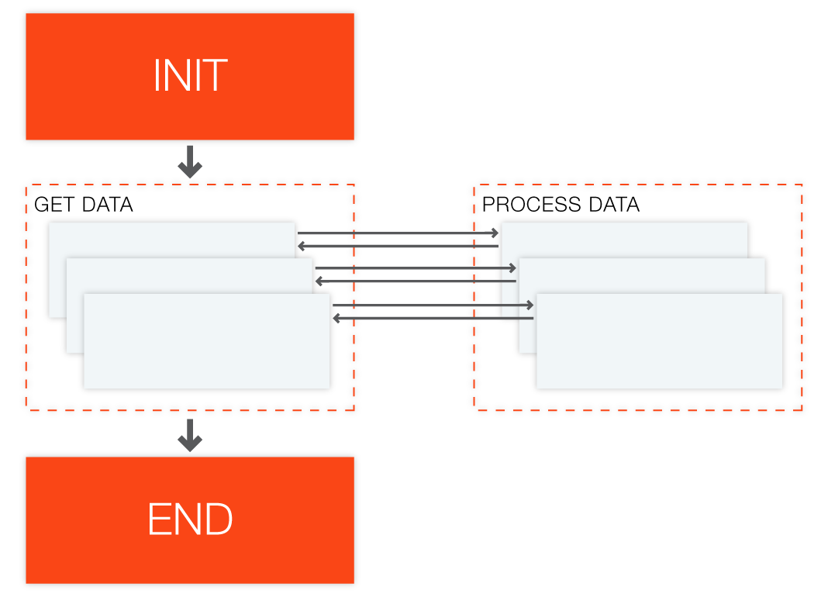

**What is a transaction?**

A transaction represents the minimum (atomic) amount of data and the necessary steps required to process the data, by fulfilling a section of a business process. A typical example would be a process that reads a single email from a mailbox and extracts data from it.

We call the data atomic because once it is processed, the assumption is that we no longer need it as we advance with the business process.

**What are some business scenarios in which I will use transaction processing?**

1) You need to read data from several invoices that are in a folder, and input that data into another system. Each invoice can be seen as a transaction, because there is a repetitive process for each of them (i.e. extract the data and input it somewhere else).

2) There is a list of people and their email addresses in a spreadsheet, and an email needs to be sent to each of them along with a personalized message. The steps in this process (i.e., get data from spreadsheet, create personalized message, and send email) are the same for each person, so each row in the spreadsheet can be considered a transaction.

3) When looking for a new apartment, a robot can be used to make a search according to some criteria. For each result of the search, the robot extracts the information about the property and inserts the data into a spreadsheet. In this case, the details page for each property constitutes a transaction.

**Email Automation with Studio**

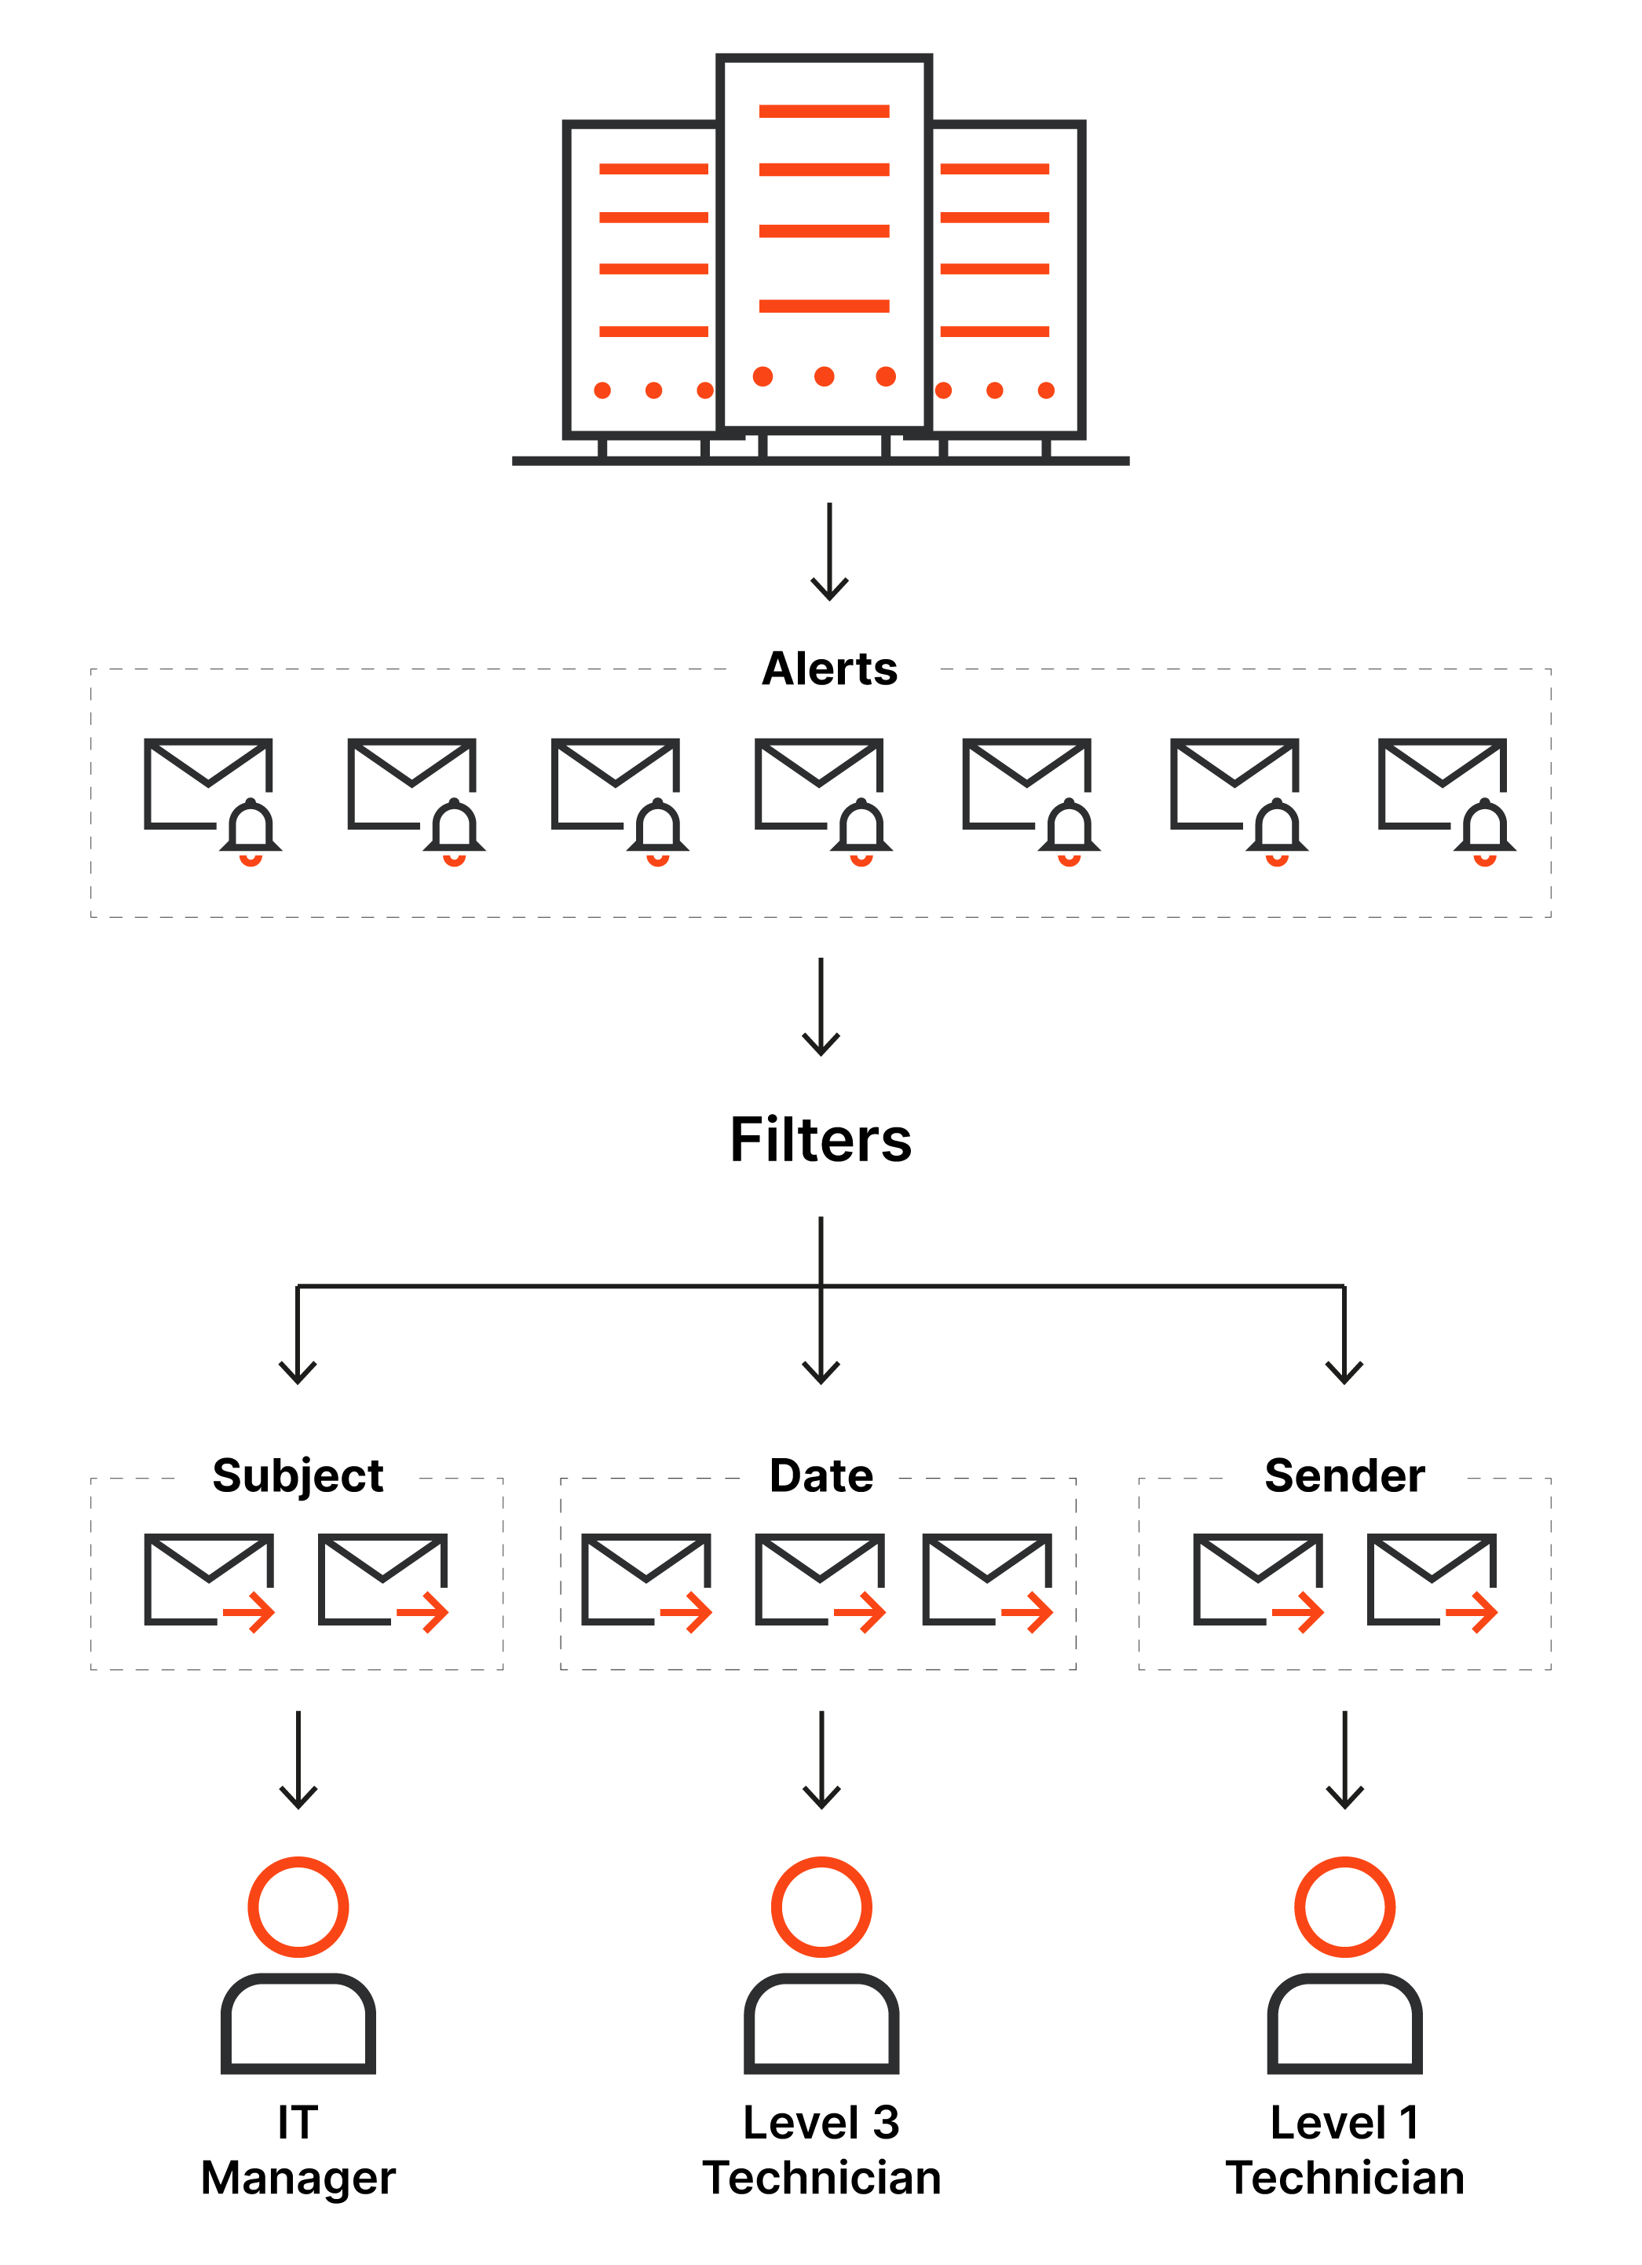

**Retrieving Emails:**

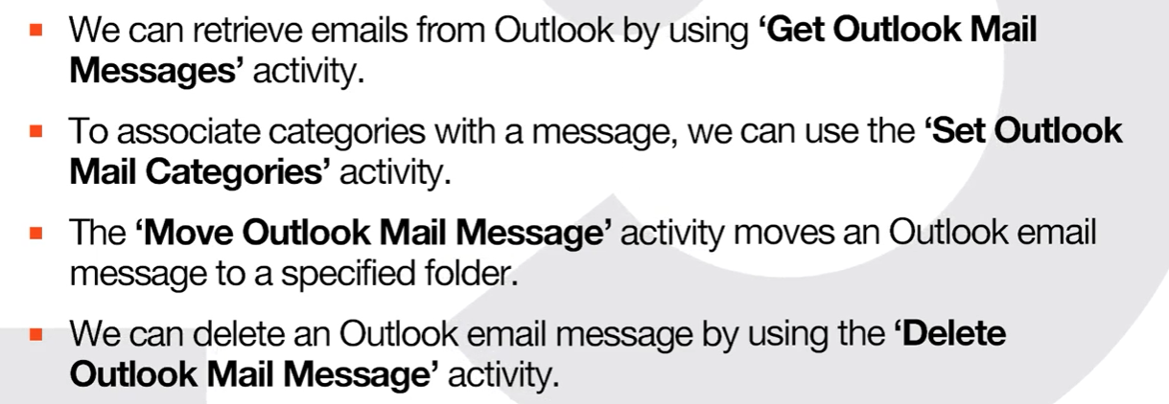

**Filtering Emails:**

In the Mail Activities Package, there are two main ways to filter emails:

* By using control flow activities.
* By using 'Get Outlook Mail Messages' activity.

The filtering options provided with 'Get Outlook Mail Messages' are:

**Filter**

–

A string used as a filter for the messages to be retrieved. Accepts JET queries or DASL queries.

Let's assume that you use Outlook and need to retrieve only the email messages that have "Critical" in the beginning of the subject line.

In this case, you can also use SQL filtering, and your expression would look like this:

"**@SQL=""urn:schemas:httpmail:subject"" like 'Critical%**'"

**FilterByMessageIds**

–

Returns only mail messages that match the specified message IDs. If set, the Filter option is ignored.

**OnlyUnreadMessages**

–

Specifies whether to retrieve only unread messages. By default, this check box is selected.

**Top**

–

The number of messages to be retrieved starting from either the newest or the oldest, depending on the OrderByDate parameter.

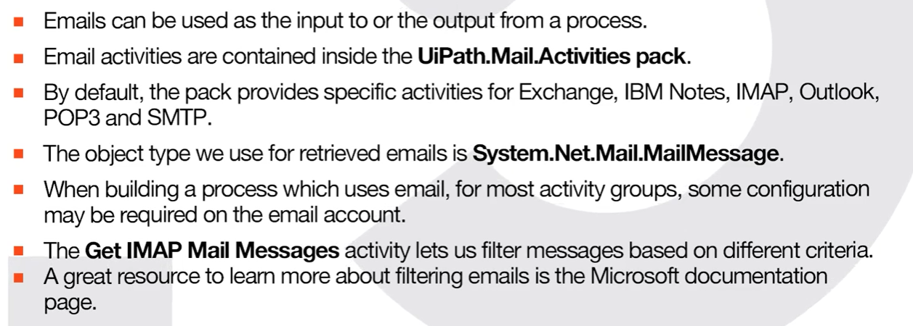

**Sending Emails:**

'**System.Net.Mail.MailMessage**' represents the main data type when working with emails in UiPath. You will be using this data type whenever you need to get or forward email messages.

When sending an email using one of the email activities in Studio, you can add a subject, custom body, attachments, or even use a template to do all these. You can also use an **Orchestrator Asset** or the '**Read Text File**' activity to access a template.

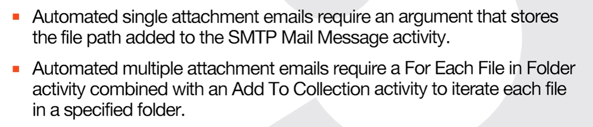

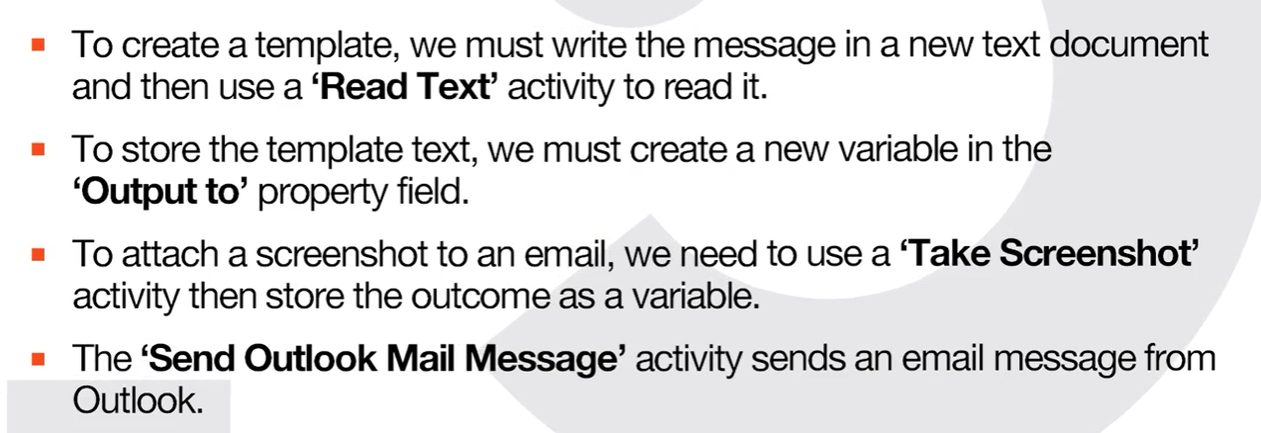

**PDF Automation with Studio**

**Types of PDF:**

**Native PDF**

–

A PDF file that is originally generated in a computer, aka "born digital", meaning that it was created from an original electronic version of a document. One quick way to tell that a PDF is native is that you can select blocks of text in the file.

**Scanned PDF**

–

A PDF file that is made up of scanned images of a given document. With scanned PDFs you will not be able to select text or use the search function because the PDF is a collection of images.

In PDF automation, data can be extracted using two separate activities:

* 1. Extract data using Read PDF Text activity.
  2. Extract data using Read PDF with OCR activity.

Read PDF Text is the more accurate of the two, but works only with native PDF documents. Read PDF with OCR is less reliable, but can extract text from scanned PDF documents. The second option also requires the selection of an OCR engine.

**Extracting a Single Piece of Data From PDF:**

We can add and configure the Get Text activity by using:

**🡪 Activity Panel and Recorder**

**Extracting Data Using Anchor Base:**

The Anchor Base activity is used to identify an element with an unstable selector relative to an element with a stable one. For example we may want to get a value from a PDF invoice. The value UI element has an unstable selector while the label element is stable.

This activity is made up of two blocks, as it performs an action in relation to another fixed element or anchor:

* The **Anchor**block: Supports only the Find Element or Find Image activities. Identifies the UI element to be used as an anchor.
* The **Action**block: Supports UI interaction activities for the target element. Most often for PDF, we will use the Get Text activity to retrieve the text in the target UI element.

**Version Control Systems Integration in Studio**

**What are version control systems?**

Version control systems are tools used by software development teams to manage the collaboration on large projects.

A version control system allows developers to track a code change, review the history of the code, and revert to a previous version of the project, if needed.

**Here are some benefits of using version control systems:**

**Enhanced collaboration**

–

Team members can work freely on any file at any time and merge the changes into a common version at the right time.

**Storing versions**

–

Only the current version is stored on the disk, all the others are in the system.

**Restoring previous versions**

–

Restore older versions of the file at any time.

**Tracking different project versions**

–

New versions are usually saved with change descriptions. Versions of the same file can also be compared.

The version control systems UiPath Studio is integrated with are **Git**, **TFS**, and **SVN**.  The connection to a version control system is done at project level. To manage your connections, access Studio, go to the **Backstage view,** and click the **Team** tab.

Alternatively, the Add to Source Control button in the status bar offers shortcuts to **Git Init**, **Copy to Git**, **Add to TFS**, and **Add to SVN**.

**Note:**You cannot connect a project to Git, TFS and SVN at the same time.

**A Closer Look at Git:**

**Git Overview**

Git is an open-source version control system. Git is distributed, unlike older centralized version control systems such as SVN and CVS, which allows every developer to have a complete history of their code repository locally. This makes the initial clone of the repository slower, but subsequent operations such as commit, blame, diff, merge, and log dramatically faster.

Git also has good support for branching, merging, and rewriting repository history. The pull request is one popular feature that allows teams to collaborate on Git branches and efficiently review each other’s code. Git is the most widely used version control system in the world and is considered the modern standard in software development.

**How Git works?**

Here is a basic overview of how Git works:

1. Create a **repository** (project) with a Git hosting tool.
2. **Copy or clone** the repository to your local machine.
3. Add a file to your local repository and **commit** (save) the changes locally.
4. **Push** your changes to the remote repository.5
5. **Pull** the file to local repository and make changes, and then **commit** and **push** the file.
6. Create a **branch** (alternative), make a change, commit the change.7
7. Open a **pull request** (propose changes to the master branch).8
8. **Merge** your branch to the master branch.

**SVN:**

With a centralized system, the **SVN**version control system stores all files and historical data on a central server. The developers commit their changes to this central server repository.

**Trunk:**The trunk is the hub of your current, stable code and product. It only includes tested, unbroken code.

**Branches:**Here you add the new codes and features. Using a copy of the trunk code, team members conduct research and development in the branch. This allows each team member to work on the enhanced features without disrupting each other’s progress.

**Tags:** Tags are a duplicate of a branch at a given point in time. Tags are not used during development but are used during deployment after the branch’s code is completed. Marking code with tags makes it easy to review and, if necessary, revert your code.

**Git:**

Git uses a central repository and a series of local repositories. Local repositories are exact copies of the central repository containing their complete history of updates.

The Git workflow is similar to SVN, but with an extra step. To create a new feature, we need to take an exact copy of the central repository to create our local repository on your local machine (consider this as our “local trunk”).

Then we work on our local repository exactly as we would in SVN by creating new branches, tags, etc. When we’re done, we merge our branches into our local repository (i.e. local trunk). When we’re ready to merge into the central repository, we push our changes from our local repository to the central repository.

Some of the benefits include the following:

* It's faster to commit.
* No more single point of failure.
* It's available offline

**The Status bar**

Now that we've seen some of the most important features in the UiPath Studio - GitHub integration, let's take a moment to check what the Status Bar can tell us at a glance.

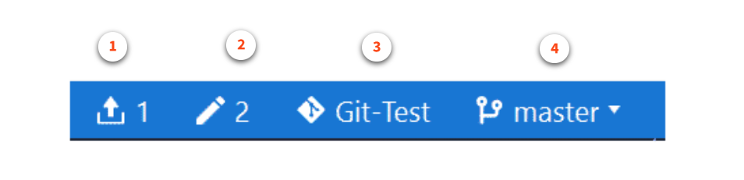

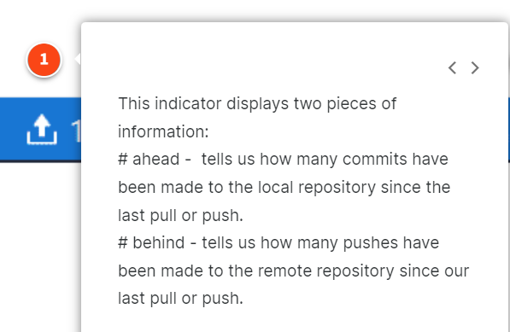

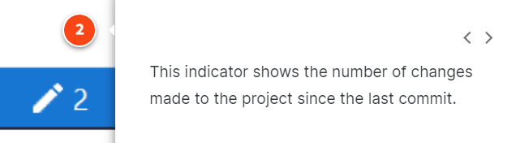

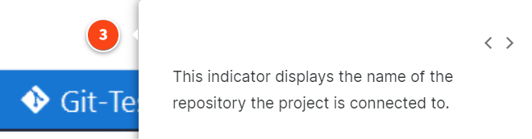

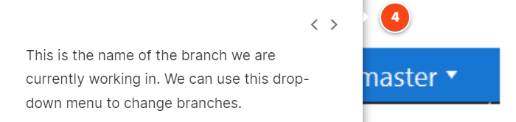

**RPA Testing With Studio**

RPA is software. It goes through all the software development stages, including testing. RPA testing deals with issues that are typically discovered in production, but aims to do it as early as possible in the process.

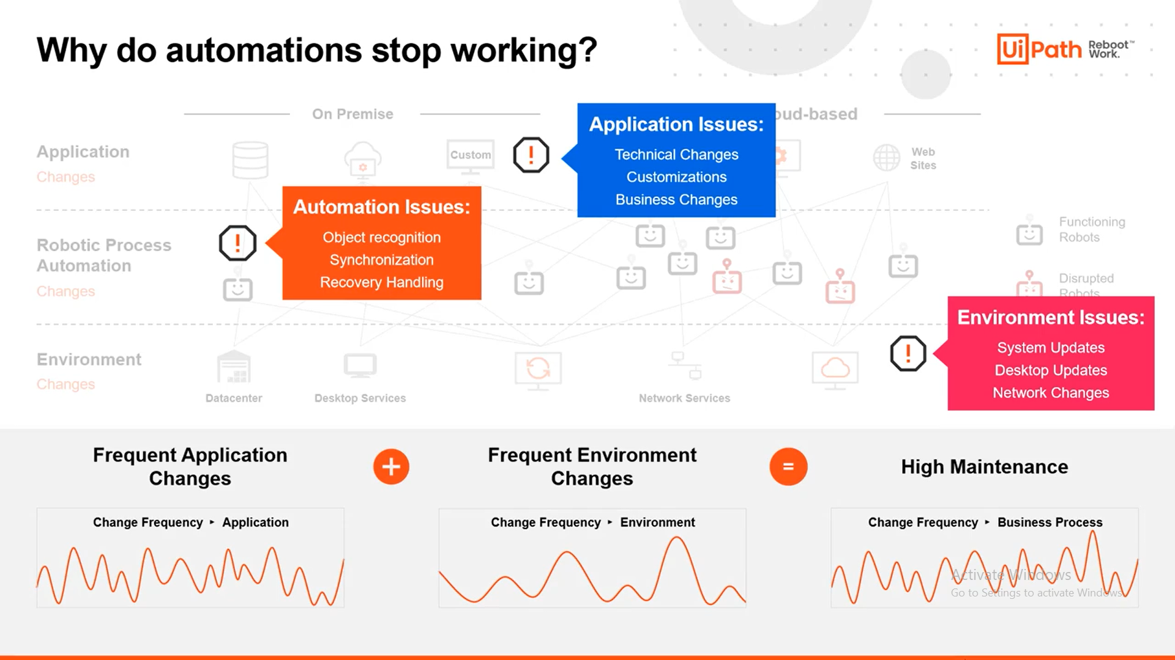

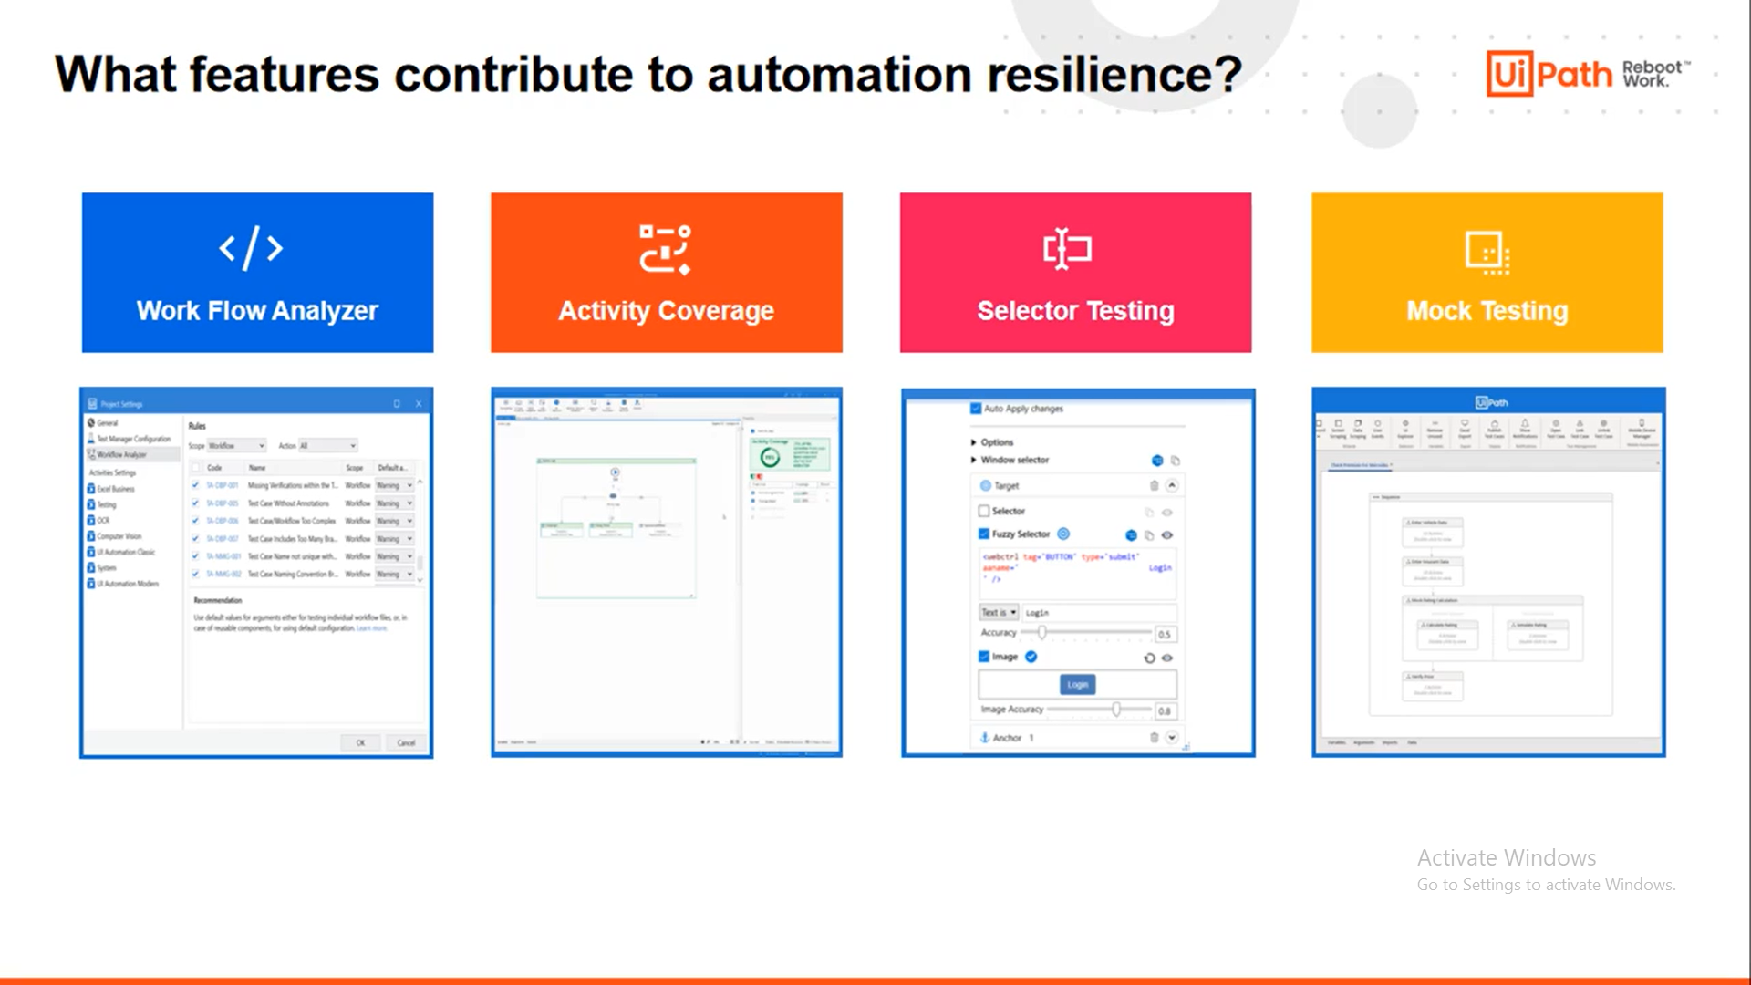

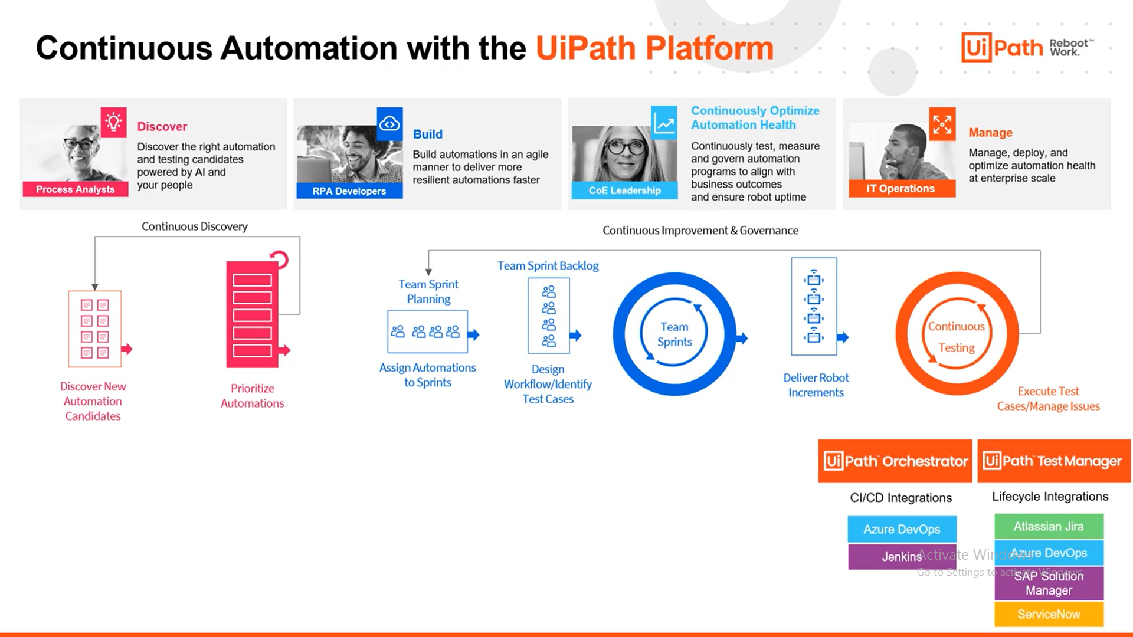

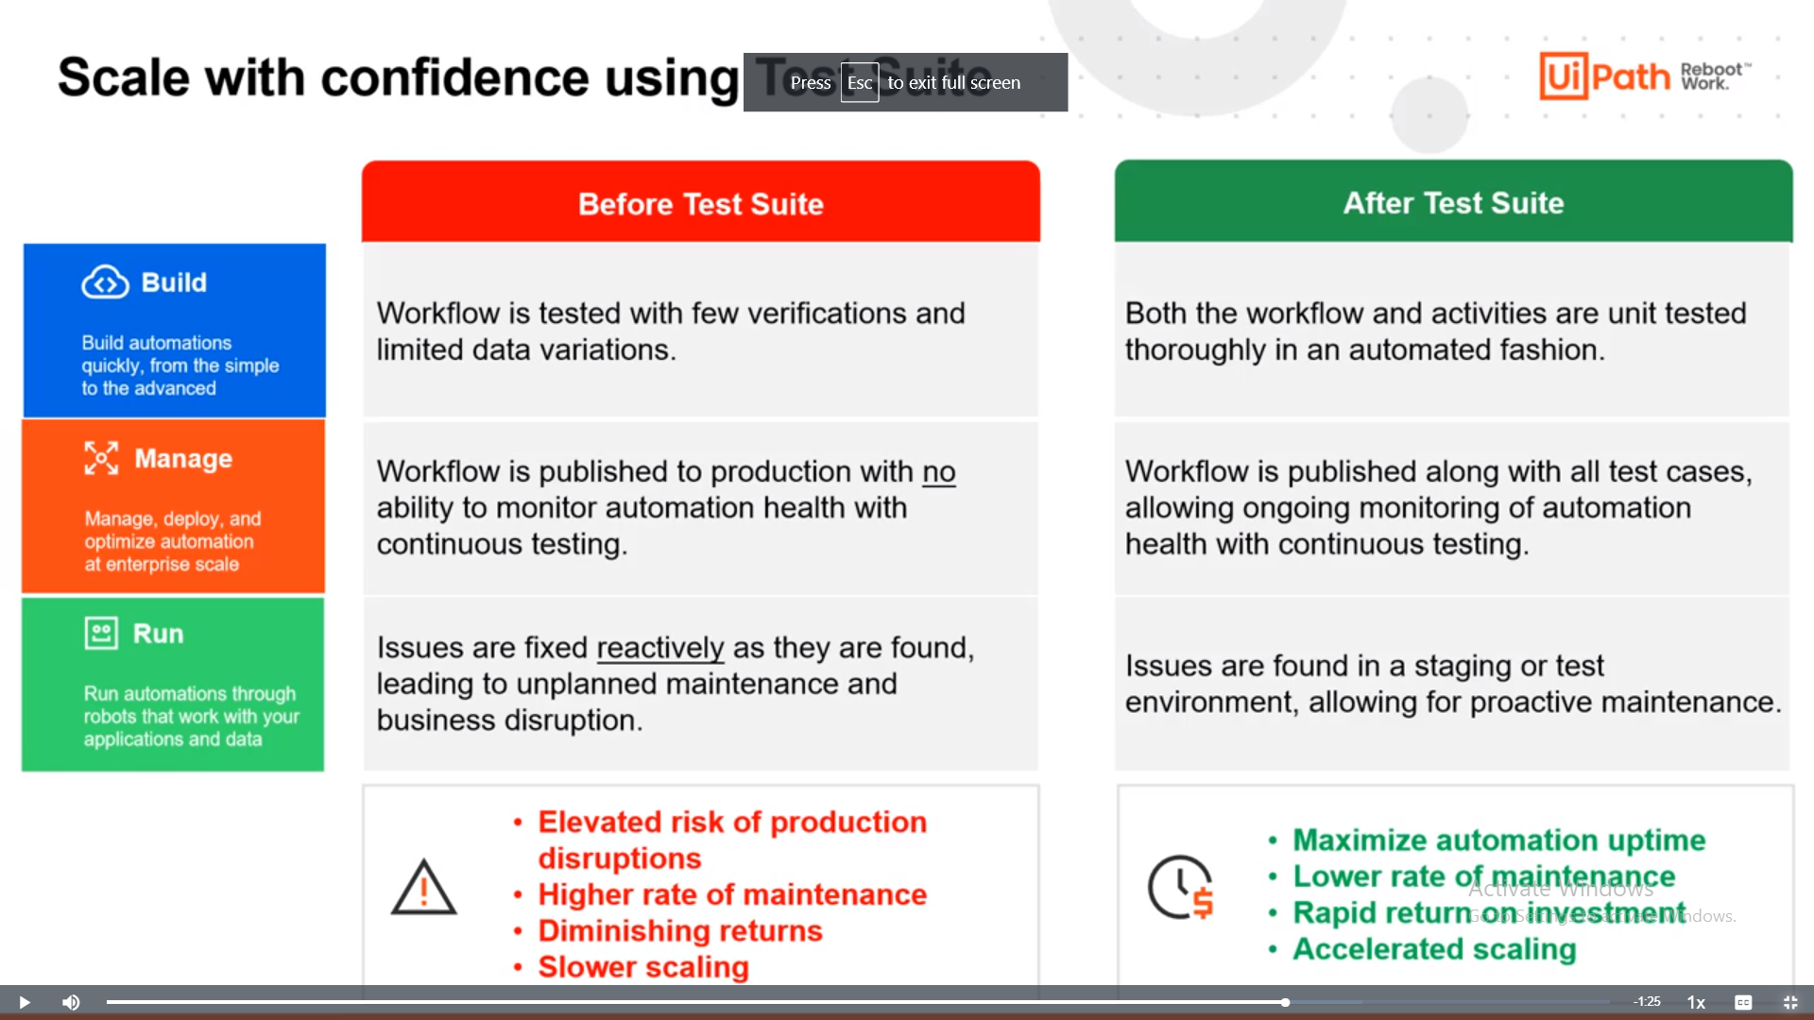

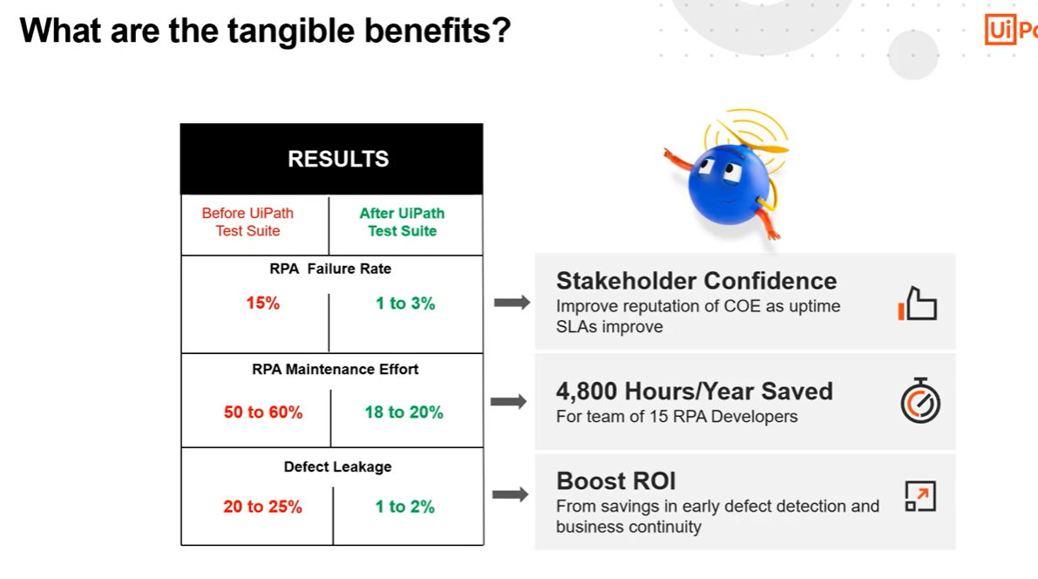

**Levels of RPA testing**

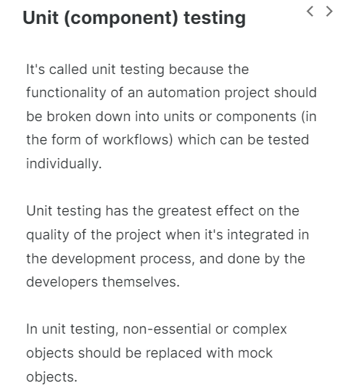

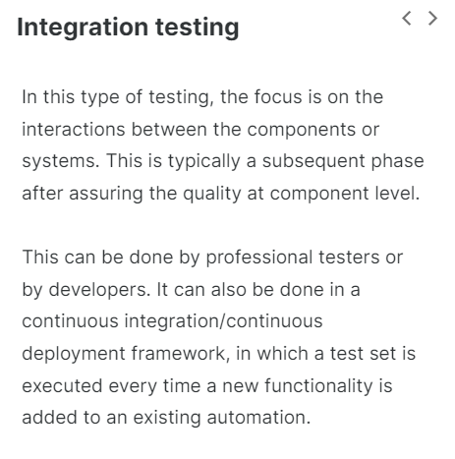

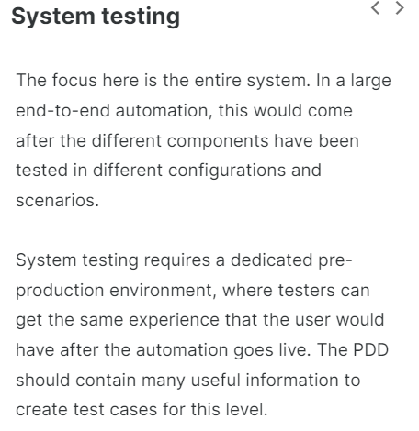

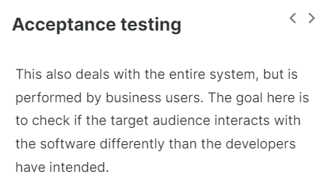

**Note: RPA testing can be done in development to tackle automation issues, as well as application issues. The environment issues are best addressed in the pre-production environment, by the IT Ops teams.**

**Creating Test Cases:**

UiPath Test Suite offers a complete solution for RPA testing during automation development, as well as during integration and before moving it into production. Depending on the deployment model, RPA testing can be integrated in a continuous integration environment.

But the first goal of RPA testing—at least chronologically—is to address application issues and automation issues as early as possible, in the RPA development phase.

Test Cases are one of the features in Studio that enable you to test your automations as you develop them.

**The structure of a test case**

The easiest way to create an RPA test case is to right-click a workflow in the Project panel and select "Create test case". The test case thus created will have the behavior-driven development structure.

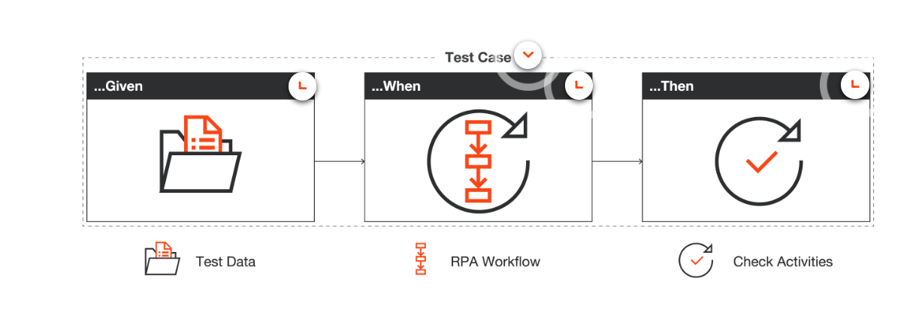

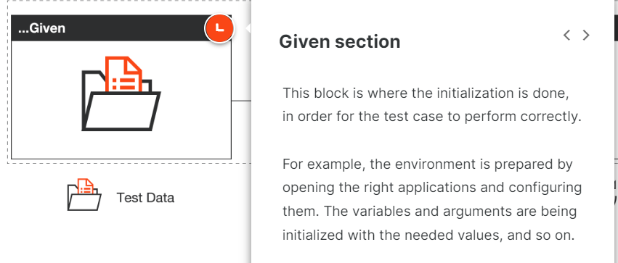

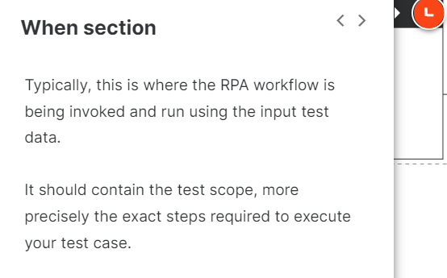

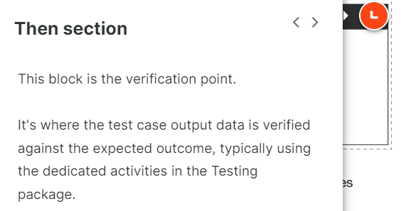

**The verification activities:**

**Verify Expression**

–

This activity verifies a single expression (e.g. whether two variables are equal). Its outcome can be True or False.

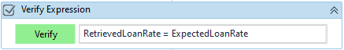

**Verify Expression with Operator**

–

This activity compares the outcomes of two expressions, variables or arguments using six predefined operators. Its outcome can also be True or False.

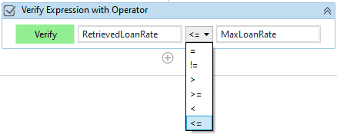

**Verify Control Attribute**

–

This is the most versatile activity in the Testing Activities Package. It allows the comparison of a property returned by another Activity with an expression, variable or argument. Its outcome can also be True or False.

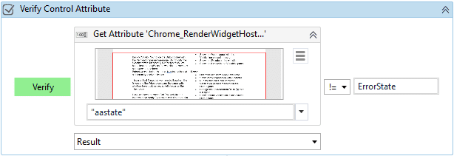

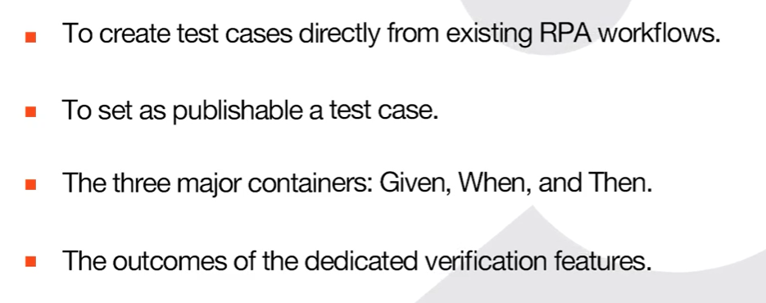

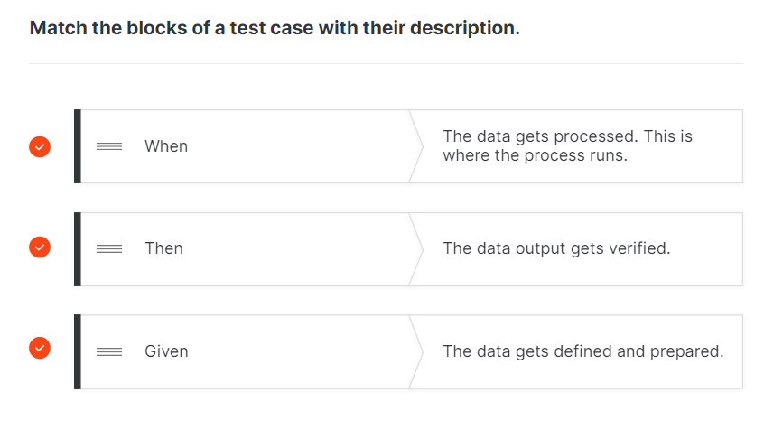

**Basic and Data-driven RPA Test Cases:**

**Basic vs. data-driven test cases**

Basic test cases run with a single set of data, and typically verify the outcomes against static values. To test an RPA workflow in different scenarios, data-driven testing is used. This typically uses an Excel file containing data variations, and the test case runs once for each chosen data set.

A basic test case can be easily converted to a data-driven one by adding the file with the data variations. When doing so, arguments are automatically created with the names of the columns in the data variation file.

**The Test Explorer Panel:**

The Test Explorer panel shows information relevant to test automation. We can use the Test Explorer panels to group tests together, perform debugging, or analyze the activity coverage.

To show only relevant information, you can use the Test Explorer toolbar to filter test results based on result state. Additionally, you can use multiple options to run the test cases again.

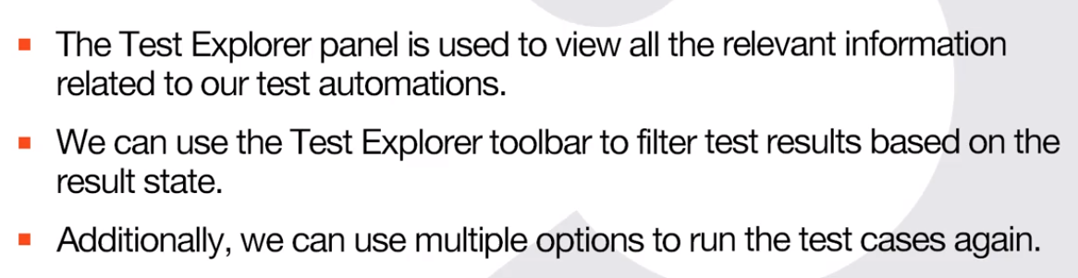

**Mock Testing:**

Automation projects often deal with business applications lacking a separate non-production environment. In such cases, testing the RPA workflows during development can become risky, through the effects in production, or costly, through the special resources needed.

Mock testing, or mocking, offers a way of replacing dependencies by creating objects that simulate the behavior of real objects. These objects are typically out of scope for the testing effort, at least in the unit testing stages.

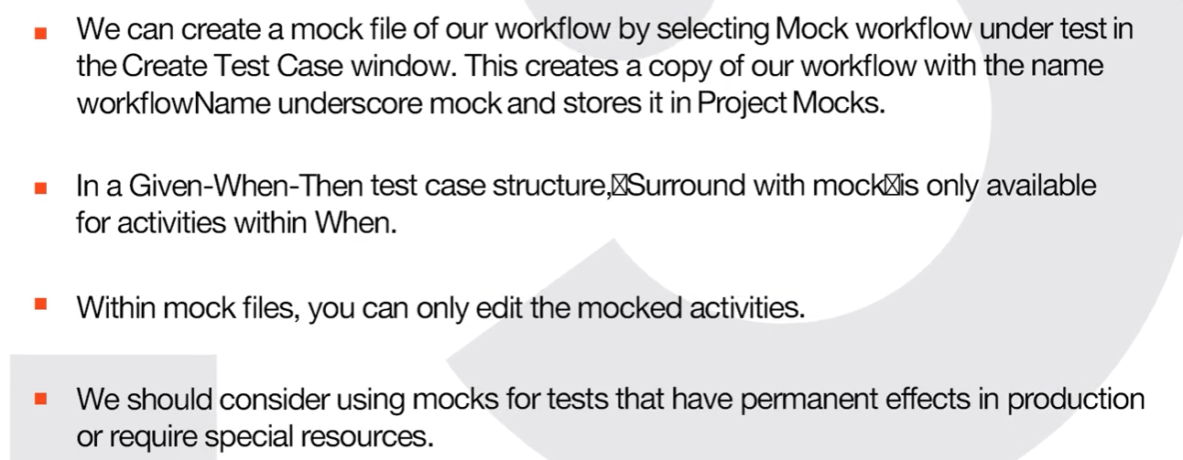

**RPA Testing Best Practices:**

### Modularity in your automation project

Good testing starts well before the test cases. An automation project should be broken down in atomic workflows, each of them having a single purpose and the smallest possible number of actions.

This way, it will be easy to understand and unit-test it.

### Modularity in your test cases

A test case should have one purpose and ideally contain one verification. On the other hand, every feature should have a unit test. If there are exceptions, create separate test cases for each of these.

### Clean structure

Test cases created from workflows have the Given-When-Then structure. You can use other structures or frameworks, but make sure you keep it clean.

If the Given block becomes too cumbersome, it might be a sign that the workflow you are trying to unit-test should be more atomic.

### Autonomy

Test cases should be autonomous, meaning that one test case should not depend on another test case's run.

### Mocking

Use mocking whenever there are complex steps irrelevant to the purpose of the test case.

### Keep test cases up to date

Update the test cases with each change request.

### Reusability

If there are test cases relevant for other automation projects, use the Import Test Case feature in Studio. If you need to rename the test cases, do it only in Studio, not outside.

### After unit testing

If your development model is configured for Continuous Integration/Continuous Deployment, include the test cases in the CI/CD pipeline.

Prepare an RPA test set that can be run by the IT team in the pre-production environment, whenever there's an environment change. On the other hand, run the test set whenever you commit a change to your automation project.

### Workflow Analyzer

Use Workflow Analyzer to ensure projects meet high quality and reliability standards. It uses a set of rules to check for various inconsistencies unrelated to project execution.

**RPA Developer Advance**

**Block User Input**:

Using block user Input we can stop the user from interfering with process execution by blocking the keyboard and mouse while UI Interactions run.

It will frizz the users keyboard and mouse when executions is in process/ running state.

When we are using block user input activity that time we have to give some key combinations that keys help us to take control again for the user.

**Send Window Messages and Simulate:**

It will help us to how we can isolate UI Interaction execution from user actions on the machine by using the Simulate and Send Window Messages input methods.

**Input method capabilities**

|  |  |  |  |  |  |
| --- | --- | --- | --- | --- | --- |
| **Capability Method** | **Compatibility** | **Background Execution** | **Speed** | **Hotkey Support** | Auto Empty Field |
| **Default** | 100% | no | 50% | yes | yes |
| **SendWindowMessages** | 80% | yes | 50% | yes | no |
| **Simulate Type/Click** | 99% - web apps 60% - desktop apps | yes | 100% | no | yes |

**Picture in Picture(PiP):**

It will help usrun our automations in a separate Windows session, thus ensuring separate workspaces for the Robot and the attended user.

It will help for simplify side by side automation.

We can run process in this mode from UiPath Assistant, from debug window and also from project setting.

It will create one separate window in our laptop for Process.

Note: Send outlook mail messages activity will not work in PiP mode.

**Background Processes and Triggers**

The **Background Process** is a template for creating processes that can run in parallel on the same Robot, together with one foreground process. For this reason, background processes must not contain activities that require UI Interaction activities like Click and Type Into.

Note that this feature is only available for Attended Robots. When using Unattended Robots to run multiple Processes at the same time, each Running Process consumes a separate license.

**Triggers** let us monitor certain events on the user's machine like UI element changes, keyboard actions, or mouse actions and define activities to be executed in response to these events.

**Invoke Method activity—Overview**

The Invoke Method activity helps us call a method that is outside the standard built-in activities. It is used to call a specific method in a class.  
The activity calls a public method of a specified type or object. It acts on either Target Type or Target Object.

**When is the Invoke Method activity useful?**

Here are some situations when we should use the Invoke Method activity:

* When we have a class library/DLL in vb.net or c# and want to call that method.
* When we want to use a method which does not generate an output (for example, Reverse) and therefore cannot be used in an Assign activity.
* When we want to use a method which generates several pieces of output (for example, TryParse which generates a Boolean and an Int32). Several values cannot be assigned using an Assign activity.

**Method Types**

There are two ways of configuring the Invoke Method activity depending on the type of method used. Methods can be of a **Static** or of an **Instance**type.

Let's take a moment to learn more about the two types of methods and how we need to configure the UiPath Studio activity based on them.

**Static Methods**

When a class is defined as static, we don't need to define the object. Thus, the static method can be called directly.  
  
If it's a static method, the Target Type is used.

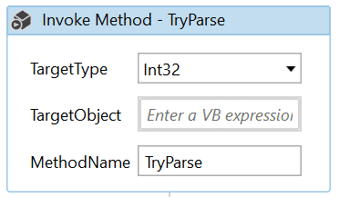

**Instance Methods**

–

In the Instance Method, the object from which the method or members are derived needs to be defined.  
  
If it's an instance method, the TargetObject is used.

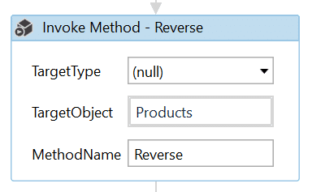

To figure out whether a method is a Static or an Instance method, you can check the Method signature in on the [MSDN website](https://docs.microsoft.com/en-us/dotnet/?view=netcore-3.1). Below, you can find the signatures for a **Static** method, Round(Decimal), and an **Instance** method Sort(Comparison<T>).

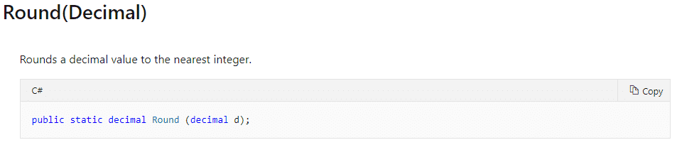

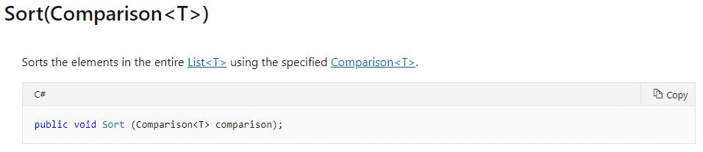

**Note:** Invoke code activity will help us for giving the hash code of the file.

We can’t **define methods, procedures, or functions in an Invoke Code activity.**